6 FEB DBMS

Download link <https://dev.mysql.com/downloads/mysql/>

* Download version 8.3.0 innovation

Download mysql workbench [*https://dev.mysql.com/downloads/workbench/*](https://dev.mysql.com/downloads/workbench/)

* Workbench not compatible with 8.3. Work with 8.0

Consequences if DBMS like CONCEPT vanishes from earth

* Before File system was used to save data
* Searching is easier in a DB
* DB are used everywhere

# TOPIC: DataManagement

Current Solution : MS Excel

Excel is an individual solution and not an enterprise solution.

For eg

1. Is Excel designed to handle [ large volumes of data ] say or eg. 4.7 gb?
2. Is Excel designed to handle Mission Critical Task in systems say for eg. NEFT/RTGS/UPI/Bookings etc?
3. Does Excel provides sophisticated solutions for security for eg. say Creating users, Granting/Denying permission at different levels?
4. Does Excel provide easy mechanisms for Accessing & Manipulating data?

DMBS characteristics

* Handle large volume of data
* Handle transactions
* Handle creation of users and security features
* Easy accessing and manipulating data

Transaction : is a unit of work performed against a database that must be completed as a whole, ensuring data integrity and consistency.

A transaction typically consists of one or more database operations, such as inserting, updating, deleting, or querying data.

Key properties of transactions in DBMS:

1. Atomicity

2. Consistency

3. Isolation

4. Durability

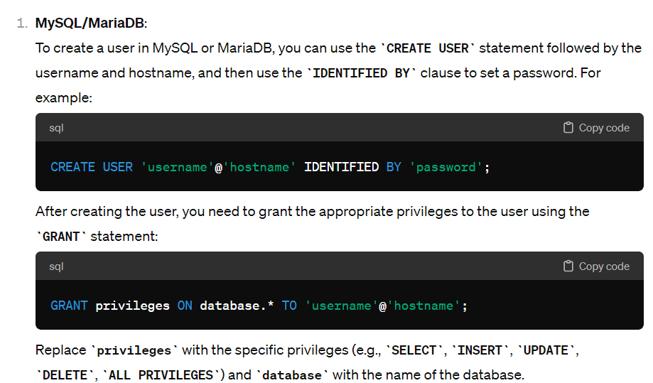

|_DBMS

|_RDBMS

Relation is a term used for tables in RDBMS ( any software that has the above characteristics and strictly stores the data in tabular data can be called a RDBMS ) MySQL

|_NoSQL

Non-relational Database

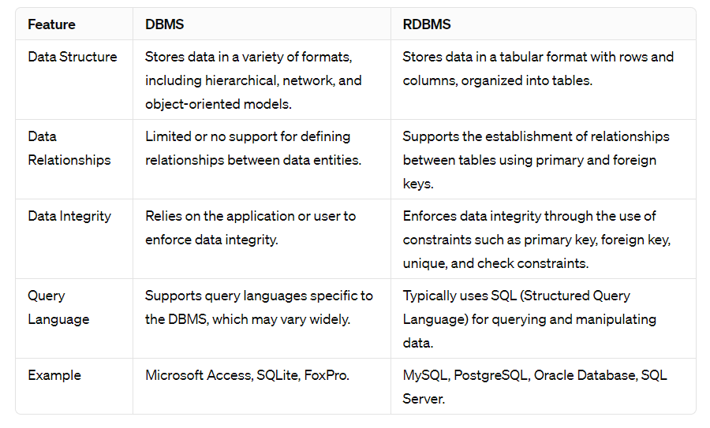

# Type of data processing tools

##### OLTP (Online Transaction Processing)

1. OLT Systems work on Transaction Data
2. Transaction means anything executing in real-time and is important
   1. Latency(Response Time) will always be LOW (fast) < 10ms
3. OLTP mostly works with small volumes of data. 100s of MB to a few GB.
4. OLTPs are used for day-to-day operations
5. Involves frequent READ/WRITE operations
   1. Scrolling through the food menu over Zomato? - read
   2. Ordering food - write
6. Bookmyshow - booking of a movie is a transaction
7. Eg. A bank processing real-time transactions such as deposits, withdrawals, and transfers, ensuring accurate and immediate updates to account balances. OLTP systems prioritize fast transaction processing and maintain data integrity.

##### OLAP (Online Analytical Processing)

1. OLAP systems are designed mainly for data analytics
2. OLAP systems work on archived or historical data
3. OLAP systems due to their nature(analytics) tend to be SLOW.
4. OLAP systems mostly work on large volumes of data or BigData.
5. OLAP systems involve INTENSE READ operations
6. Ex: An e-commerce platform analyzing sales data over several years to identify seasonal trends and optimize inventory. OLAP helps in generating reports for strategic decision-making.

BIG DATA : Any data that cannot be managed or handled using traditional data processing systems say RDBMS is called BIG data

For eg. if in your organization servers can process and produce results for up to 1500GB but post 1500GB if the expected response time are not matching with the standard ( eg latency limit ) then Data beyond 1500 GB will be called BigData for your organization

The volume of big data depends upon the infrastructure capability of any organization

Eg. Amazon REDSHIFT!

MySql allows up to 80% consumption of RAM for current transactions. Now imagine if memory size in a normal server is just 32 GB (ideally it is 64GB)

What 80% will make? 24 GB

Needed for RDBMS

Normalization is a process of removing anomalies (data discrepancy/issues in data)from raw data before storing the data.

Anomalies

1. Duplicate values in the table / Data Redundancy
   1. Increased Disk Storage consumption
   2. Increased/Redundant Data leads to loss of performance
2. Update Anomaly : update Table set Price=0 where Name=’Mahesh’
3. Missing Unique Identifier is an anomaly
   1. Leads to update/insert/delete anomaly

Summary: For a dbms candidate it is very important to understand discrepancy in structure of data, understand anomalies in data and learn the fix or solution to anomalies.

**Ultimate mission as a DBMS learner:** to maintain/retain the Right State of Data also called Data Integrity.

**Normalization**

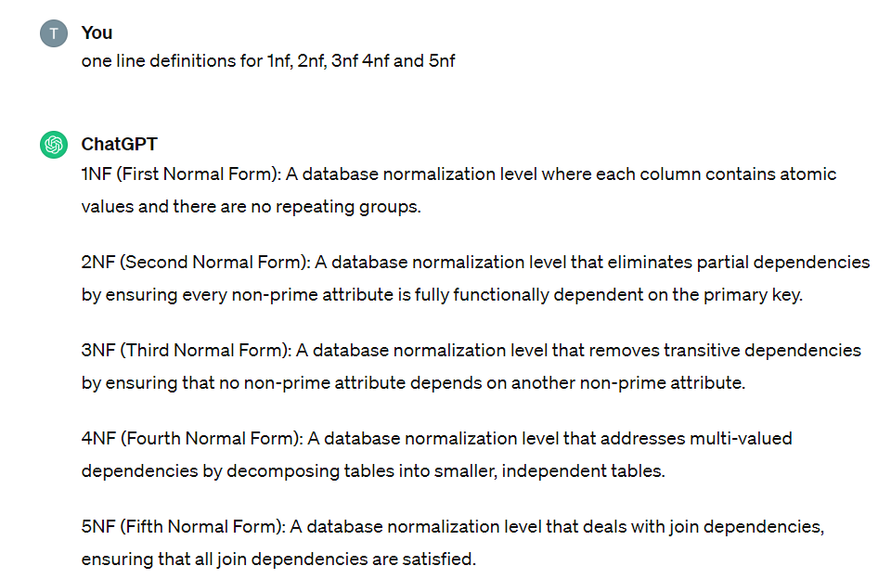

5NF:

A join dependency exists when a relationship between attributes in one table can only be expressed through joining it with another table.

Eliminating or reducing join dependencies often involves decomposing tables into smaller, more atomic tables and creating additional join tables as needed to represent the relationships between them. This helps to ensure that each table in the database schema represents a single logical entity, with minimal overlap or redundancy, and allows for easier maintenance and querying of the database.

**1NF**

Definition:

It states that each attribute (or column) in a table must contain atomic (indivisible) values, and there should be no repeating groups or arrays within the table.

Significance:

By adhering to 1NF, you ensure that your database design avoids data redundancy and inconsistency, making it easier to query, update, and maintain.

Criteria for Adherence:

1. Each table cell should contain a single, indivisible value.
2. Each column in a table must have a unique name.
3. The order of the rows and columns should not affect the data stored in the table.
4. Each column must contain values of the same data type.

Practical Examples:

a simple example of a table that violates 1NF and then modify it to adhere to 1NF.

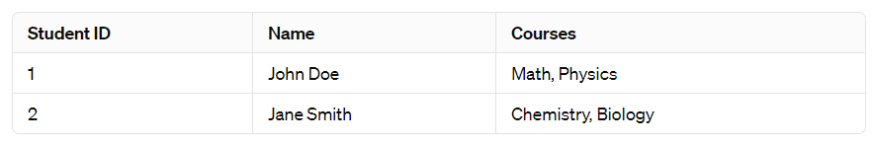

The "Courses" column violates 1NF because it contains multiple values separated by commas.

To adhere to 1NF, we need to split the table into two separate tables:

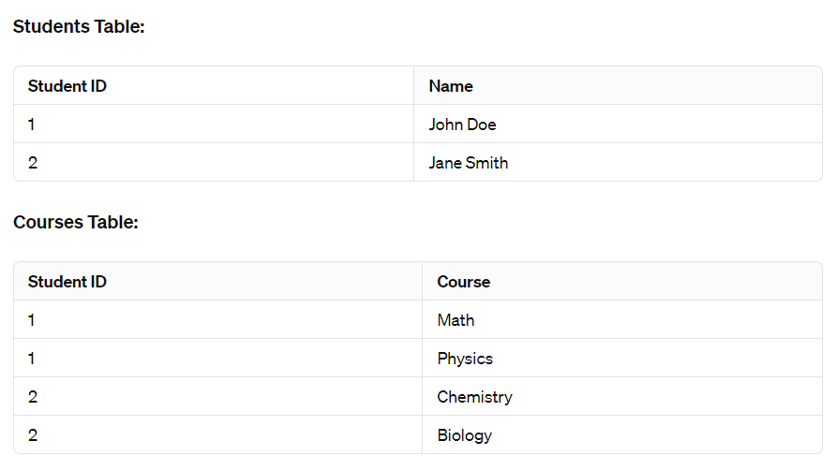

By splitting the data into two tables, each table now contains atomic values, and there are no repeating groups, thus satisfying 1NF.

Adhering to 1NF helps maintain data integrity and facilitates easier data manipulation and querying in a relational database environment.

**2NF**

Definition:

Second Normal Form (2NF) is a level of database normalization designed to eliminate redundant data within a table by ensuring that each column in a table depends solely on the table's primary key.

It builds upon the first normal form (1NF) by addressing the issue of partial dependency, where attributes depend on only a part of the primary key.

Significance:

1. Reduces Redundancy: By eliminating partial dependencies, 2NF helps in reducing redundancy in the database, thereby saving storage space and ensuring data consistency.
2. Improves Data Integrity: By organizing data more efficiently, 2NF enhances data integrity, making it less prone to anomalies during updates, deletions, and insertions.
3. Simplifies Database Design: Following normalization principles like 2NF leads to a more organized and efficient database schema, making it easier to understand, maintain, and scale.

Criteria for Adherence:

1. Be in First Normal Form (1NF): The table should already be in 1NF, meaning it should have a primary key, and each column should hold atomic values.
2. No Partial Dependencies: Every non-prime attribute (i.e., not part of the primary key) must be fully functionally dependent on the entire primary key.

Practical Examples:

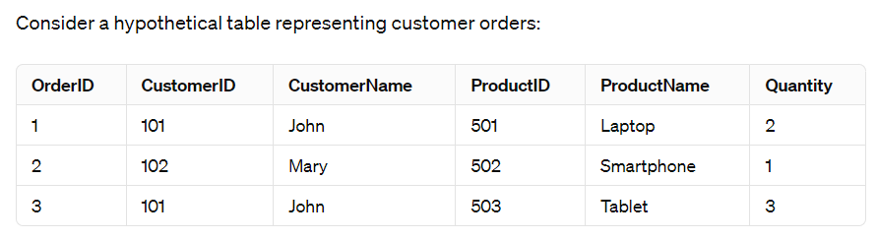

This table violates 2NF because the attribute CustomerName is functionally dependent only on CustomerID and not on the entire primary key (OrderID). To bring it to 2NF, we split the table into two:

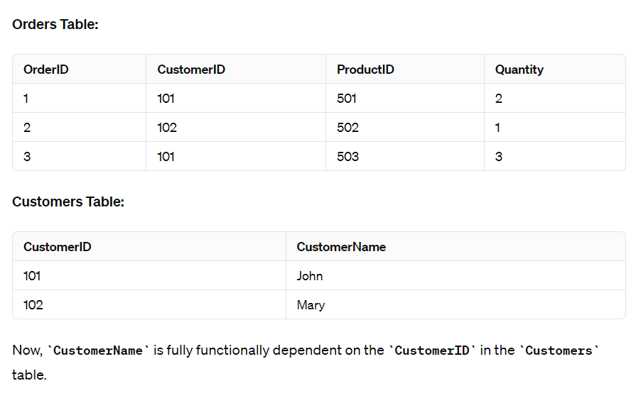

**3NF**

Criteria for Adherence:

To adhere to Third Normal Form, a table must satisfy the following criteria:

1. First Normal Form (1NF): The table must already be in 1NF, meaning it should have a primary key and each column should contain atomic values (indivisible).
2. Second Normal Form (2NF): The table must be in 2NF, meaning it should not have partial dependencies. All non-key attributes should be fully dependent on the entire primary key, not just part of it.
3. No Transitive Dependencies: There should be no transitive dependencies, meaning that non-prime attributes (attributes not part of any candidate key) should not depend on other non-prime attributes.

**4NF**

Definition:

Fourth Normal Form (4NF) is a level of database normalization that builds upon the principles of Third Normal Form (3NF). It aims to further reduce data redundancy and improve data integrity by addressing certain types of multi-valued dependencies that cannot be handled by 3NF.

Significance:

By adhering to 4NF, databases can achieve a higher level of organization and structure, making them easier to maintain and query.

Criteria for Adherence:

To adhere to Fourth Normal Form, a relation (table) must already satisfy the criteria of Third Normal Form (3NF). Additionally, it must not contain any non-trivial multi-valued dependencies (MVDs). A non-trivial MVD occurs when a dependency exists between attributes in a relation that are not simply logical consequences of the candidate keys.

Practical Examples:

Suppose we have a relation called Employee_Project, where each tuple represents an employee working on various projects. The attributes are Employee_ID, Project_ID, and Task.

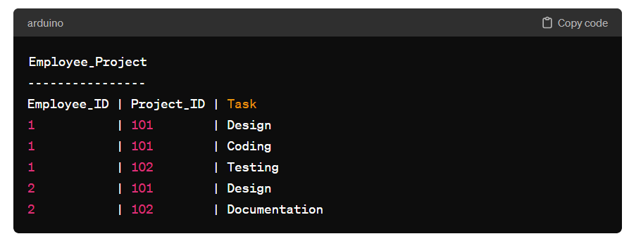

In this relation, (Employee_ID, Project_ID) is the composite key. However, we observe that an employee can have multiple tasks within a project, leading to multi-valued dependencies. For example, Employee 1 is assigned both "Design" and "Coding" tasks for Project 101.

To normalize this relation to 4NF, we can split it into two relations:

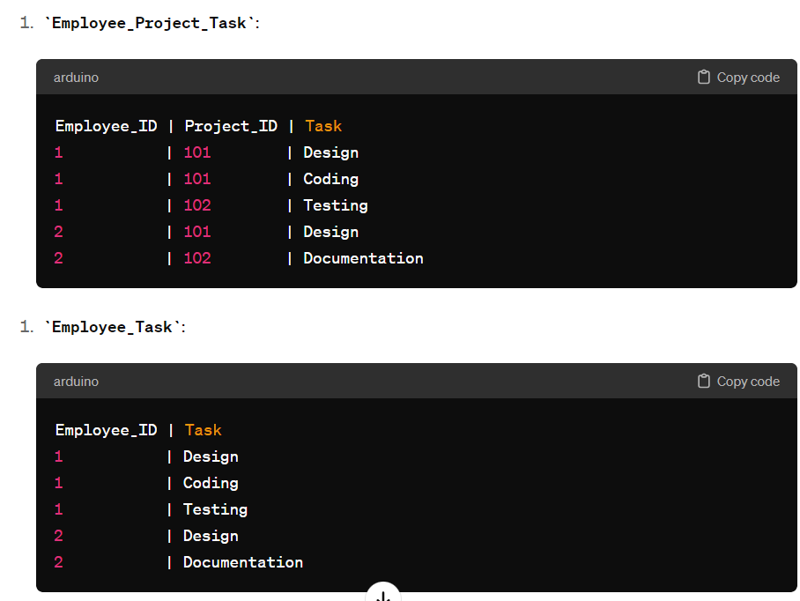

By doing this, we eliminate the multi-valued dependency between Employee_ID and Task, ensuring that each relation satisfies 4NF.

In summary, Fourth Normal Form (4NF) is a crucial concept in database design, aimed at minimizing redundancy and anomalies by addressing multi-valued dependencies. Adhering to 4NF helps maintain data integrity and facilitates efficient data management in DBMS.

**5NF**

Fifth Normal Form (5NF): A level of database normalization that addresses the issue of join dependencies in addition to the concerns addressed by lower normal forms (1NF, 2NF, 3NF, BCNF, and 4NF). It ensures that all join dependencies are eliminated, leading to a more robust and efficient database schema.

Significance:

* Reduction of Redundancy: 5NF eliminates redundant data, which helps in reducing storage space and improving data integrity.
* Improved Data Integrity: By removing all types of dependencies, 5NF ensures that updates, insertions, and deletions maintain data consistency.
* Support for Complex Data Models: It's particularly useful for complex data models where higher levels of normalization are required to maintain data consistency and integrity.

Criteria for Adherence:

1. It must be in Fourth Normal Form (4NF).
2. It must not have any join dependency. A join dependency occurs when three or more attributes are dependent on each other in such a way that they cannot be expressed through a series of binary join operations.

Practical Examples:

Scenario:

Suppose we have a database for a university that tracks courses, professors, and the classrooms where courses are taught.

Initial Schema (Not in 5NF):

Courses (CourseID, CourseName, ProfessorID, ProfessorName, RoomNumber)

Implementation Steps to Achieve 5NF:

Create Separate Relations for Professors and Courses:

* Professors: (ProfessorID, ProfessorName)
* Courses: (CourseID, CourseName)

Create a Relation for Room Allocation:

* RoomAllocation: (CourseID, ProfessorID, RoomNumber)

Achieving 5NF:

* Ensure that there are no join dependencies. In this case, there are no non-trivial join dependencies, as each relation is defined by its own set of attributes.

Final Schema (In 5NF):

* Professors: (ProfessorID, ProfessorName)
* Courses: (CourseID, CourseName)
* RoomAllocation: (CourseID, ProfessorID, RoomNumber)

##### Normalization looks like a funnel

* Each stage has a predefined law or rule that is applied on each data
* The more laws you follow the better structure/schema you end up with
  + Better structure implies reliable data

\ I NF /

\ IINF /

\ III NF /

\ IV NF /

\ V NF /

SO ON

ER diagram

* Types of entities
* Types of relationships
* Types of schemas
* Types of dependencies

Logical model vs physical model vs conceptual model

##### ONLINE NOTES: <https://www.geeksforgeeks.org/last-minute-notes-dbms/?ref=lbp>

7th Feb

1. Normalization
2. Using MySQL Workbench
3. Writing & Running queries
4. DDL commands
5. Practice Exercises

Priority for designing schema:

* No loss of data
* Data Redundancy
* Well structured
* Simply to maintain Data Integrity

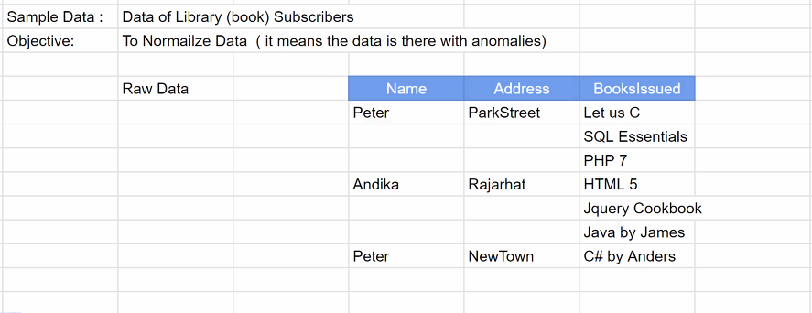

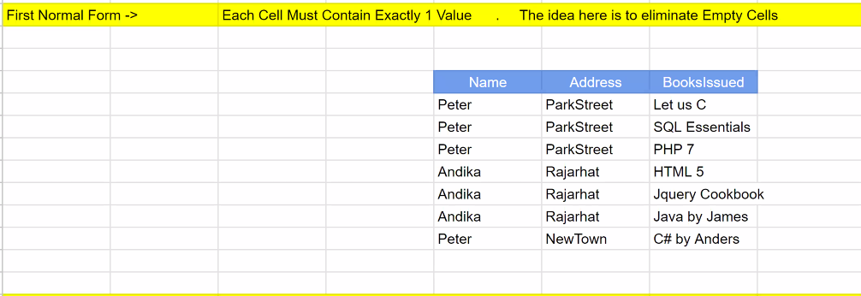

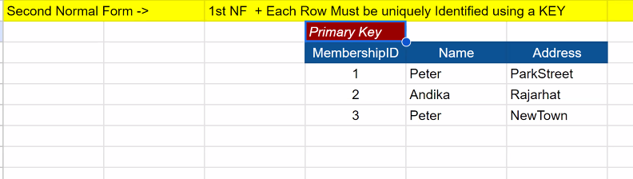

##### What is a Constraint in SQL?

Constraint in SQL ensures the data integrity of the column. In other words, constraint doesn’t allow invalid data in a given column.

There are many constraints for eg. primary key / foreign key / unique / check / default / not null.

Primary Key is applied in the previous example

CODE: create table sample (membershipID int primary key)

##### Characteristics of primary key constraint

A primary key is a unique identifier for each record in a database table, ensuring data integrity and enabling efficient data retrieval.

* A primary key constraint doesn't allow duplicates in a column.
* Each value in a primary key column will be unique, Hence each value is or acts as a UNIQUE ROW IDENTIFIER in primary key column.
* Primary Key prevents / disallows Nulls.
* There can only be one primary key column per table.

Create table sample ( membership int primary key,

email varchar(255) unique

);

Characteristics of UNIQUE constraint

* Unique constraint is same as Primary Key constraint
  + Similarity: Similar to primary key constraint Unique also prevents/disallows duplicates
  + Difference: Unique constraint allows nulls whereas Primary key doesn’t allows nulls

Age column

Objective: to ensure that age must always be greater than 18

##### Check Constraint : ensures that a given column only accepts a range of values or a specified set of values

Eg 1. Age column must be greater than 18

Eg 2. Nationality column must accept only accept indian/bhutanese value and reject all other values

Eg.

create table sample(membership int primary key,

age int,

nationality varchar(255),

constraint ageCheck check (age>=18),

constraint natCheck check nationality in (‘indian’,’bhutanese’)

);

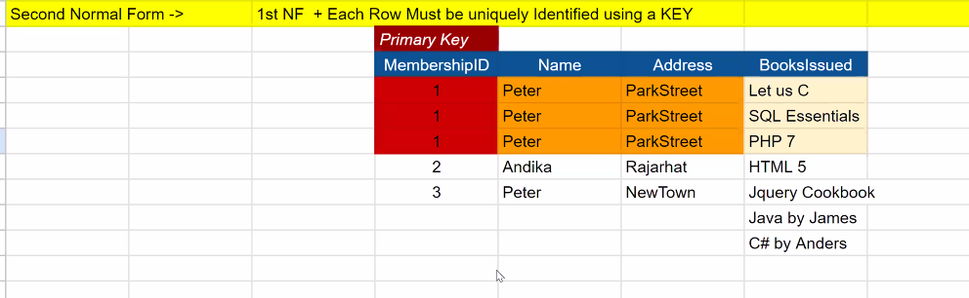

We can’t add the BooksIssued column in the same table

* Violation of normalization/data redundancy
* Violation of primary key
* Solution
  + Keep the books issues column in a second table

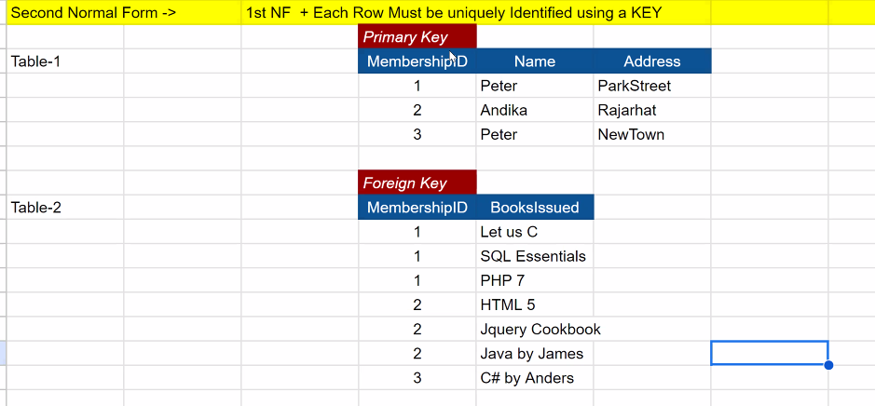

The repeated primary key is called foreign key in table-2

A foreign key is a column in a table that references the primary key of another table, ensuring referential integrity between related data.

##### Characteristics of Foreign key

* Foreign key help us correlate the rows of 1 table with rows of other table using primary key
* Foreign key help us create/link relationship with other table
* Foreign key can accept null values
  + Rows with null value foreign keys are called ORPHAN rows
* Foreign key can’t accept duplicate values
* Foreign key accepts only values that are present in corresponding primary key. If any other value is provided then the query/command will be rejected.
* This feature of foreign key is called referential integrity
* How foreign key allows null but primary key doesn’t?
  + We associate Foreign key with primary key, but it is not necessary. We can create a FOREIGN KEY without a PRIMARY KEY as well. It will refer to UNIQUE KEY in another table to create foreign key
* In simple language:
  + Thank you foreign key (pointing to referential integrity feature)
  + For ensuring that only registered users can issue book

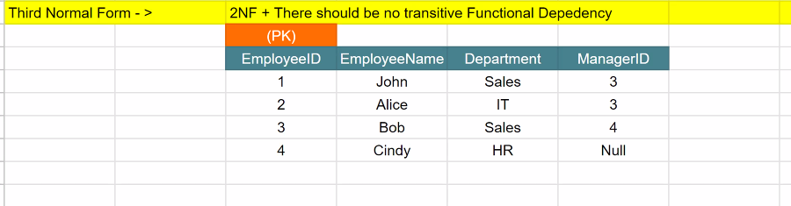

EmployeeID -> EmployeeName : Determine name of a particular employee from ID

EmployeeID -> Department : Determine department of a particular employee from ID

EmployeeID -> ManagerID : Determine manager ID of a particular employee from ID

Summary: Every non key attribute is dependent on Primary key

ManagerID indirectly determines department via EmployeeID - transitive functional dependency

A is dependent upon B and B is dependent on C

Hence

A is indirectly dependent upon C

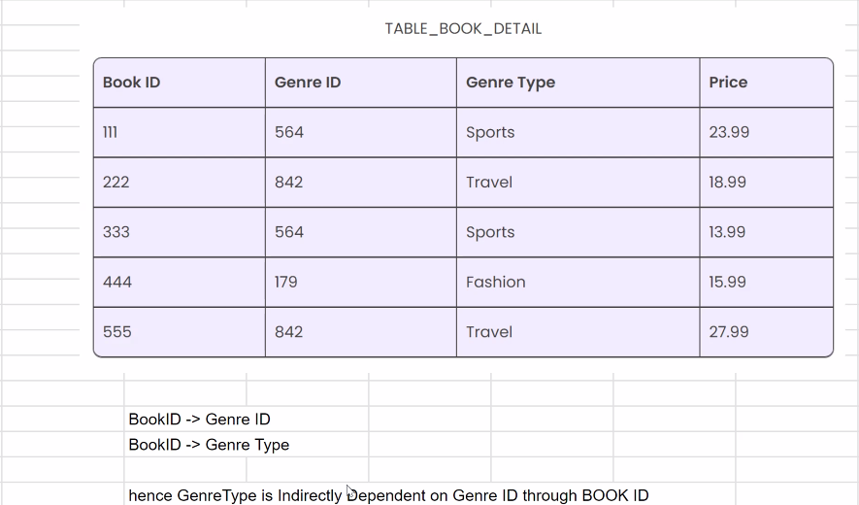

Solution

Create a new table with GenreID and GenreType

Go with better structures not the rules

Practicals

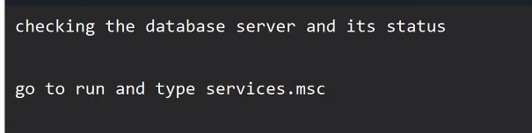

mysql 83

Port number of mysql is 3306

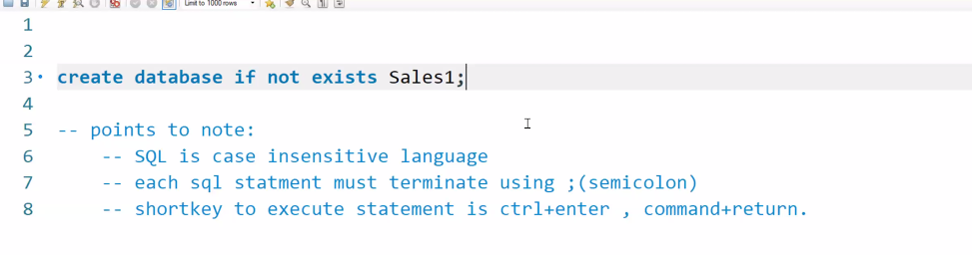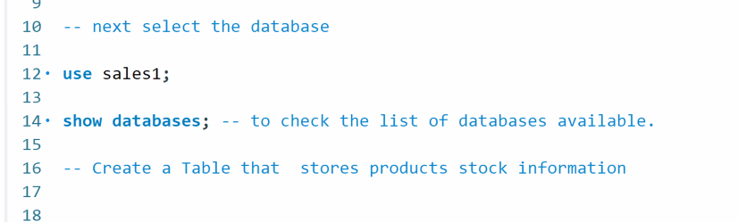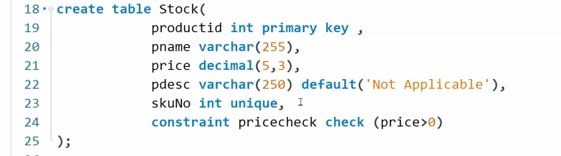

Varchar is like string in sql

– 5,3 means, the total length of digits will be 5, and the decimals will be retained up to 3 decimal places

– default: is a constraint in mysql, it is used to specify default value of a given column

##### Interview Question

What is the difference in char vs varchar datatype?

* Char is a fixed data type and varchar is variable
* When mentioning char(10) it will always occupy 10 bytes on disk even if you pass less data say ‘abc’ will occupy 10 bytes.
* When mentioning varchar(10) it will occupy disk space as per the value passed say ‘abc’ will occupy 3 bytes.

How to Display tables’ data?

* Using select
* select * from <table name>

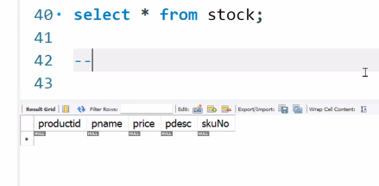

What does * represent? It represents all columns.

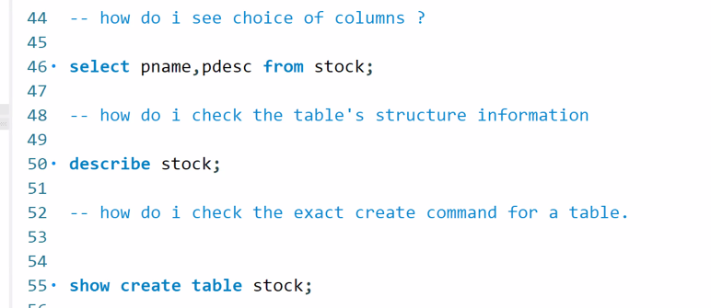

##### MYSQL ENGINES

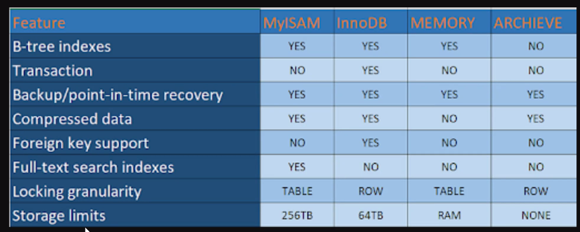

* innoDB supports transactions
* Memory loads the DB into the ram for high performance

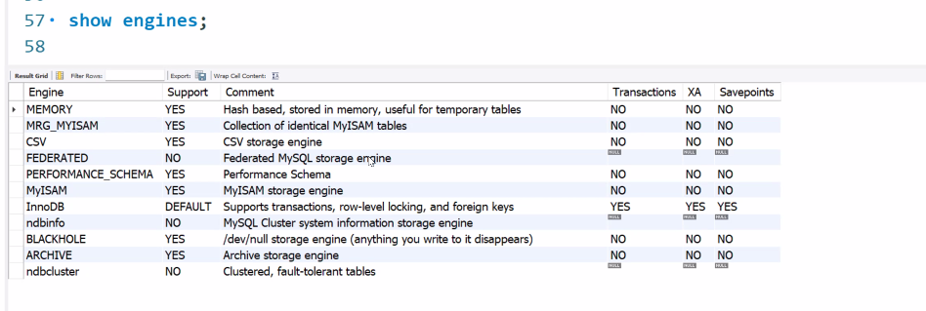

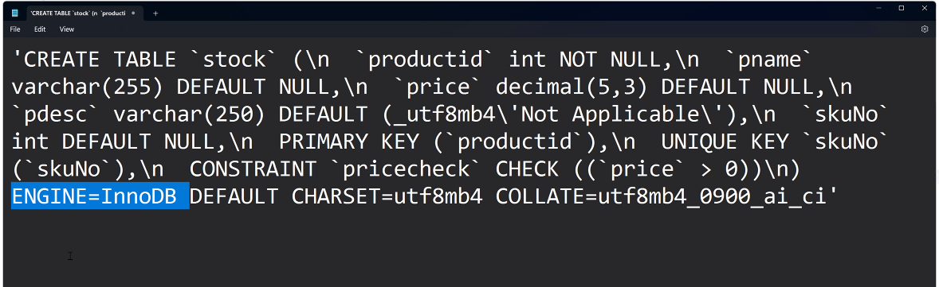

* The Engine is InnoDB by default

##### Add new column in a table

* alter : alter is used to change the structure of a table
* To add a new column syntax is as follows
  + alter table <tablename> add column <columnName> <datatype>;
  + You can specify any constraint as well it works
  + Eg. alter table stock add column skuNo int unique;

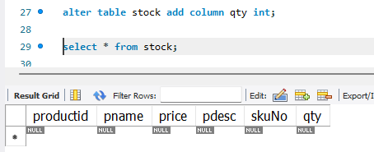

* To drop a column
  + alter table <tablename> drop column <columnName>;

##### Insert a row in a table using insert statement

* syntax : insert <tablename> values ( ? , ? , ? , ? , ? );

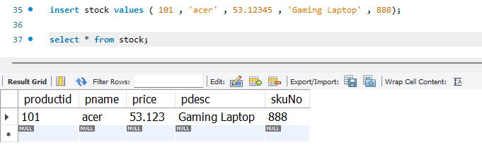

Notice the price got truncated to 3 decimal places





Run insert stock with same 101 id, primary key constraint is enforced





Constraint being enforced

Id is primary key ;Sku should be unique; Only 3 decimals allowed; Price cannot be more than 2 digits

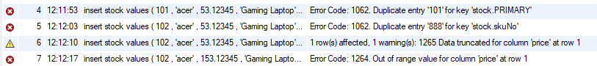

For negative constraint on price -53



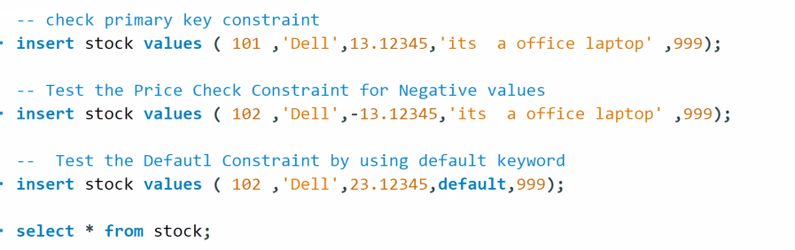



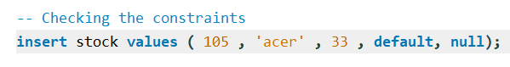



Shows the schema of the table with which it was created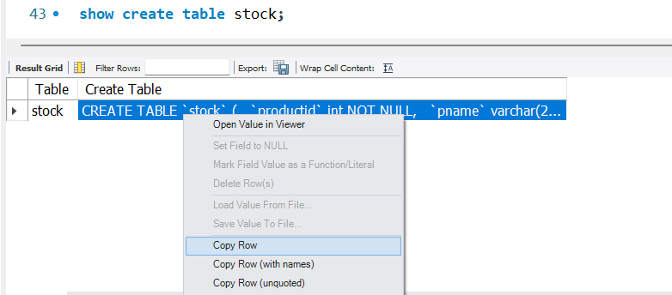

##### Identity columns

We have inserted multiple rows at the end

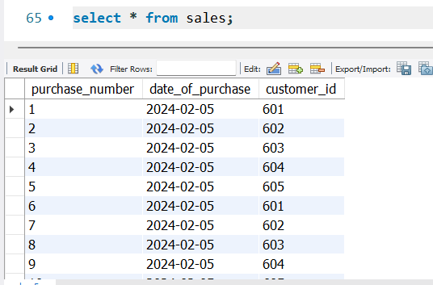

Identity columns are auto incrementing columns that are primary keys

##### Create foreign key

* You cannot create a foreign key without referencing a primary key
* 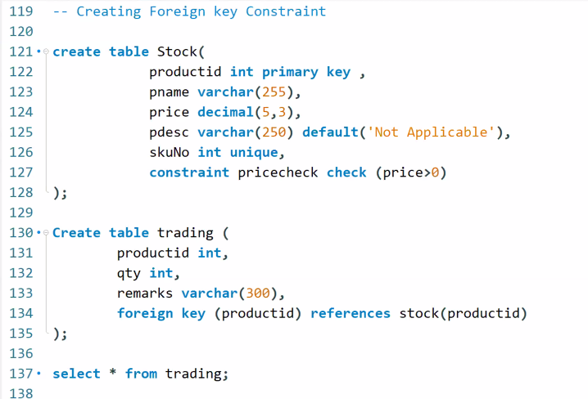

##### Generate ER model

Select database>reverse engineer> select connection and next> enter password if prompted and next>select database you want model for (sales1) and next and then execute and next.

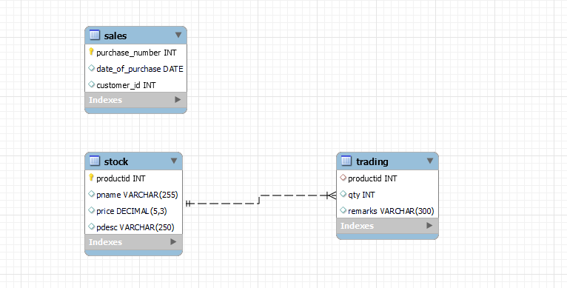

Interview question

##### What is a candidate key?

Any attributes(i.e.column) which is not primary key but is eligible for becoming primary key is called candidate key.

For eg

Create table sales(

purchase_number int ,

date_of_purchase date,

customer_id int

);

* purchase_number and custmor_id are both candidate for primary key

##### What is a composite key?

* A primary key formed by combining 2 or more attributes (column) is called composite key
* Eg

Create table demo(

name varchar(200),

address varchar(200),

sale int,

primary key ( name , address)

);

desc demo;

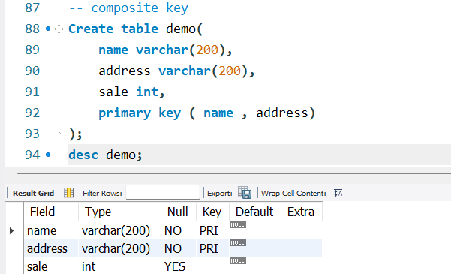

##### Date in SQL

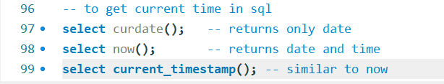

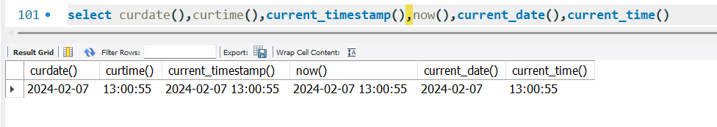

All of these functions works!!!

8 Feb

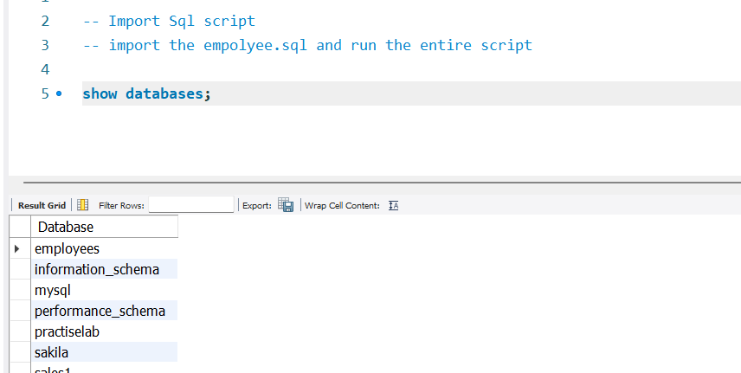

import database into the workbench

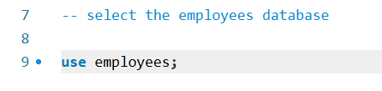

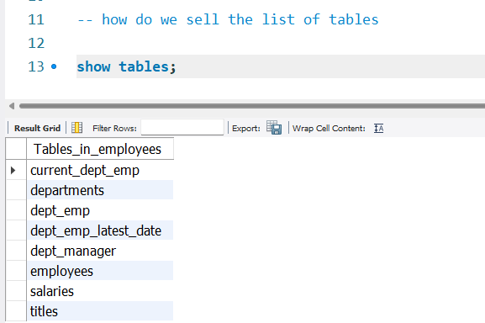

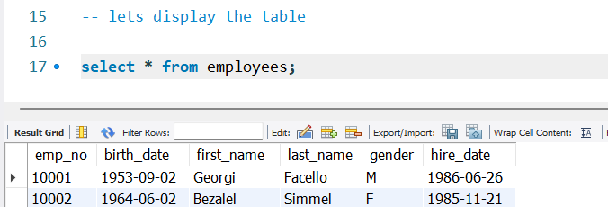

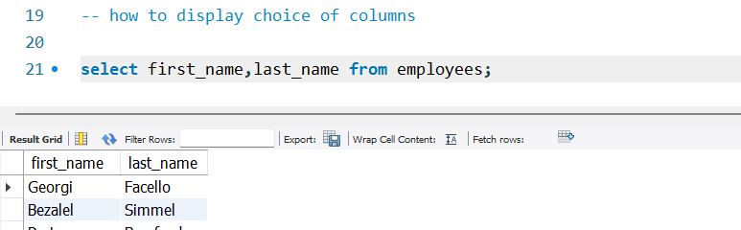

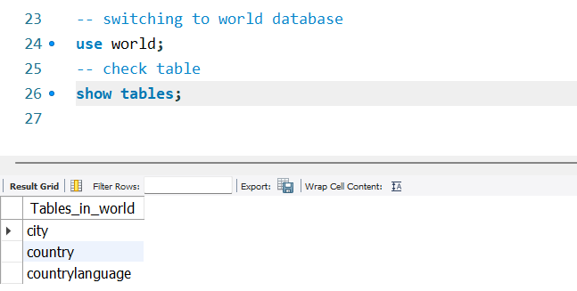

##### 

##### Filtering Records

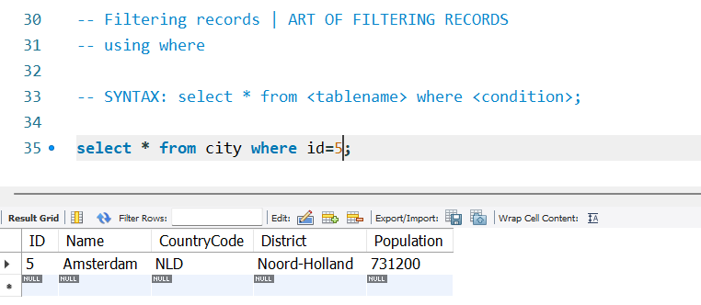

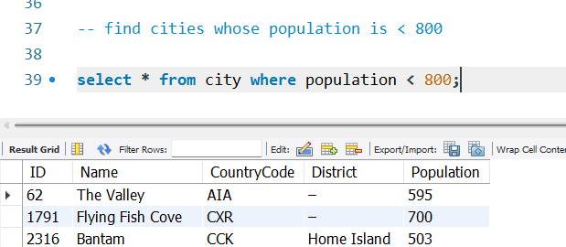

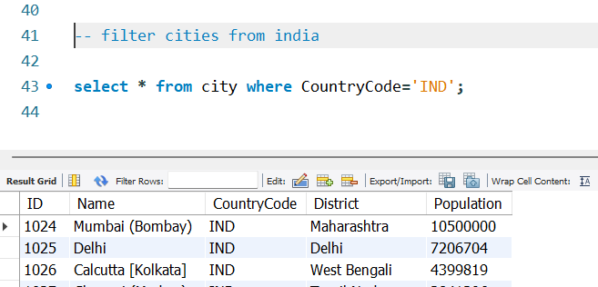

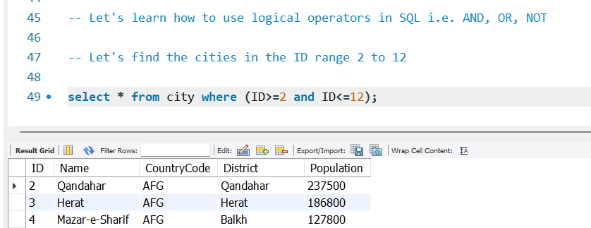

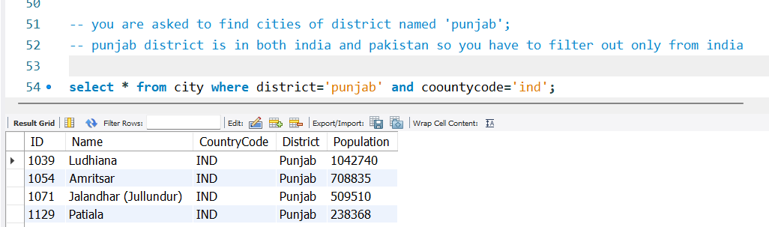

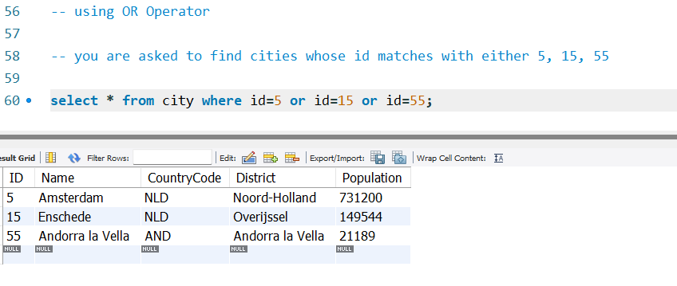

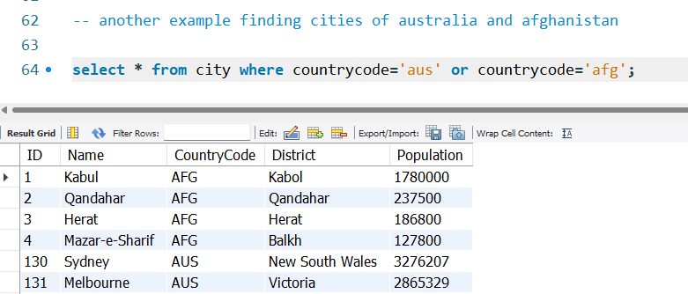

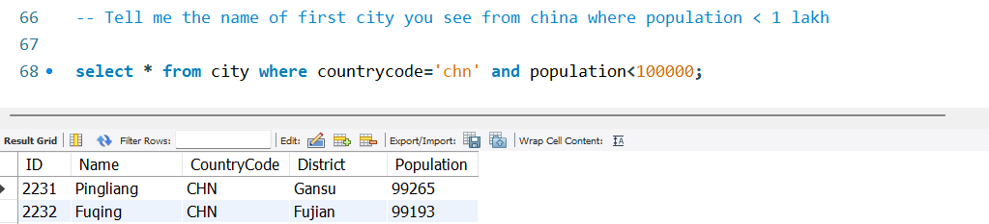

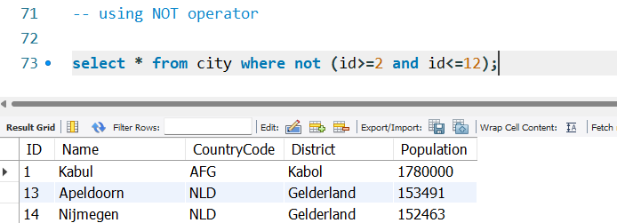

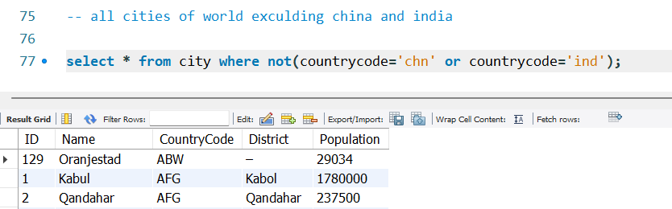

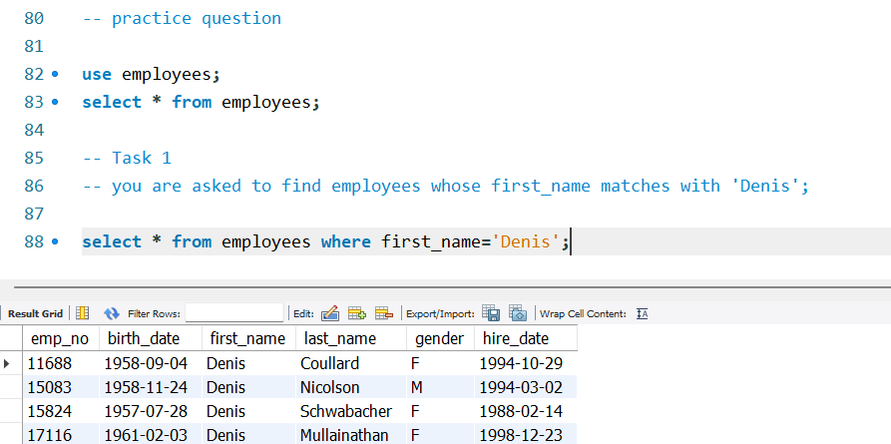

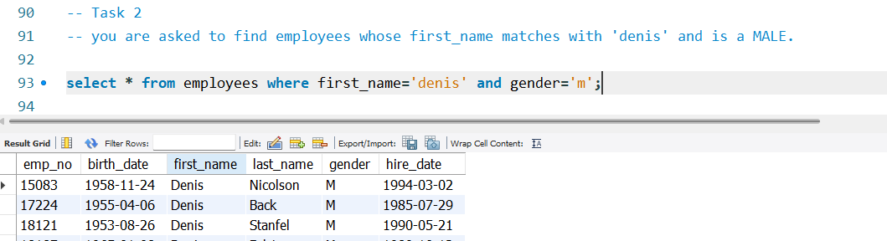

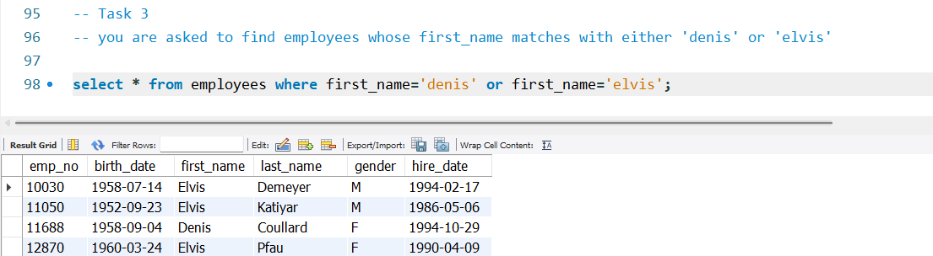

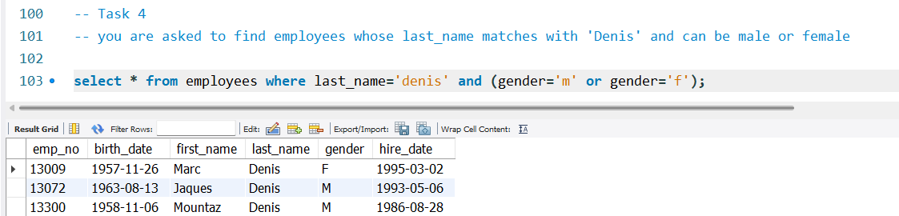

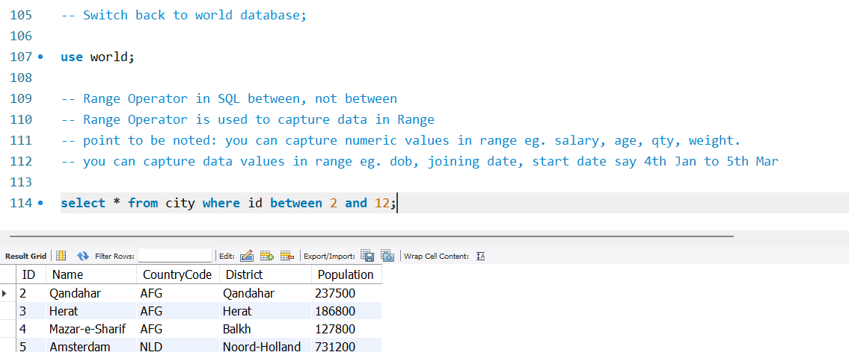

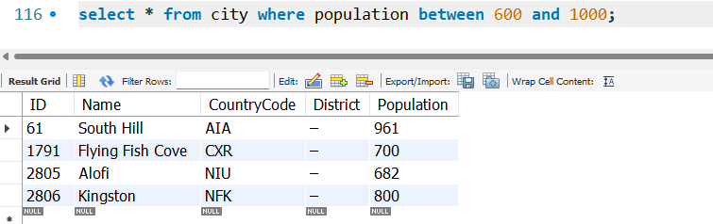

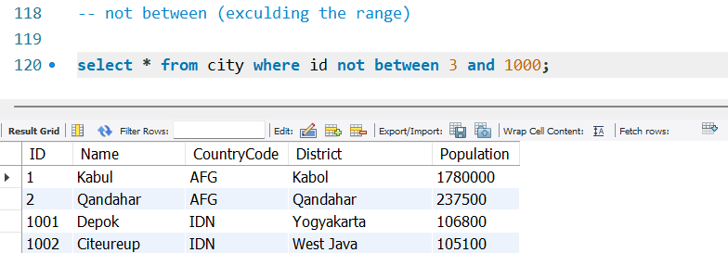

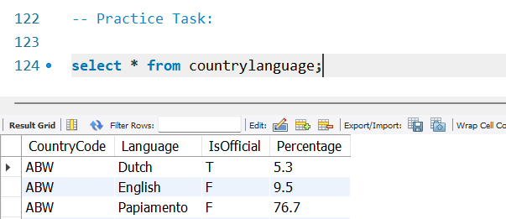

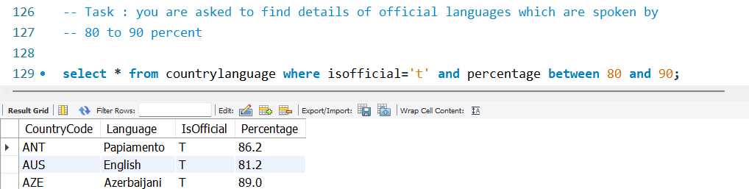

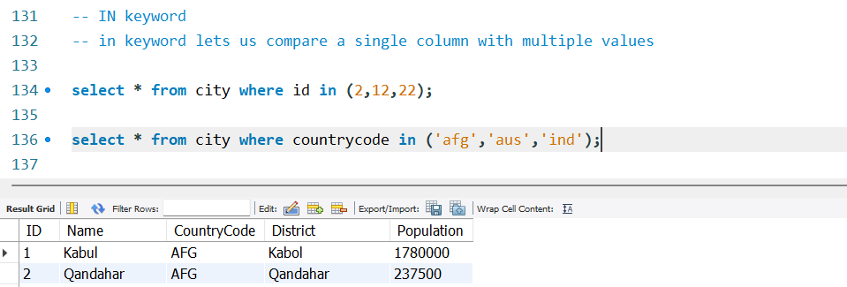

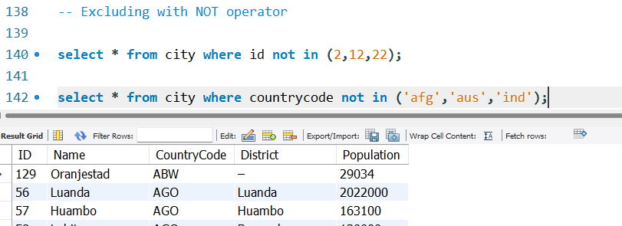

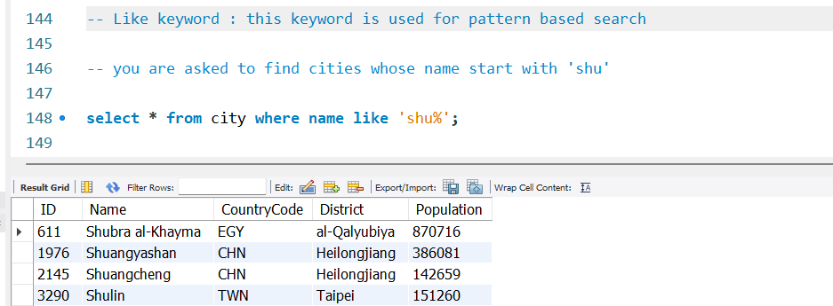

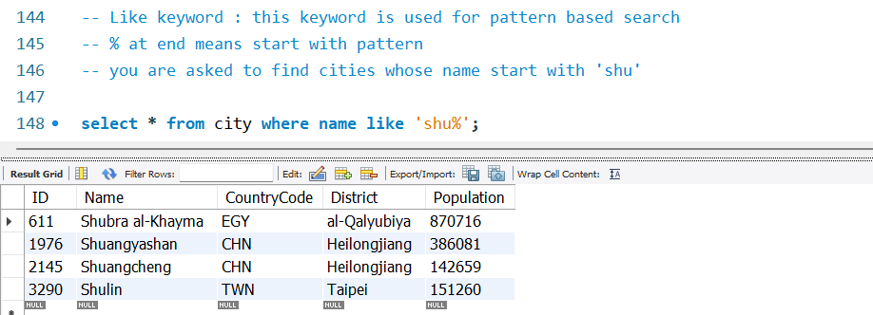

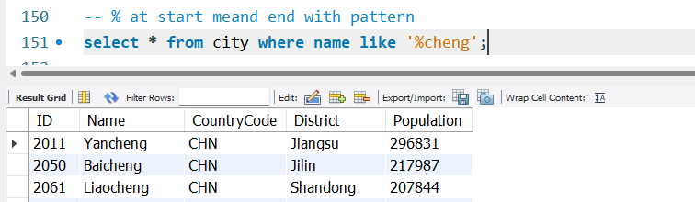

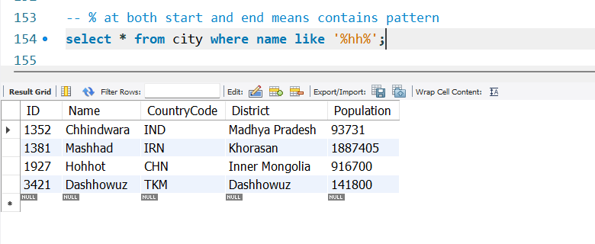

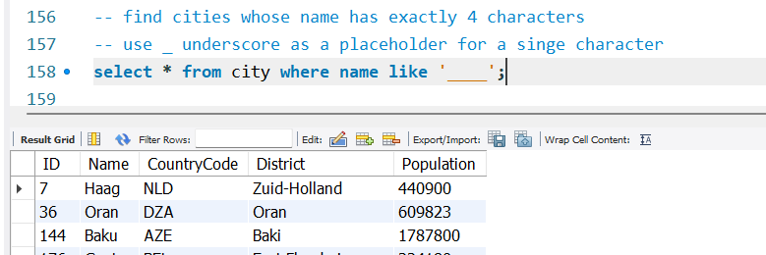

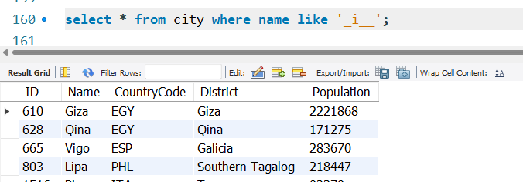

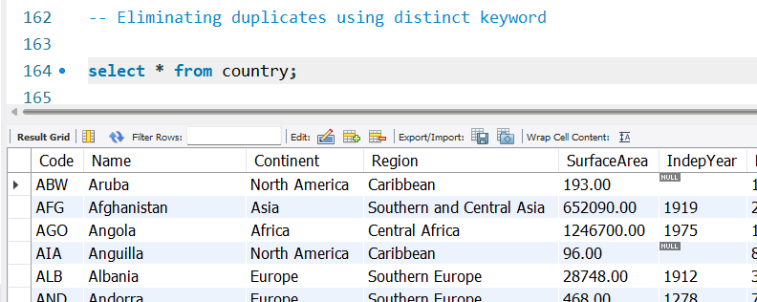

There are duplicates in the continent column

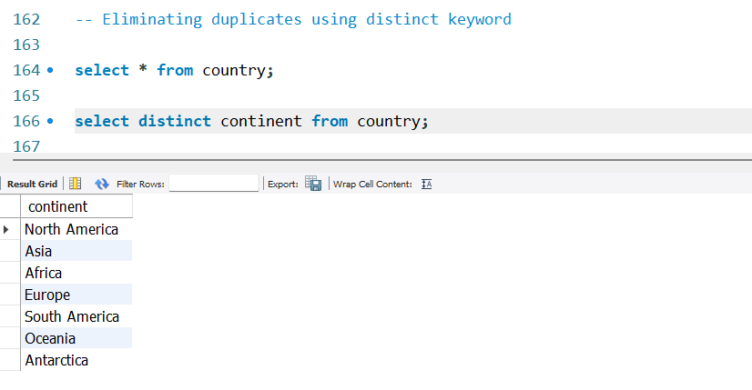

##### Dealing with nulls

Notice some countries have null values

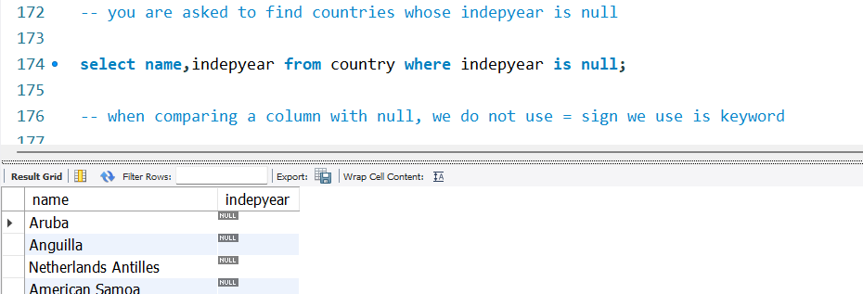

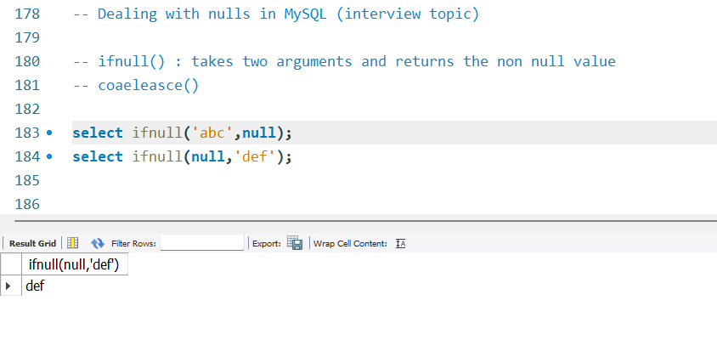

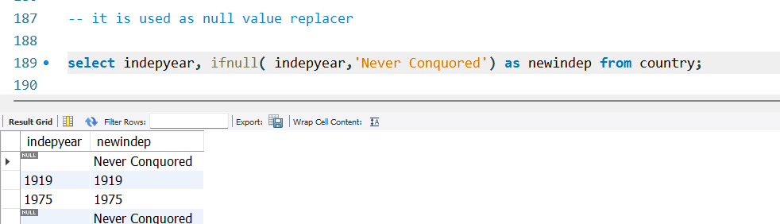

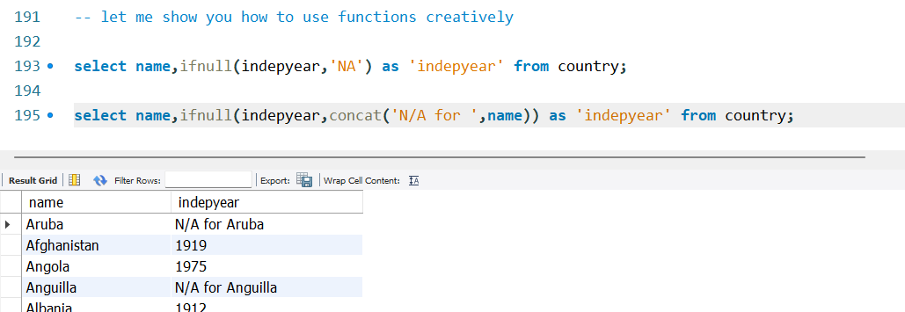

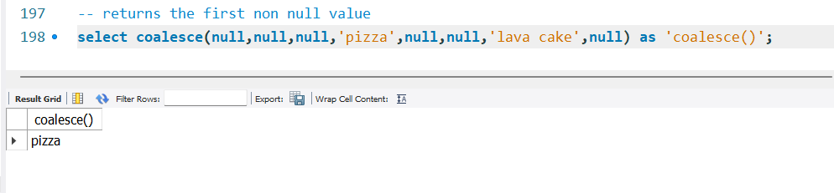

9 Feb joins,

##### sorting

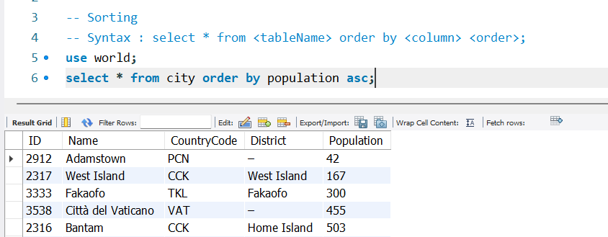

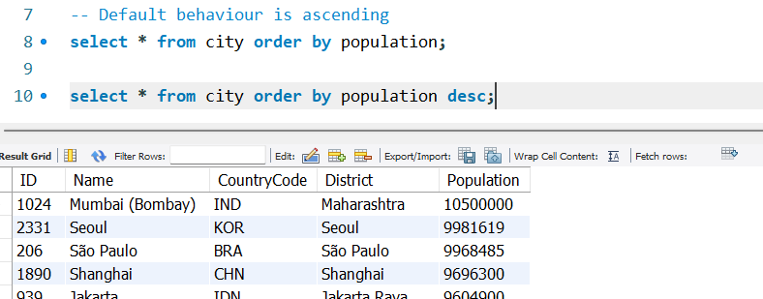

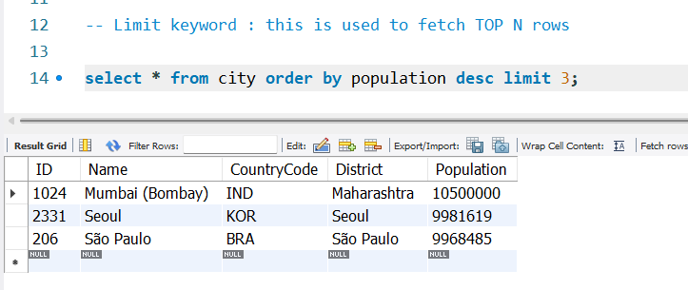

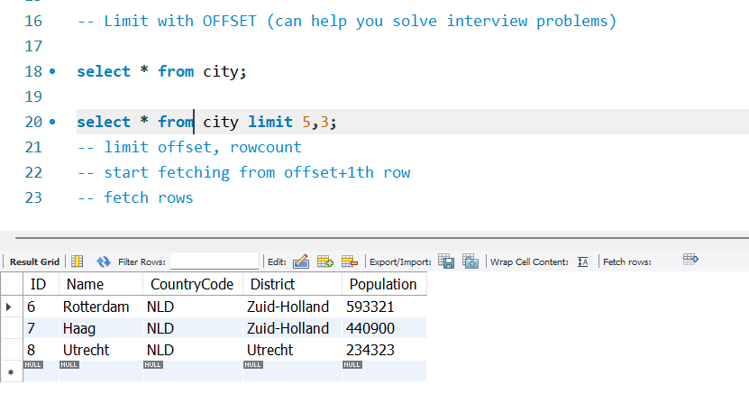

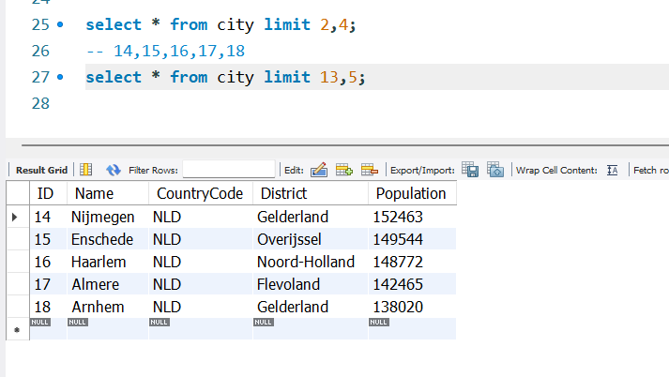

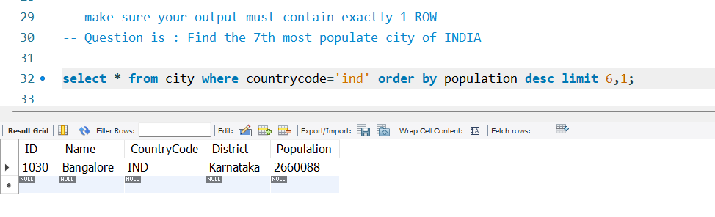

Limit function is a weak approach to this question. Window is the strongest approach

##### Aggregate functions

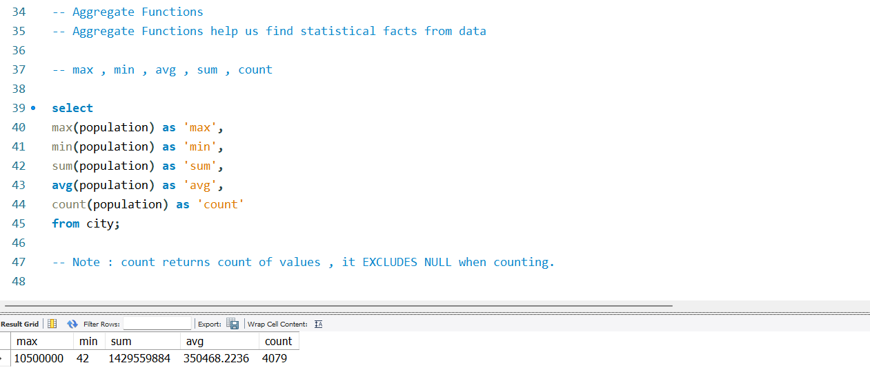



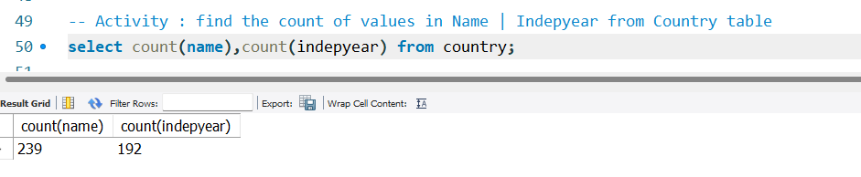

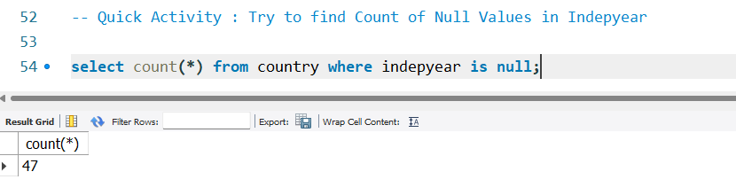

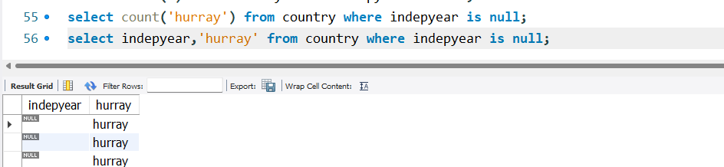

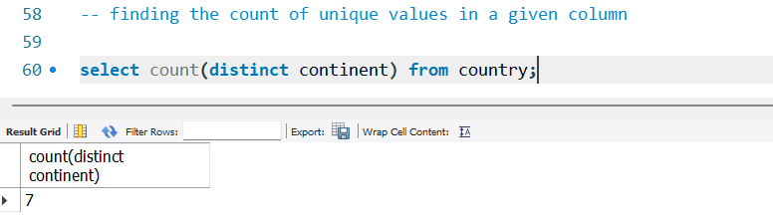

##### GROUPING

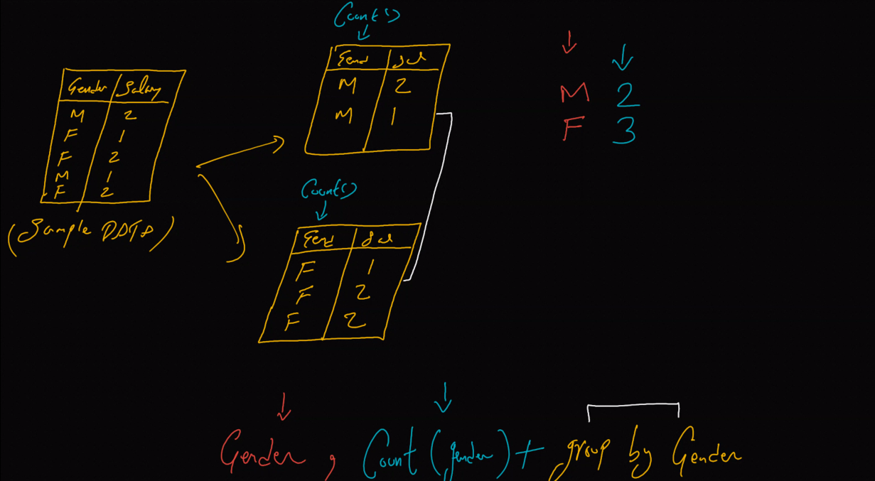

* Group splits the sample data into two table based on gender
* Grouping is useful when it is applied together with aggregate functions
* Here applying count on both separately and gets the count
* Color coded - what function gives what output
* Grouping always reduces the data
* Gender, avg(salary) + group by gender

M 1.5

F 1.6

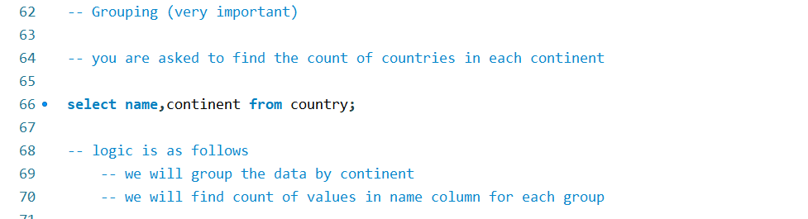

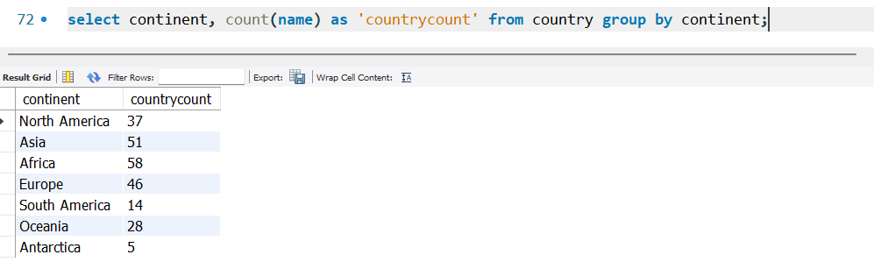

##### SQL query order of execution

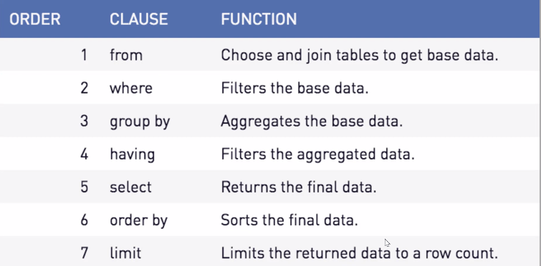

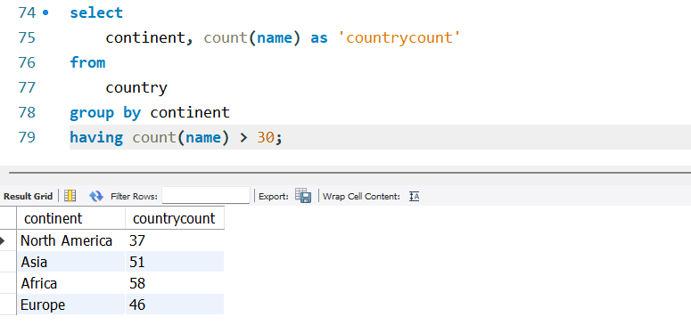

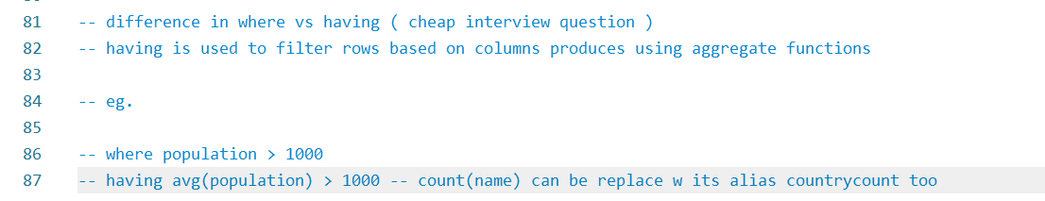

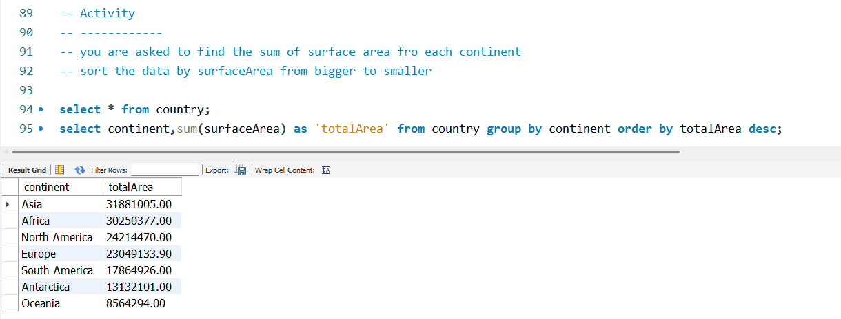

The **WHERE** clause is used to filter rows before any groupings are applied.

It is applied to individual rows in the original dataset based on specified conditions.

It is commonly used with SELECT, UPDATE, and DELETE statements to filter rows from a single table.

**Having**

The HAVING clause is used to filter rows after groupings have been applied using the GROUP BY clause.

It is applied to the result set after groupings are made and aggregate functions are applied.

It filters groups based on aggregate values (e.g., COUNT, SUM, AVG) calculated from the grouped data.

It is commonly used with GROUP BY queries to filter grouped data.

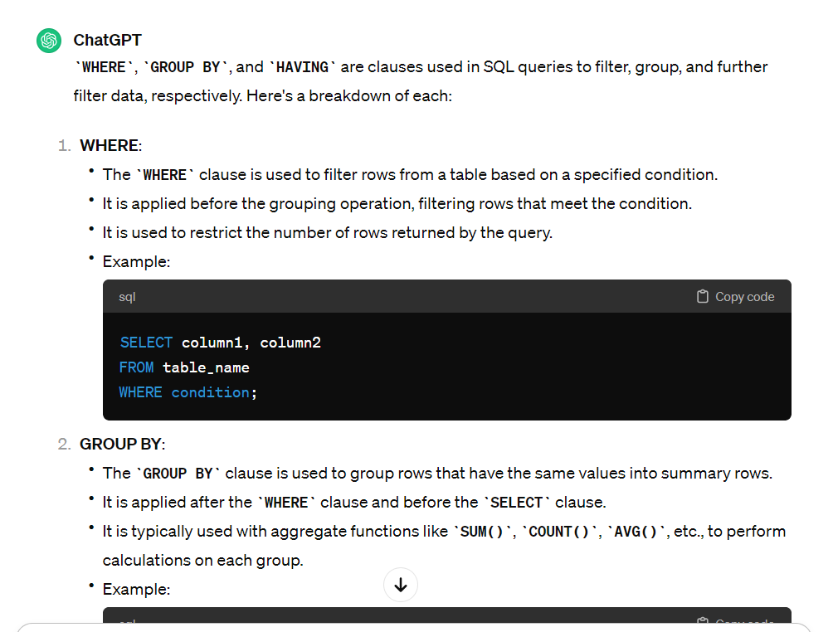

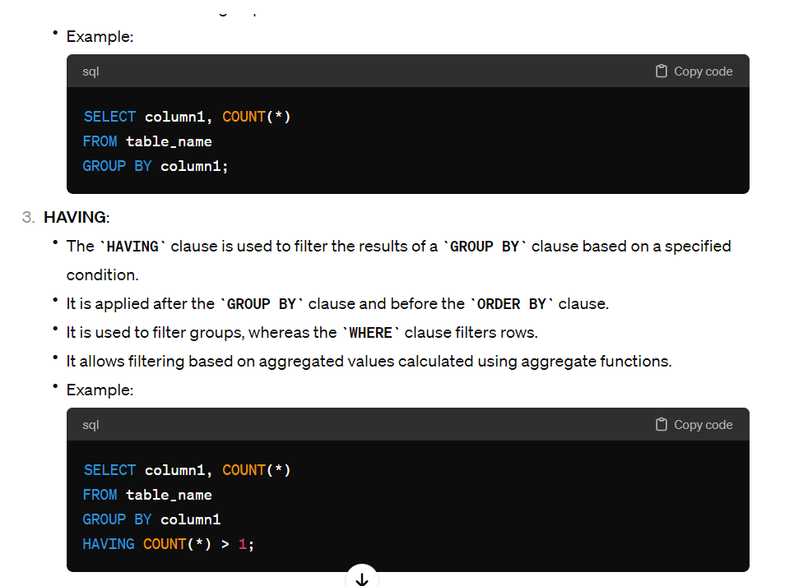

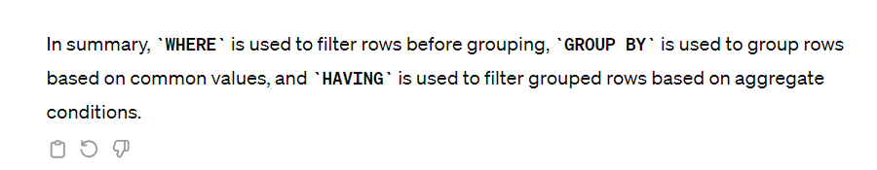

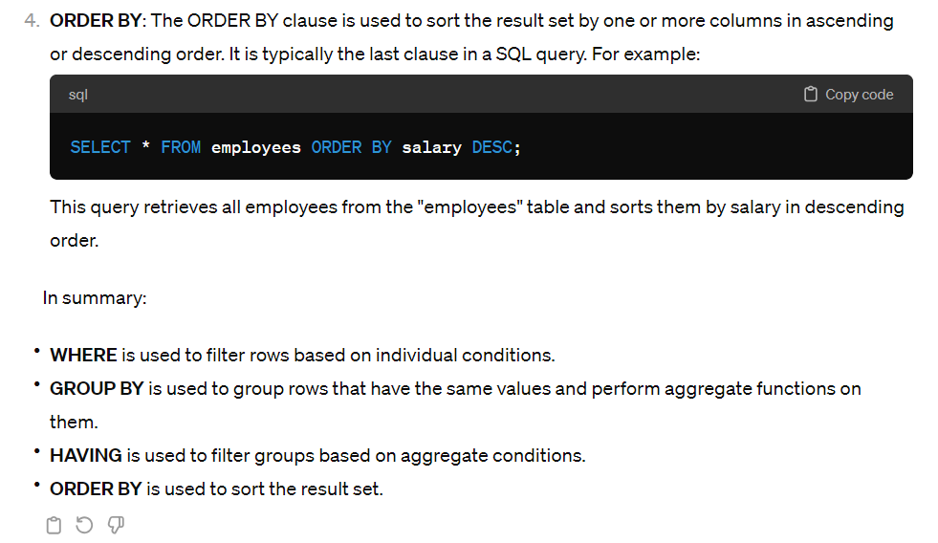

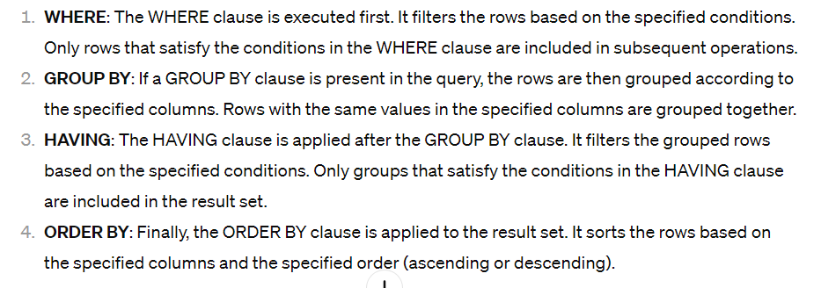

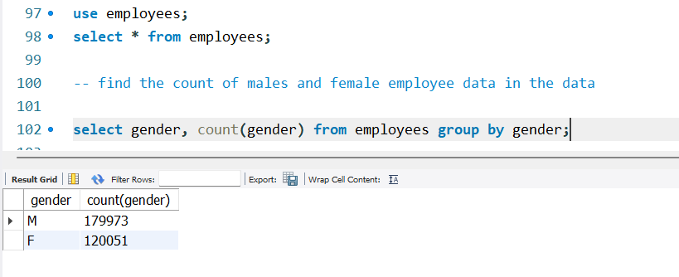

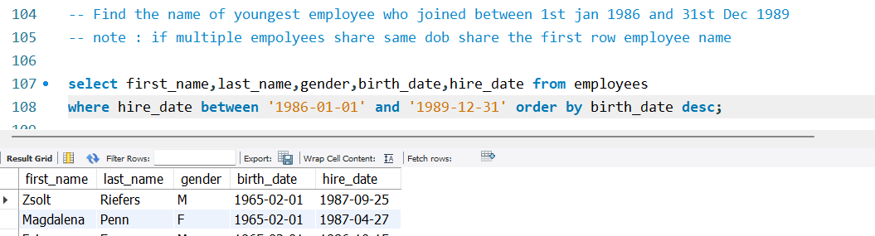

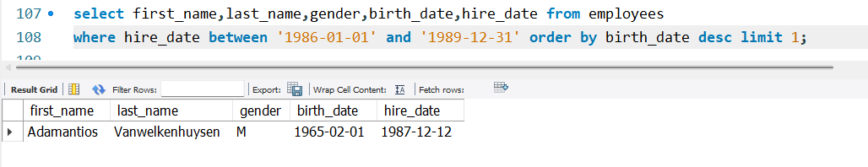

##### Subquery

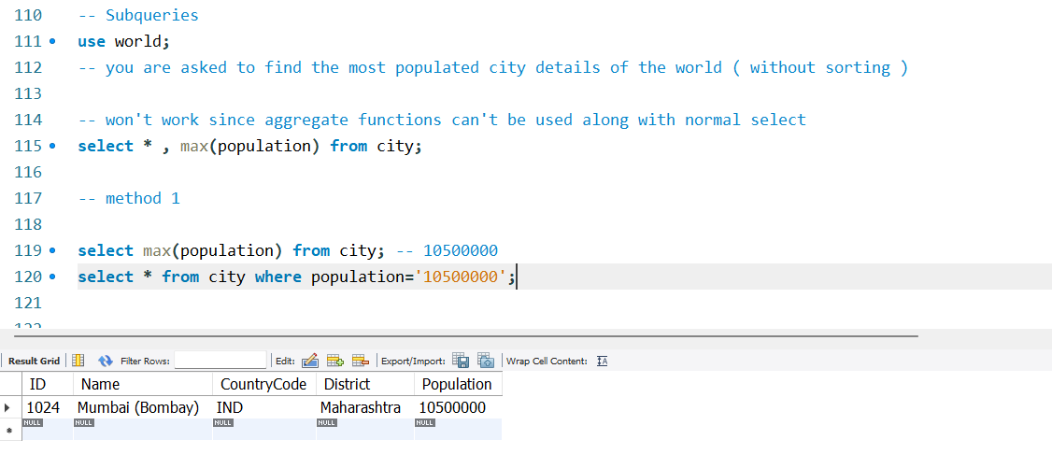

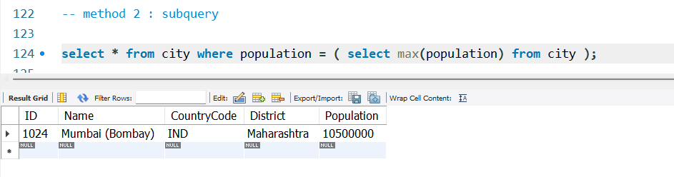

We reduced the code to one line and there is not copy pasting

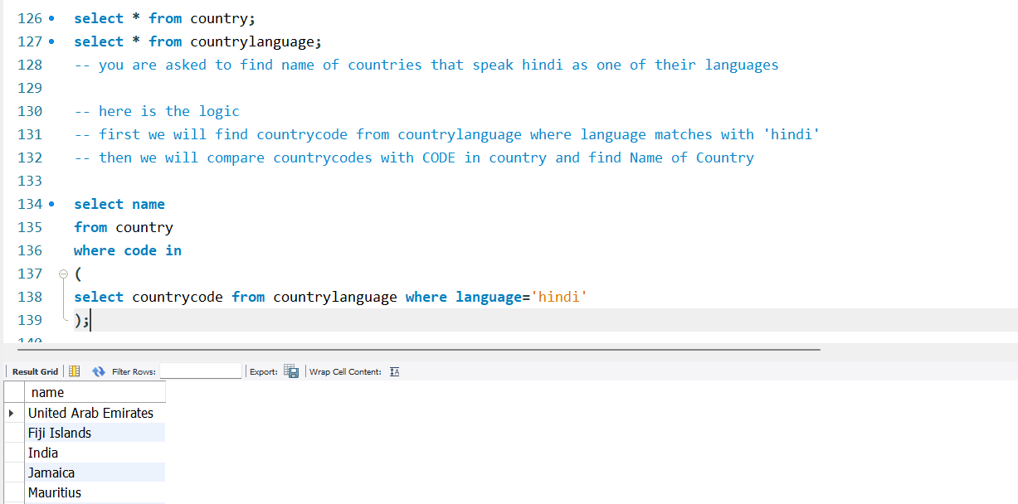



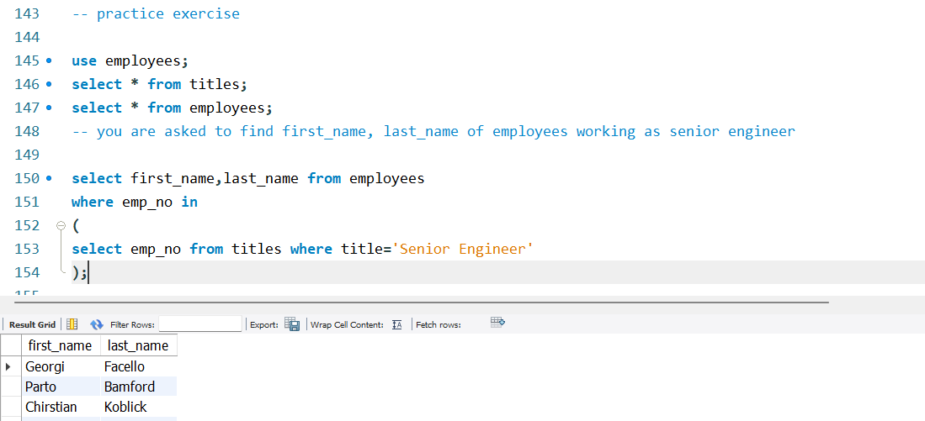

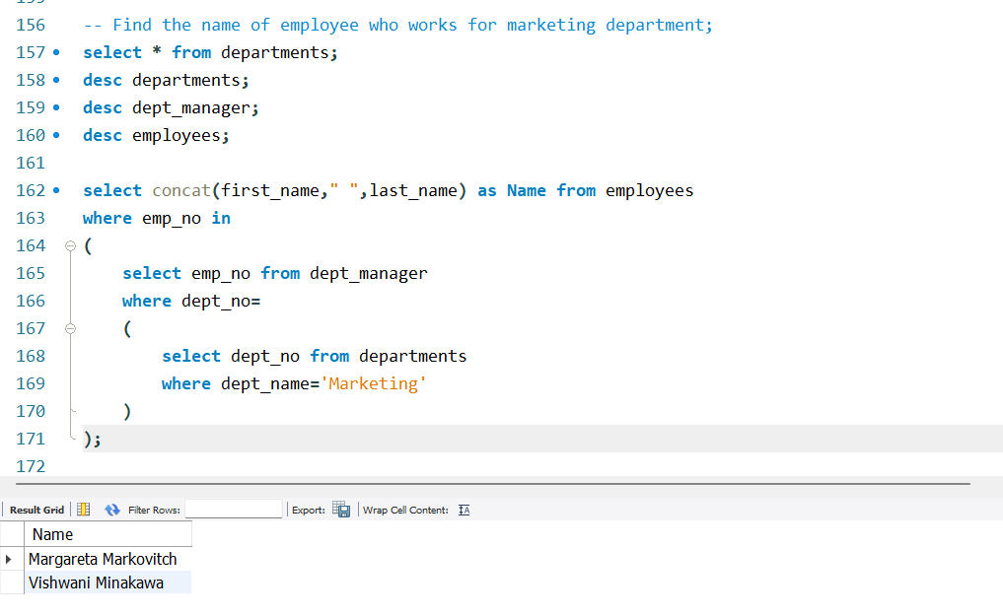

##### 

##### Correlated queries

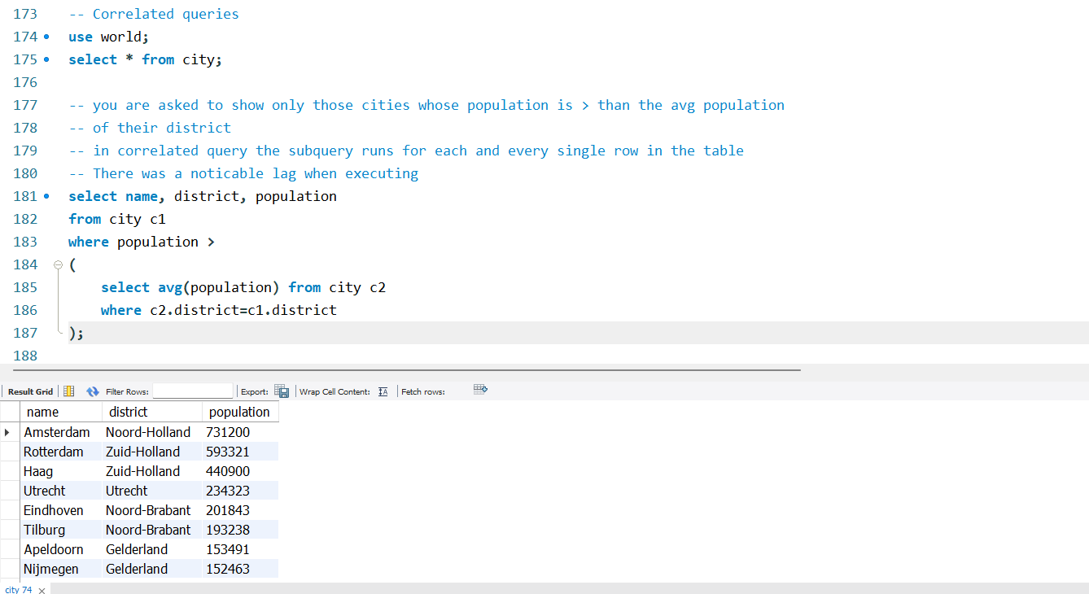

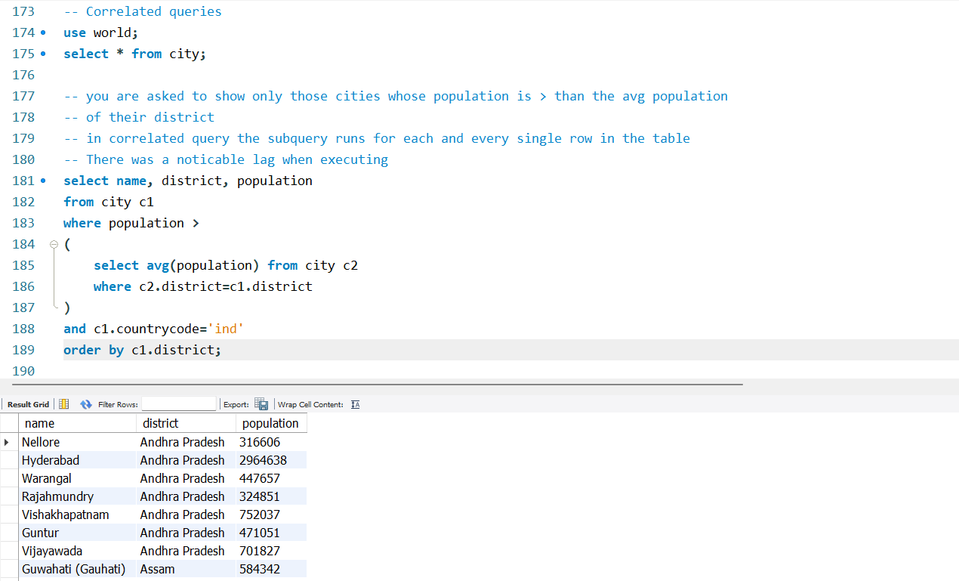

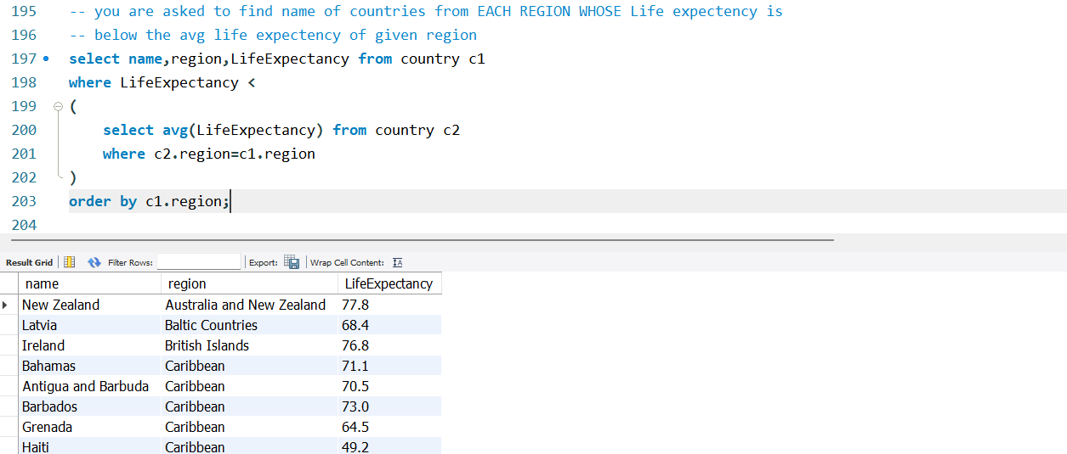

##### Joins

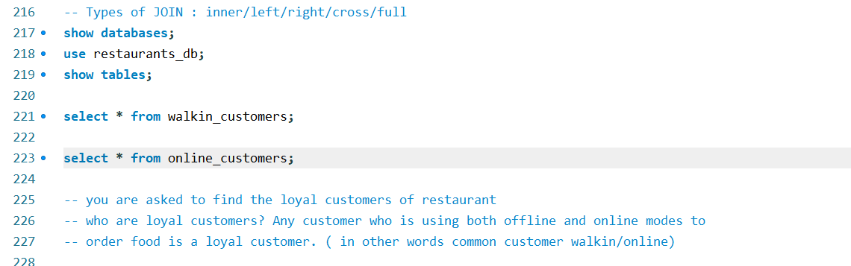

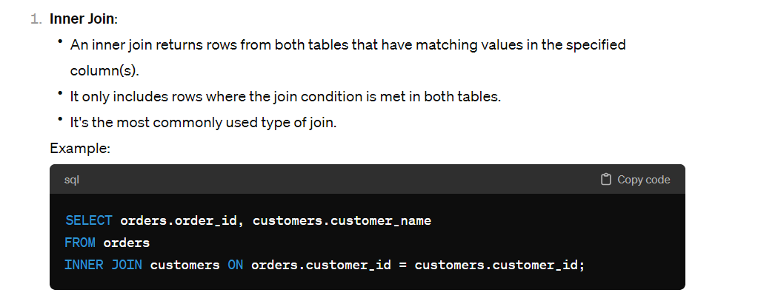

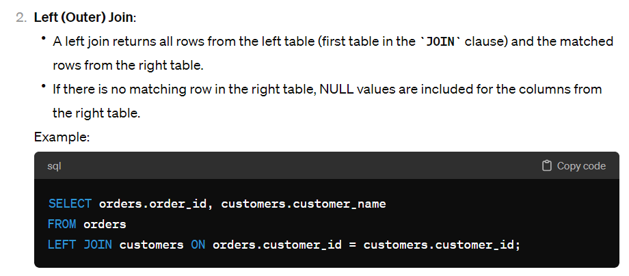

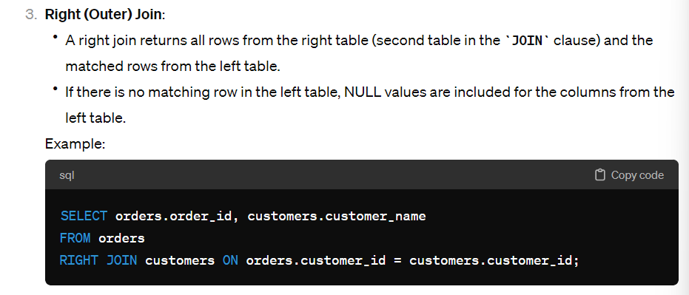

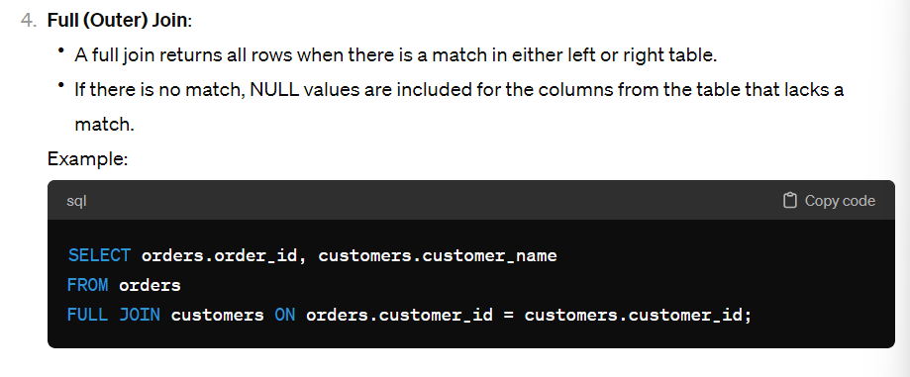

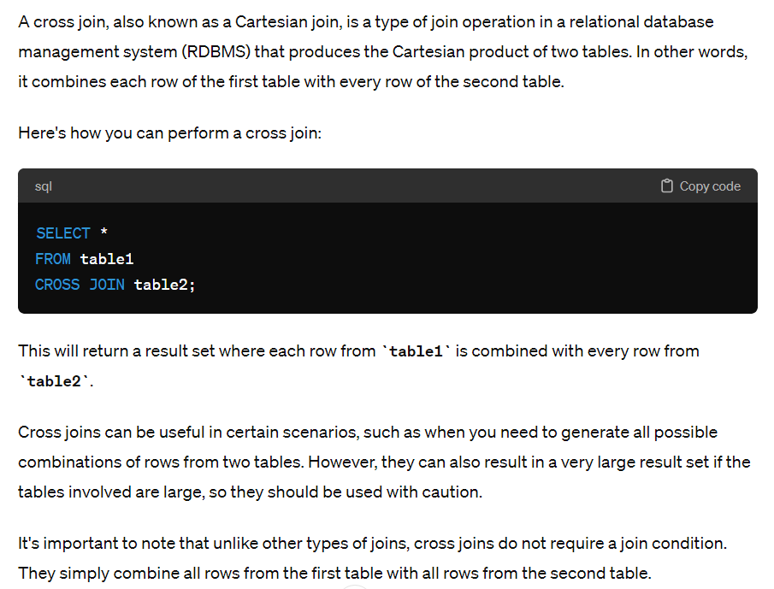

###### Inner Join

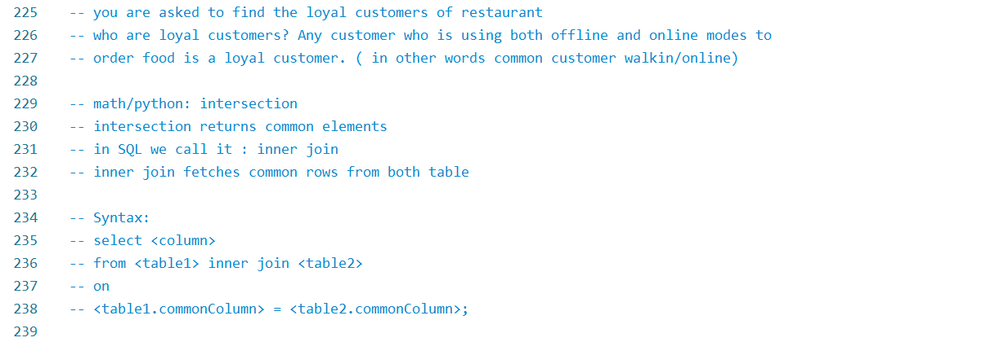

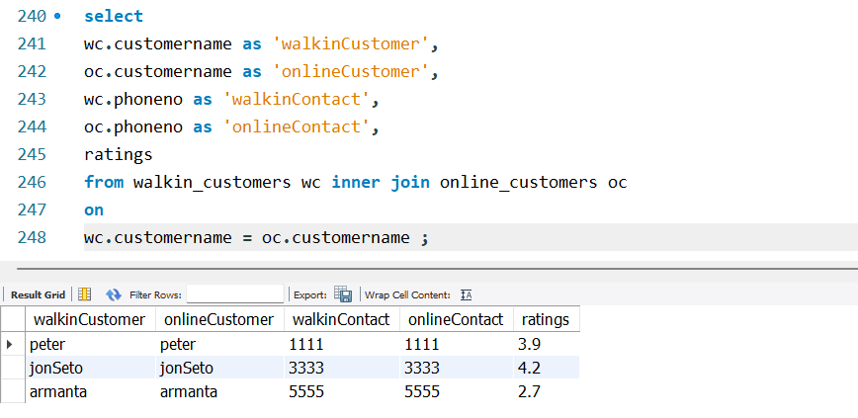

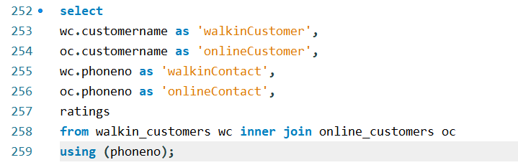

Here both customer name and phone no are common fields in both tables

###### Left Join

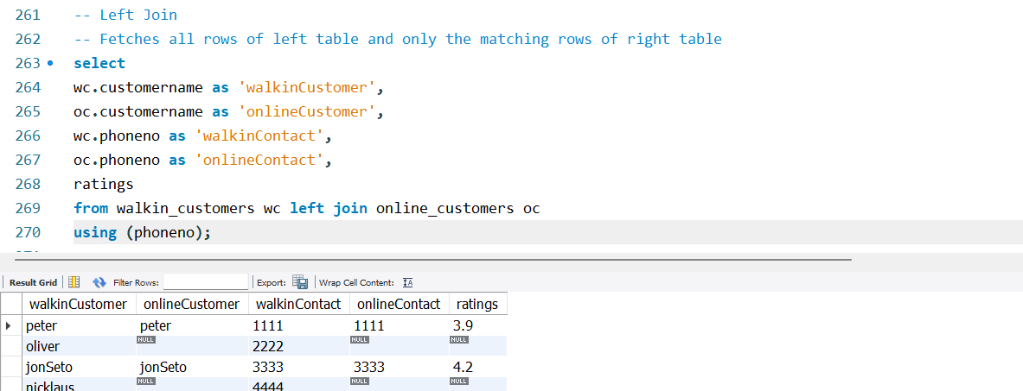

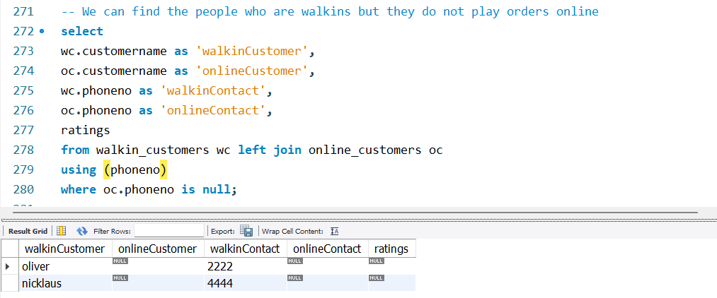

###### Right join

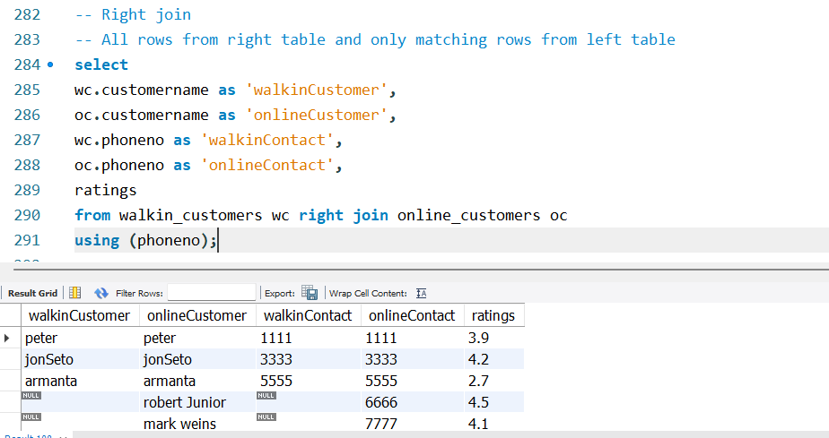

###### Full join

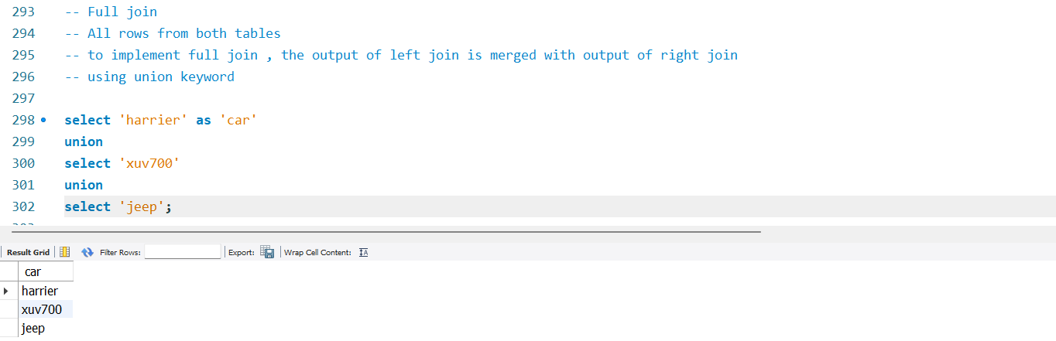

Union eliminates duplicates Union all retails duplicates

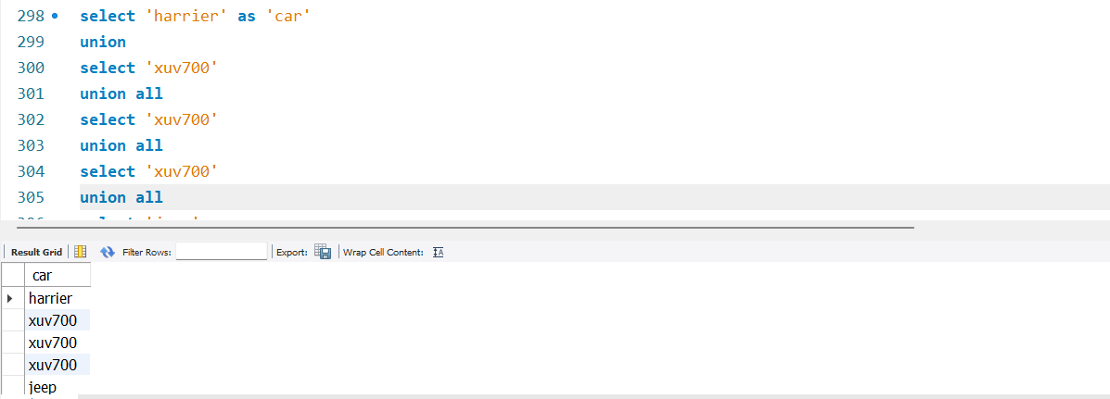

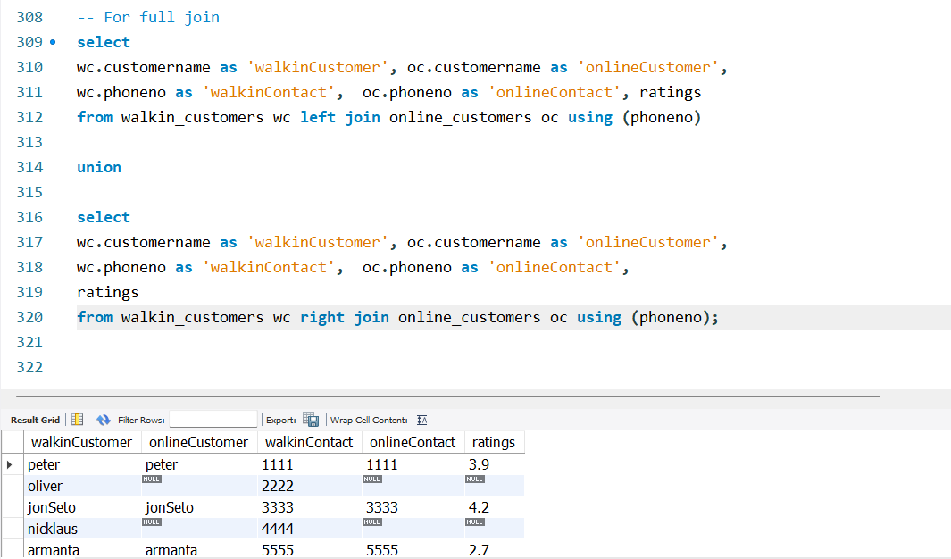

###### Cross Join

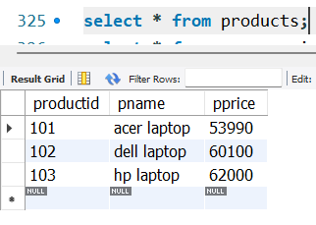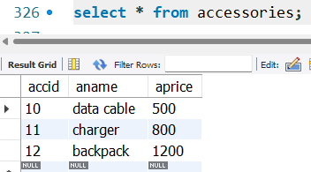

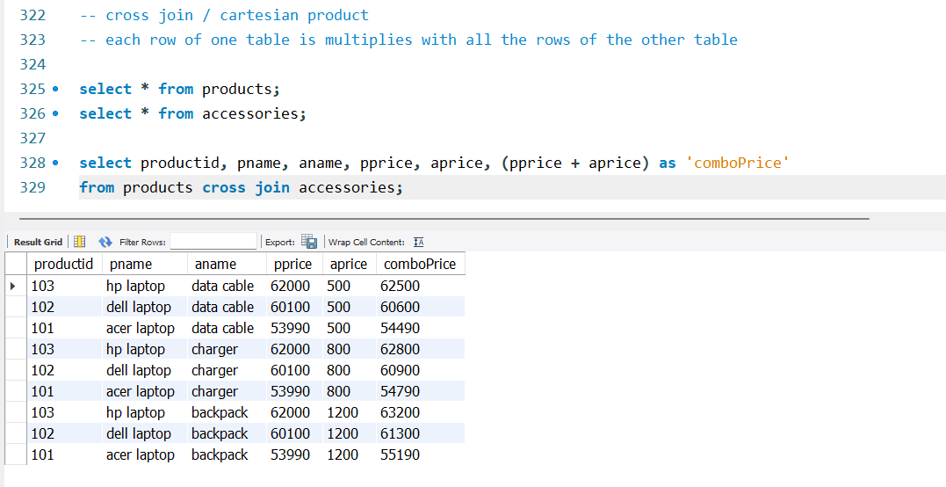

**Locks**

**Deadlocks**

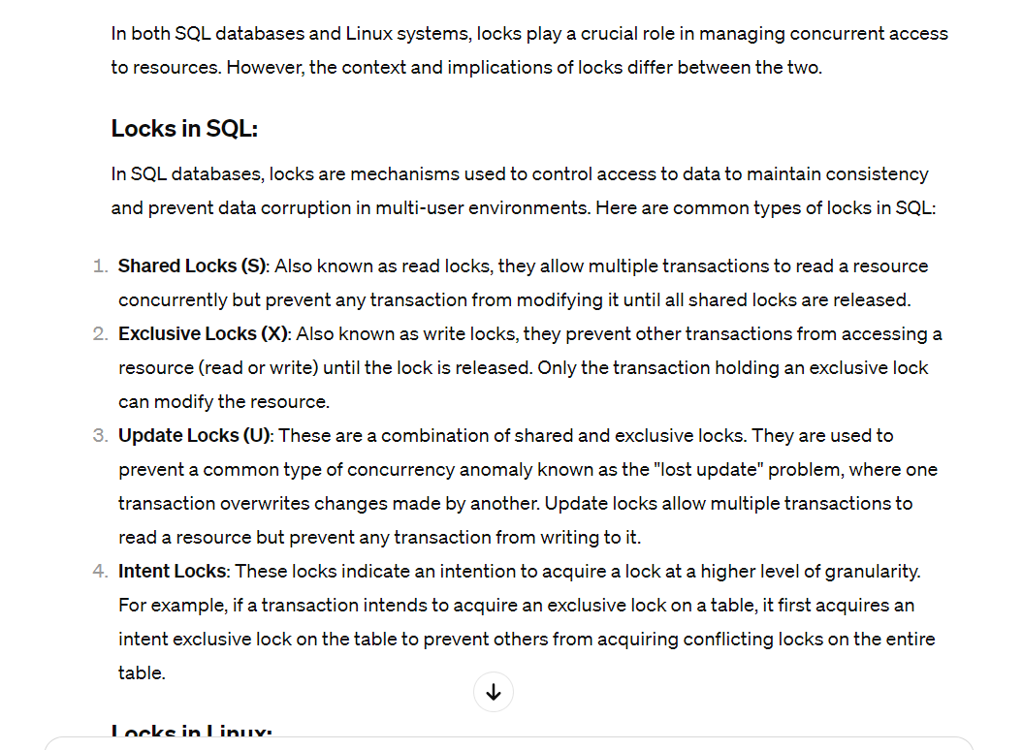

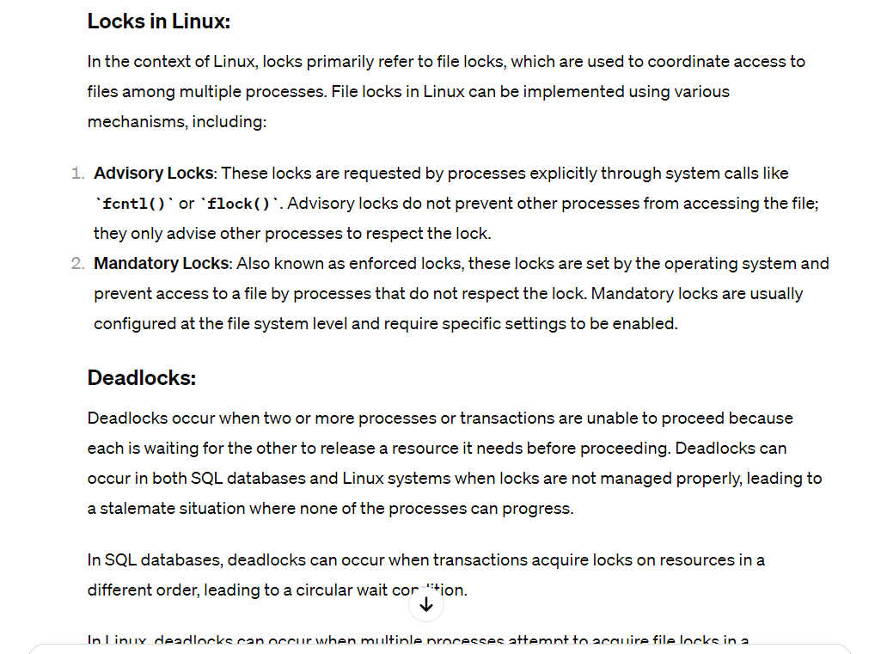

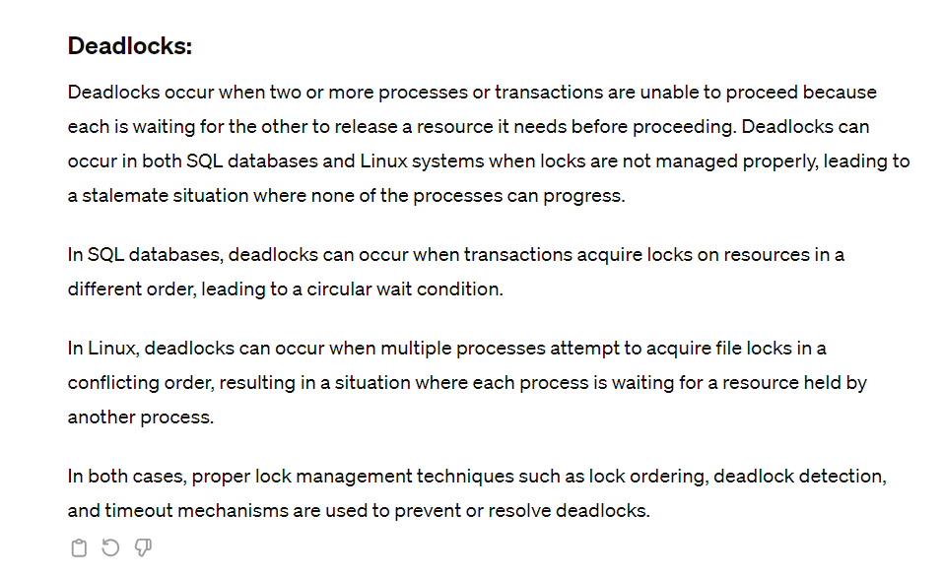

12 Feb

# Data Modeling

* Structuring the data
* Normalizing data redundancy
* Defining entities/relationships
* Performance tuning
* Definition in at conceptual, physical and logical levels
* Conversely, it comes with its own set of disadvantages too
* It’s about creating a shared understanding between the business and the data teams. Building trust, and delivering value with the data.

## [conceptual-vs-logical-vs-physical-data-models](https://www.thoughtspot.com/data-trends/data-modeling/conceptual-vs-logical-vs-physical-data-models)

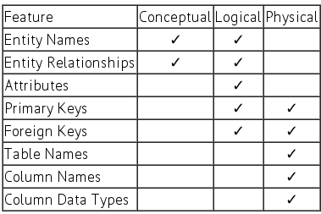

ER diagram for a say Department Store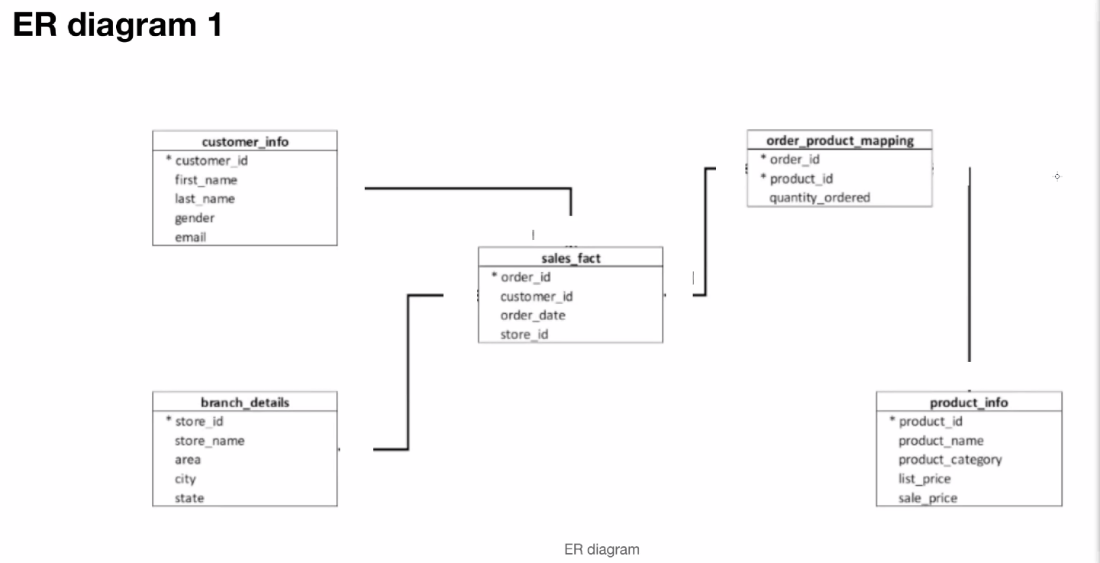

* before the name indicates primary key

1. Which table among all can be used to understand the business performance?
   1. Sales fact.
2. Which table is expected to grow vertically faster than any other table?
   1. Sales fact
3. Which table is mostly the composition of foreign keys?
   1. Sales fact

FACT TABLE:

Describes business performance

DIMENSION TABLE : What is a dimension table?

Dimension tables do not describe business performance.

Dimension table describes the entity or subject.

For eg. customer_info

INTERVIEW TOPIC : <https://acho.io/glossary/cardinality-sql> = Cardinality

**Cardinality**

In SQL, cardinality refers to the uniqueness of data in a specific column of a table. A table would be said to have less cardinality if it has more duplicated data in a column. So, more the cardinality less the data duplication (in a column) of SQL database table.

To calculate the cardinality of a column or combination of columns, you can use the COUNT(DISTINCT column_name) function.

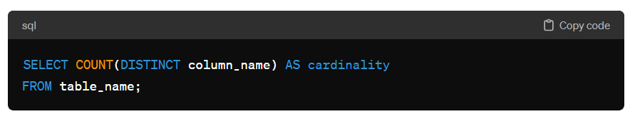

If you want to calculate the cardinality of multiple columns combined, you can include multiple columns inside the COUNT(DISTINCT ...) function separated by commas.

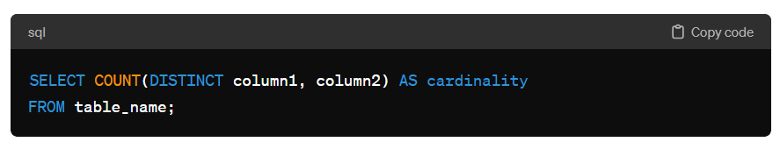

Take away: Cardinality is essential in understanding database performance and optimization, as high cardinality columns are better suited for indexing and can result in more efficient query execution plans.

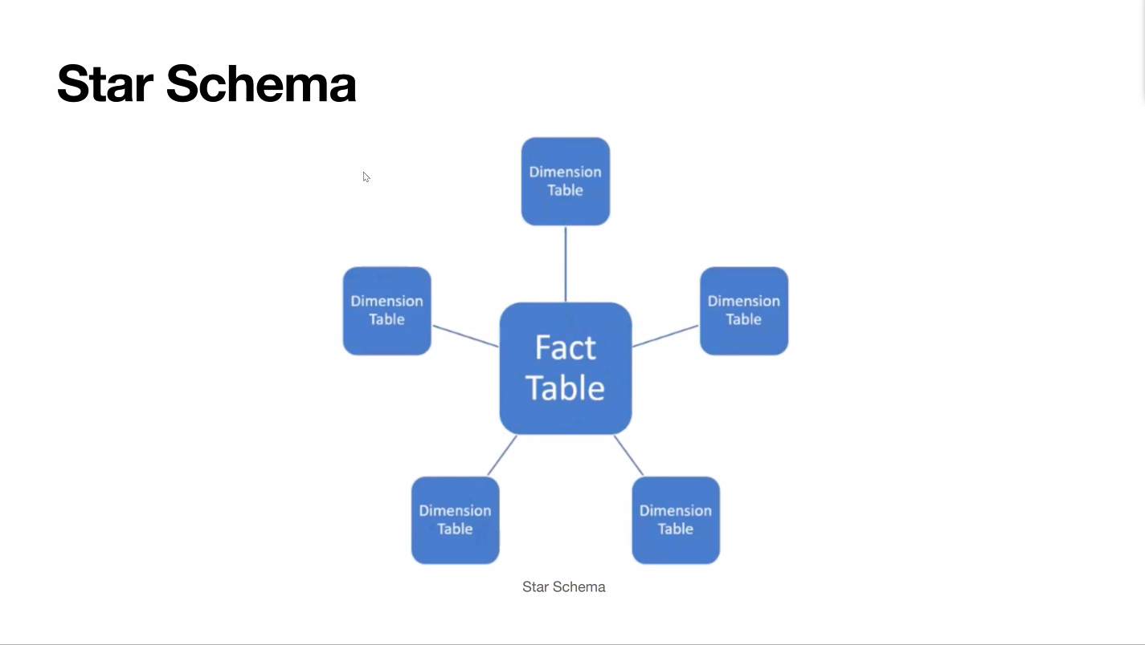

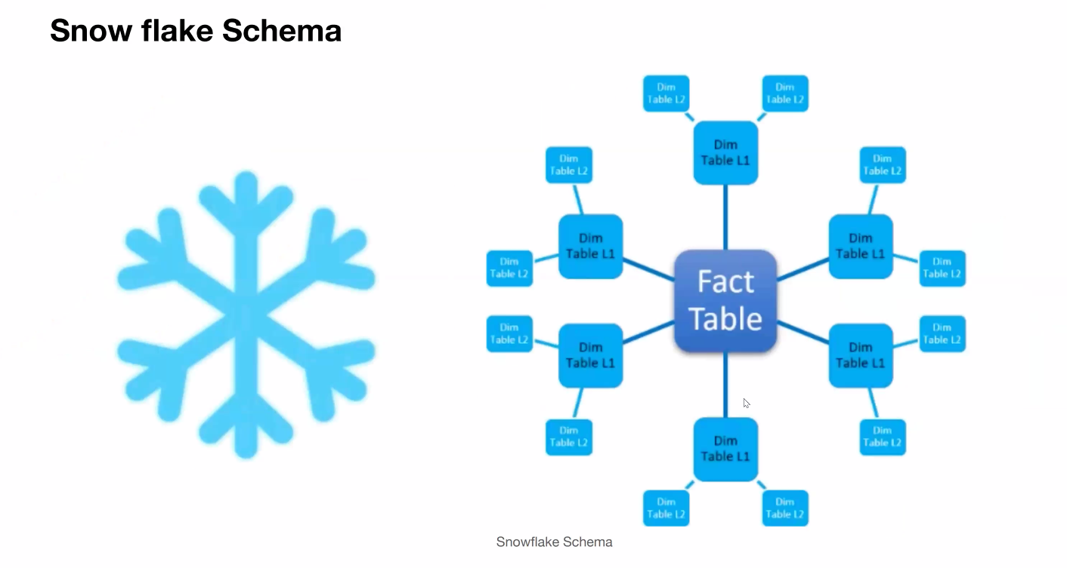

Only derived tables can be called sub tables / sub dimension. Otherwise they are just two tables with a relationship.



Identify the fact and dimension tables

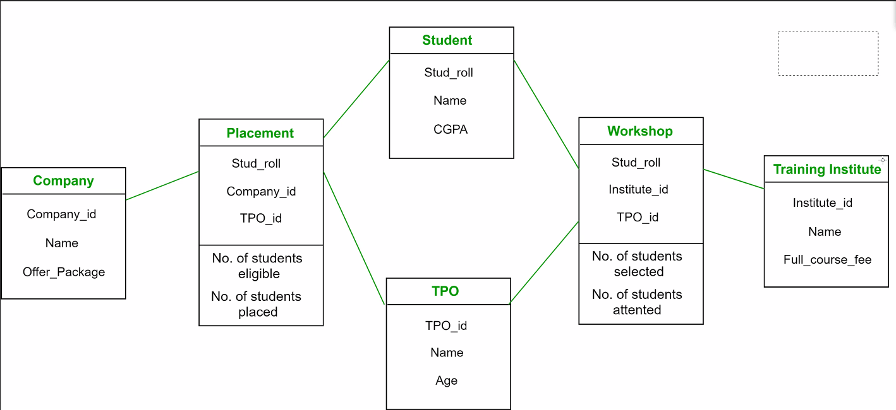

FACT: placement, workshop - no.of foreign keys

Dimension: student, TPO, training institute, company

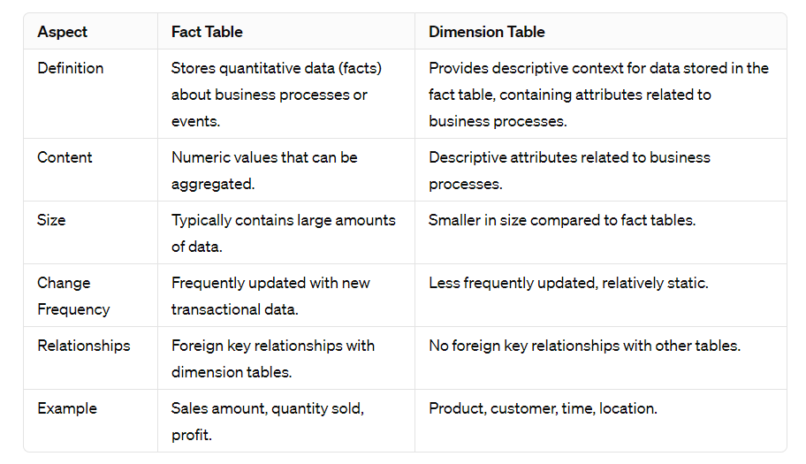

<https://www.geeksforgeeks.org/difference-between-fact-table-and-dimension-table/>

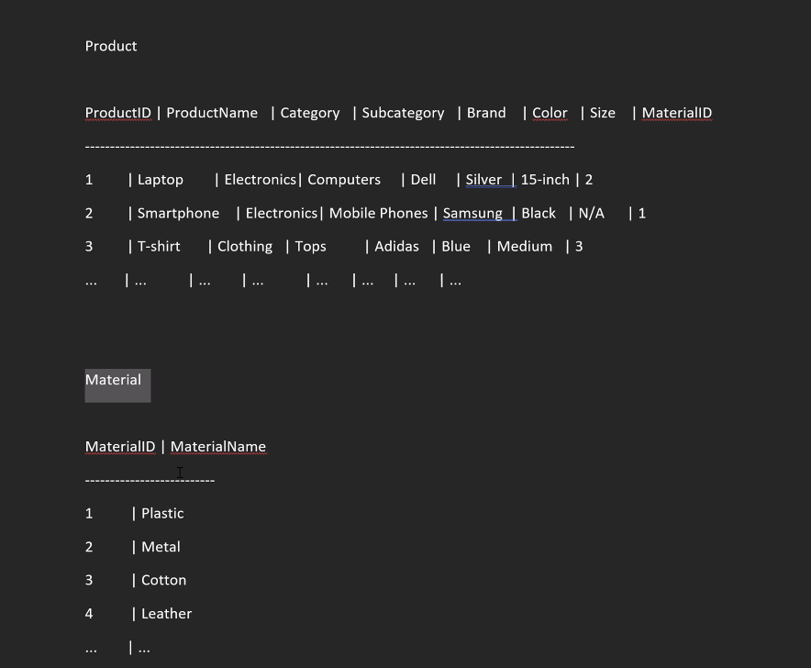

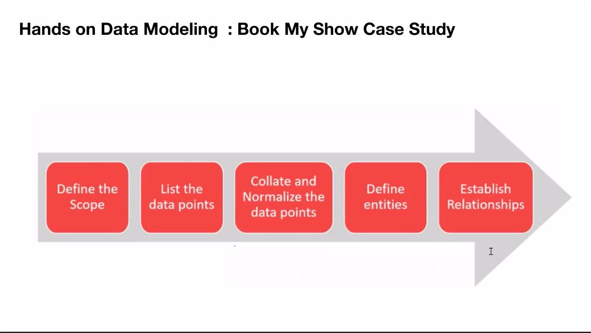

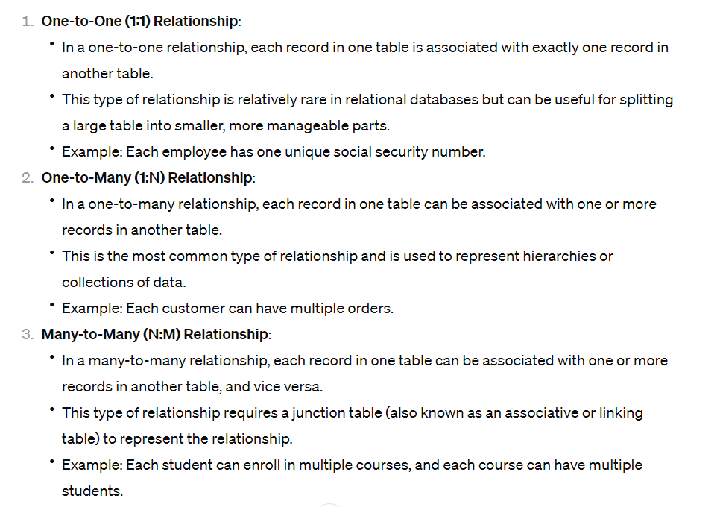



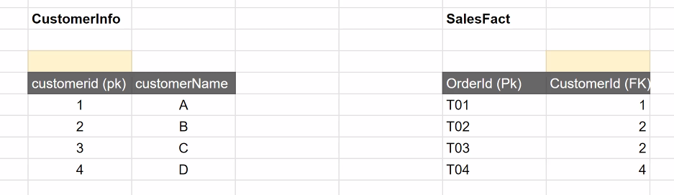

When identifying relationships we only need to look at the primary key and foreign key of salesFact or CustomerInfo.

CustomerInfo -> salesFact

For a given customerId in customerInfo table what is the minimum occurrence possible in sastFact customerId? Zero

Max occurrence -> many

salesFact -> customerInfo

For a given customerId in salesFact instance what is the minimum occurrence possible in customer info? 1

For a given customerId in salesFact instance what is the maximum occurrence possible in customer info? 1 and only 1

One to One

|  |  |
| --- | --- |
| Aadhar | Passport |
| What is the min and max occurrence possible for a given aadhaar no?  One and one | If you link aadhar in passport what is the min/max occurrence of passport?  One and one |

Basis is PK and FK : use these terms when explaining

One to one 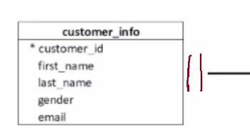

One to many 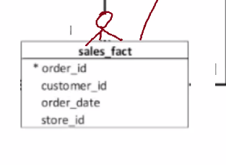

Whats the relationship bw sales and opm?

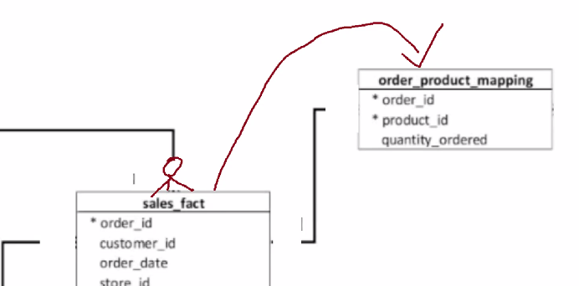

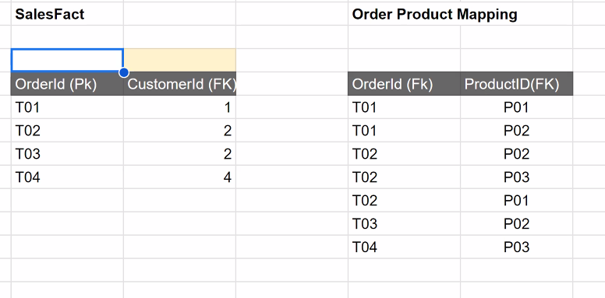

Compare the primary key and foreign key

salesFact -> opm

For a given orderId in salesFact what is the min occurrence possibility in OPM(orderID)?

One

orderId is a reference of orderId PK in sales hence cannot be 0. PK disallows nulls.

orderId and Product id together make up a composite key which is a PK with two columns. Which means it cannot be allowed to contain nulls.

Max occurrence -> many

OPM and product info

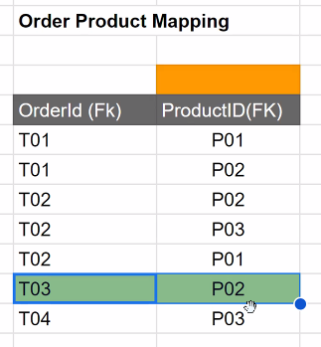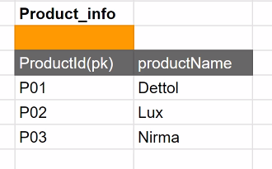

OPM -> productInfo

1. What is the min occurrence possible of productID from OPM to productId in productInfo? 1
2. What is the max occurrence possible of productID from OPM to productId in productInfo? 1

One and only one

productInfo -> OPM

1. What is the min occurrence possible of productID from productInfo to productId in OPM? 1 bcoz PK can’t be null
2. What is the max occurrence possible of productID from productInfo to productId in OPM? Many

One to many

Write the relationships of each table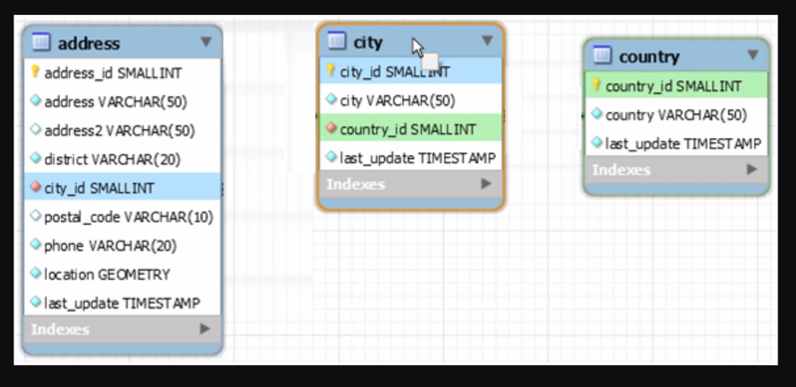

City -> address : one and only one

Address -> city : one to many / can be zero to many bcoz it is possible that a city might not have any addressed associated with it

City -> country : one to many / can be zero to many bcoz it is possible that a country might not have any cities associated with it

Country -> city : one and only one

<https://blog.sqlauthority.com/2011/08/08/sql-server-tips-from-the-sql-joes-2-pros-development-series-many-to-many-relationships-day-8-of-35/>

14 Feb

Window Functions

Ranking Functions

row_number()

rank()

dense_rank()

Common Table Expressions

Lead()

LAG()

Misc Exercises

Window functions provide powerful capabilities for performing complex analytical tasks within SQL queries, such as ranking, aggregating, and comparing values across rows, without the need for subqueries or self-joins.

#### SQL rankingdb and table

Create database rankingdb;

Use rankingdb;

create table employee(emp_id int(5),Name varchar(20),Phone varchar(20),Address varchar(20),salary int(10),projects_comp int (5));

insert into `employee`(`emp_id`,`Name`,`phone`,`Address`,`salary`,`projects_comp`) values

(103,'Atelie',8059912345,'New York',137000,21),

(100,'Harris',9546248620,'California',200000,25),

(1002,'Murphy',8568612304,'Washington',120000,14),

(102,'Maria',8568705304,'Washington',125000,24),

(105,'Max',8708612304,'Chicago',132000,25),

(107,'Martin',7456612304,' Los Angeles',130000,15),

(106,'Thomas',7456632504,'Austin',135000,17),

(108,'Jessica',7866632504,'Boston',140000,16),

(109,'James',8479632504,'Chicago',115000,14),

(110,'John',9516632504,'New York',137000,15),

(111,'Jackie',7421032504,'Boston',138000,27),

(101,'Janet',7050032504,'Houston',139000,19);

##### Row number

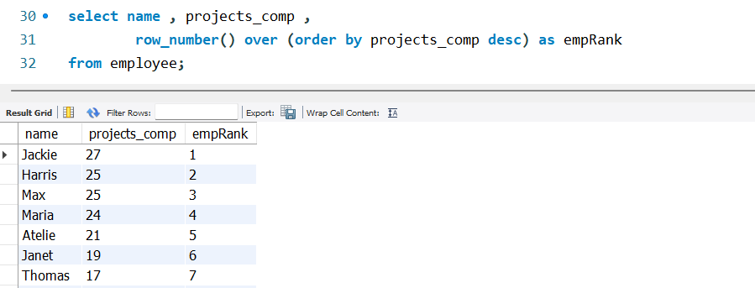

Data Science is full of tables where there are no unique row identifiers. Row_number is used to generate a primary key like column.

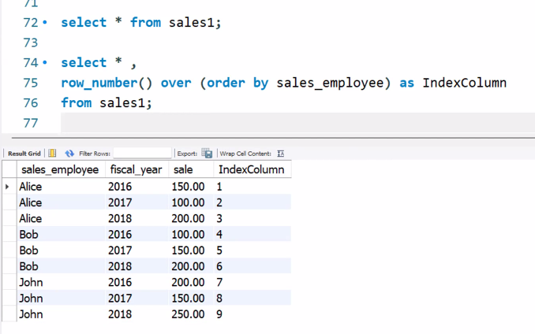

#### SQL sales1 table

CREATE TABLE IF NOT EXISTS sales1(

sales_employee VARCHAR(50) NOT NULL,

fiscal_year INT NOT NULL,

sale DECIMAL(14,2) NOT NULL,

PRIMARY KEY(sales_employee,fiscal_year)

);

INSERT INTO sales1(sales_employee,fiscal_year,sale)

VALUES('Bob',2016,100),

('Bob',2017,150),

('Bob',2018,200),

('Alice',2016,150),

('Alice',2017,100),

('Alice',2018,200),

('John',2016,200),

('John',2017,150),

('John',2018,250);

##### Rank()

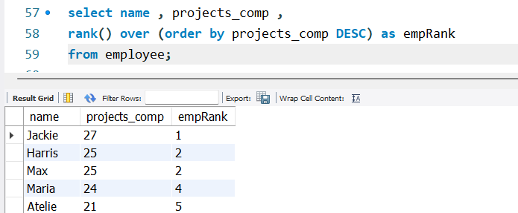

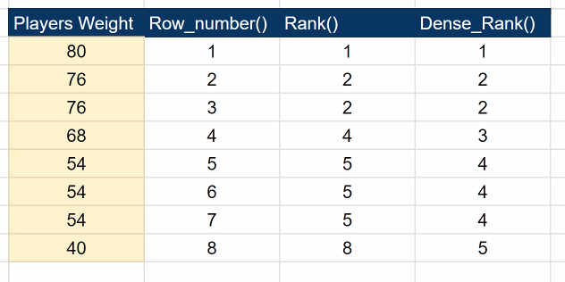

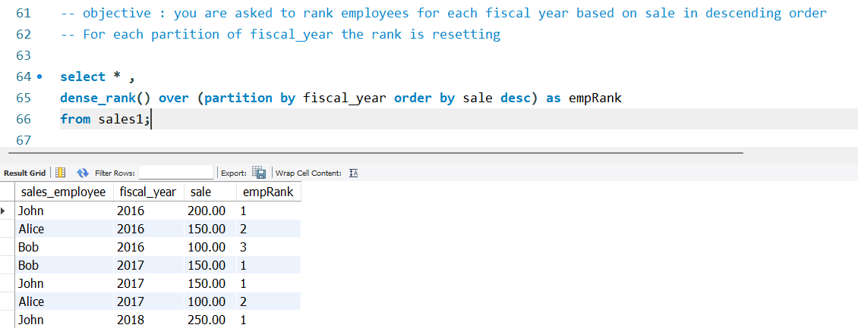

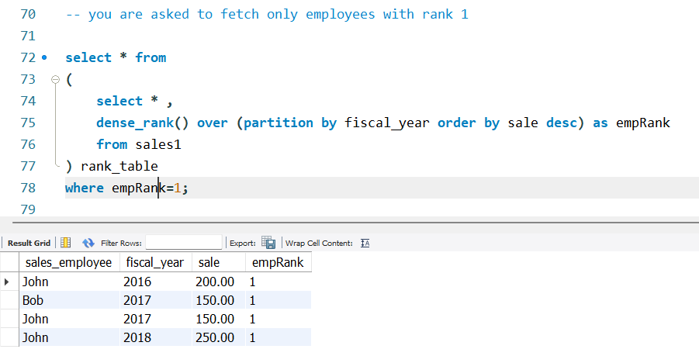

##### Common Table Expression

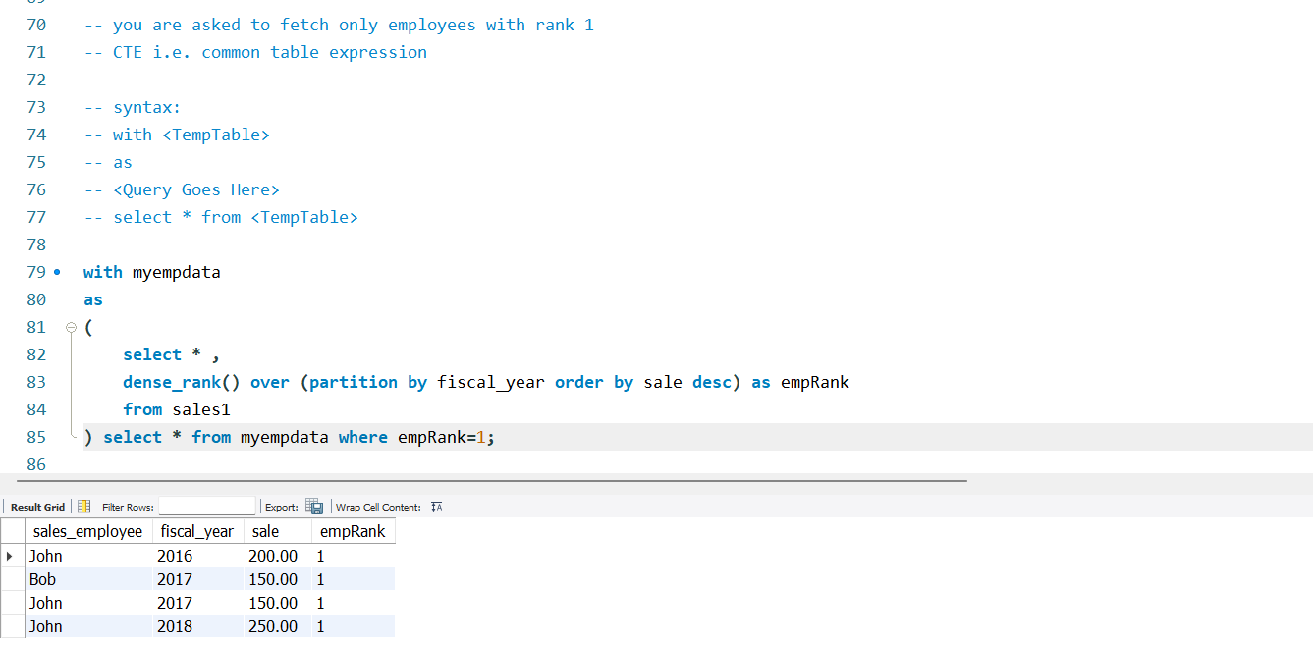

* CTE help to split tasks and solve each task separately
* Here myempdata is a temporary table
* First the query in ( ) is executed and that output is stored in the temporary table
* And then we can query that same table after that
* We can filter the data using columns that are dynamically produced

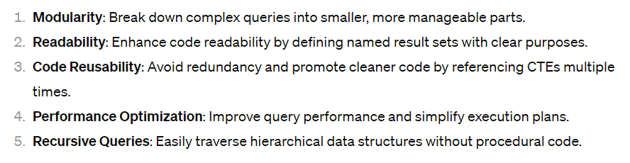

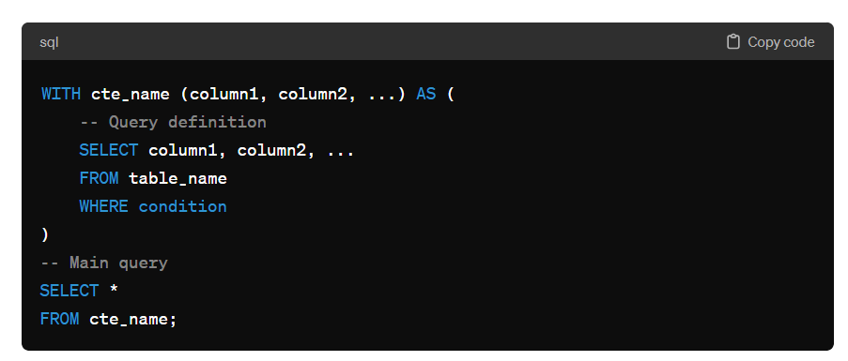

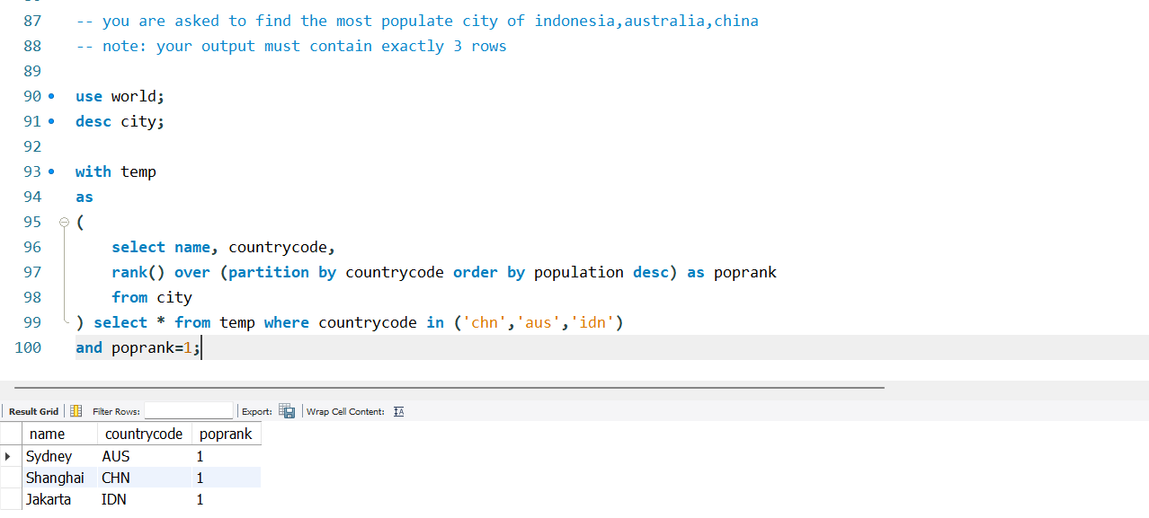

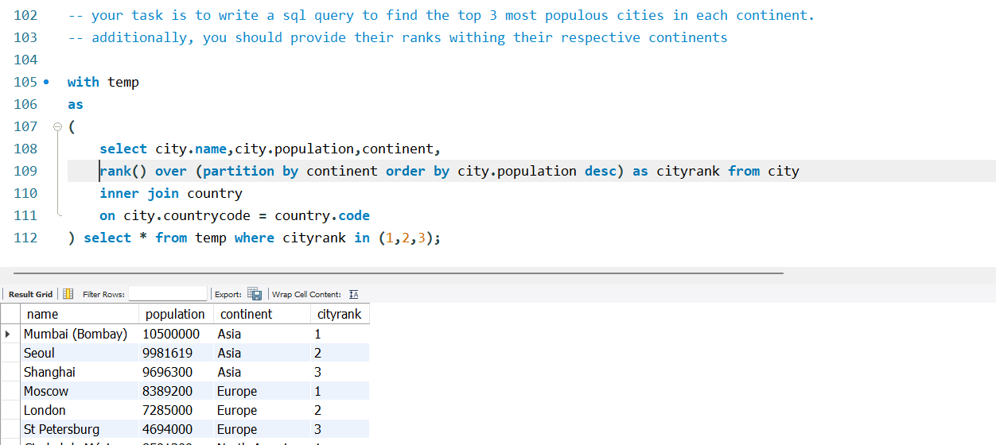

##### Lead

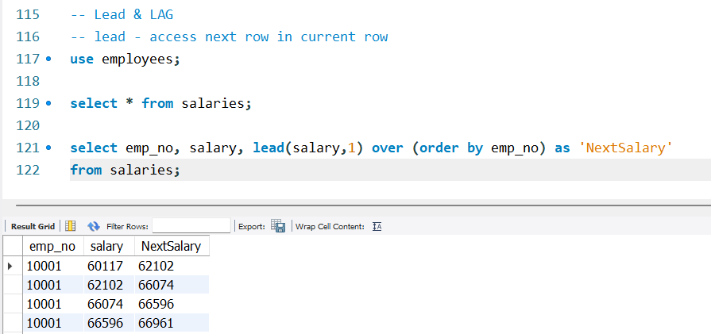

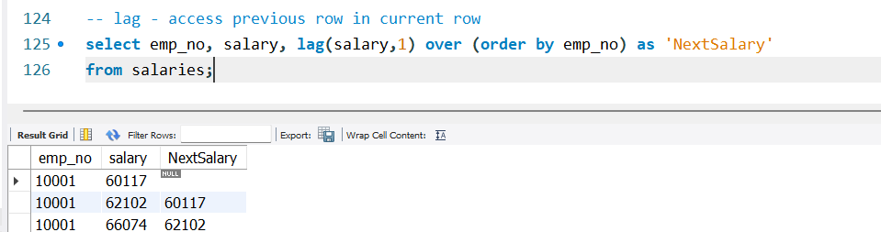

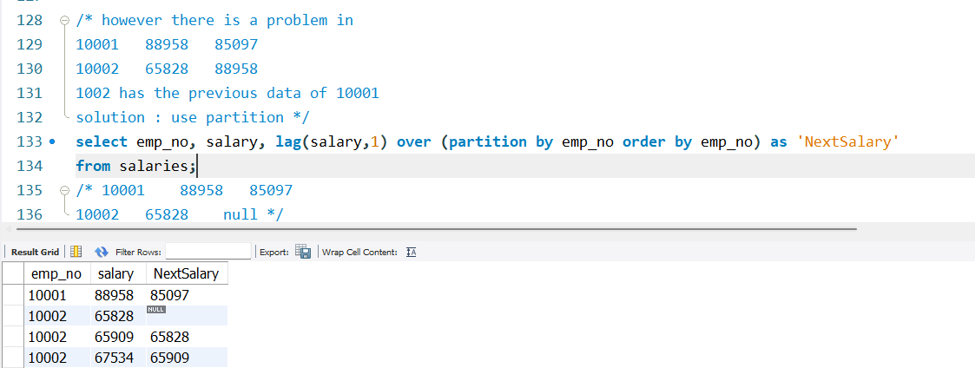

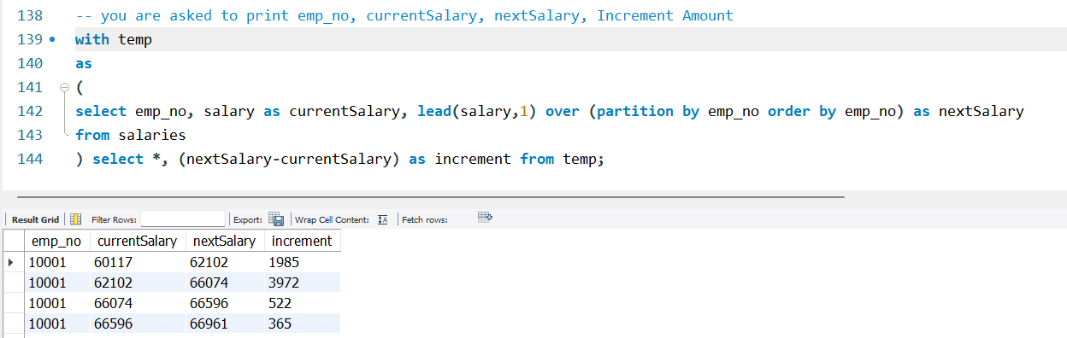

#### SQL sales table

CREATE TABLE sales (

sale_id INT AUTO_INCREMENT PRIMARY KEY,

product_id INT,

sale_date DATE,

sale_amount DECIMAL(10, 2)

);

INSERT INTO sales (product_id, sale_date, sale_amount) VALUES

(1, '2024-02-01', 100.00),

(1, '2024-02-03', 120.00),

(1, '2024-02-05', 150.00),

(2, '2024-02-02', 75.00),

(2, '2024-02-04', 90.00),

(2, '2024-02-06', 110.00);

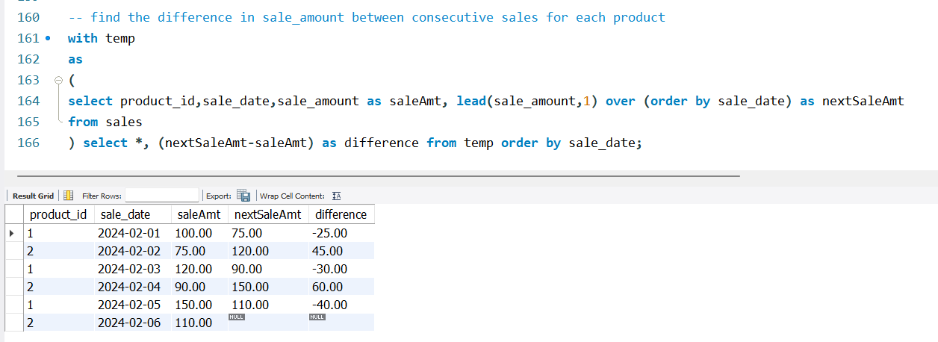

15 Feb

##### Views

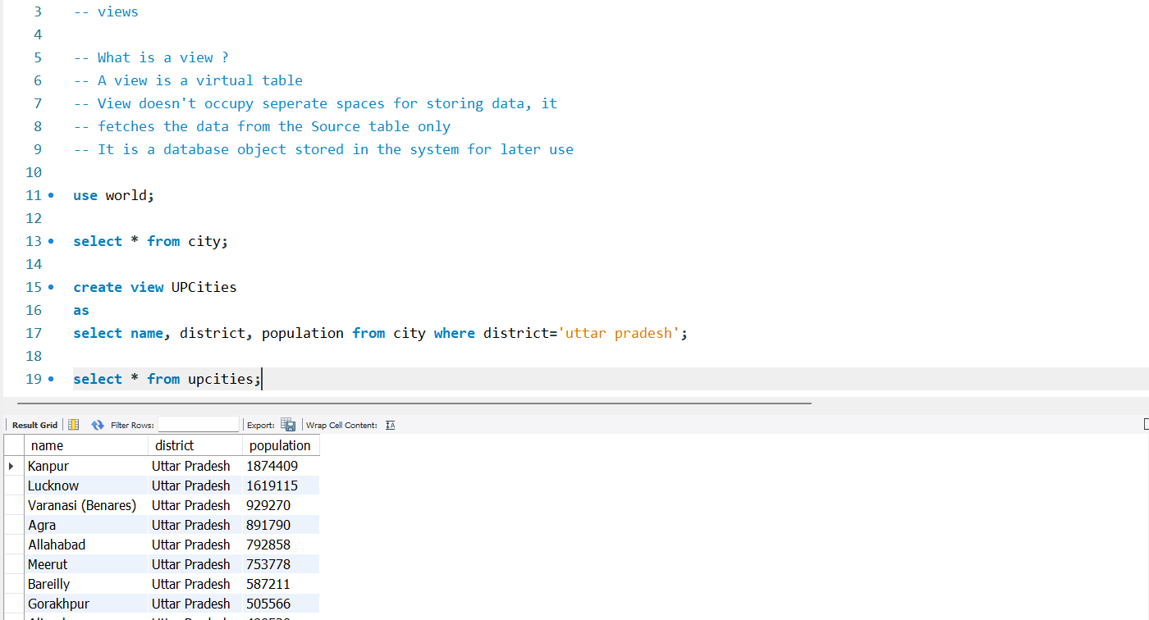

1. In a database management system (DBMS), a view is a virtual table that is derived from one or more base tables (or other views) through a predefined query.

It represents a subset of data or a specific perspective on the underlying tables, 2. and it does not store any data itself or doesn’t occupy extra space.

3. It is a database object stored in the system for later use.

Views are 4. primarily used to simplify complex queries, provide a layer of security by restricting access to sensitive data, 5. and present data in a more meaningful and understandable way to users.

They offer a way to encapsulate complex SQL logic, 6. reduce redundancy, and enhance data integrity and consistency within a database system.

7. sales summary to analysts without providing direct access to raw data.

To disable safe mode go to edit > preferences and uncheck the last box safe updates

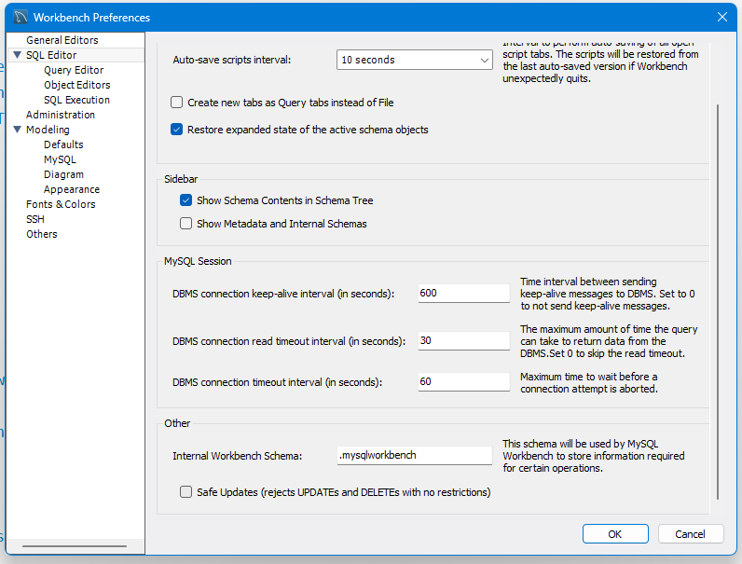

Or run this query: SET SQL_SAFE_UPDATES = 0;

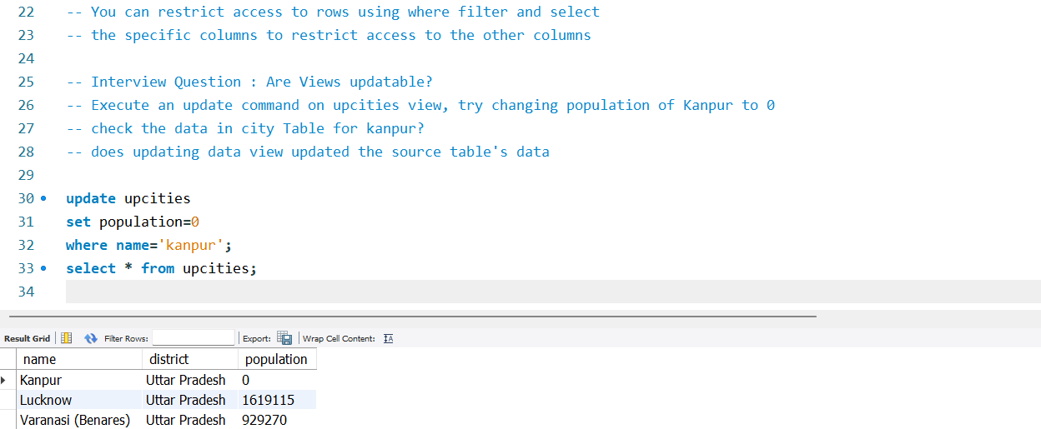

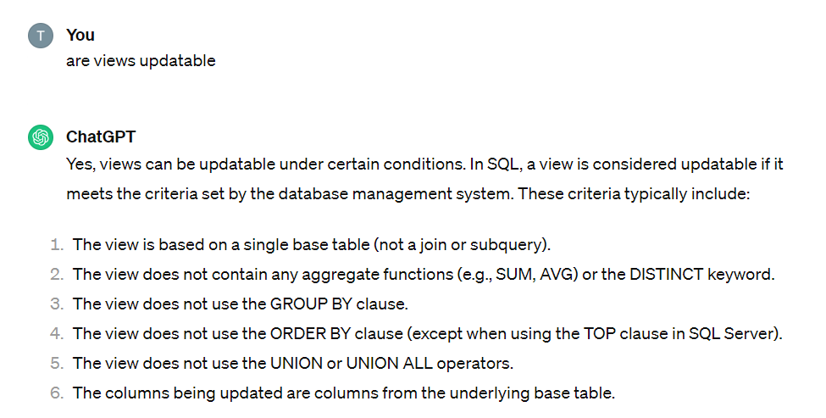

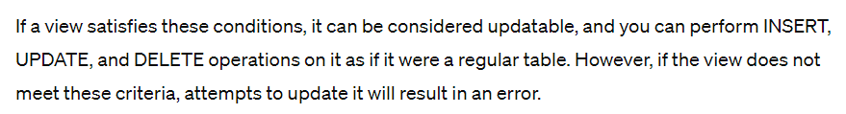

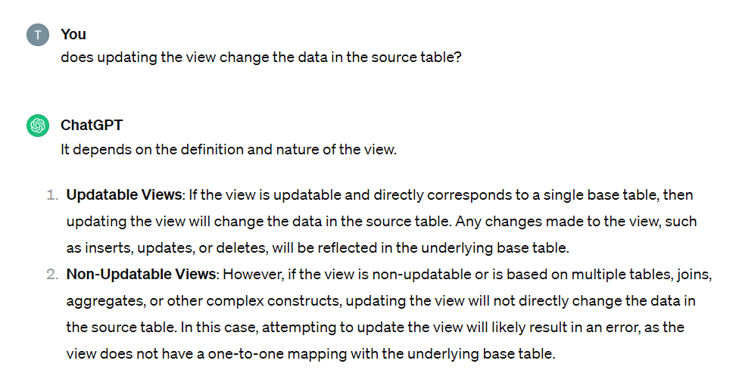

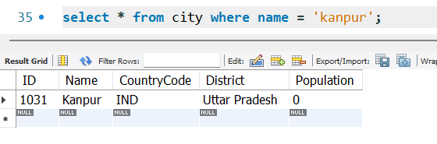

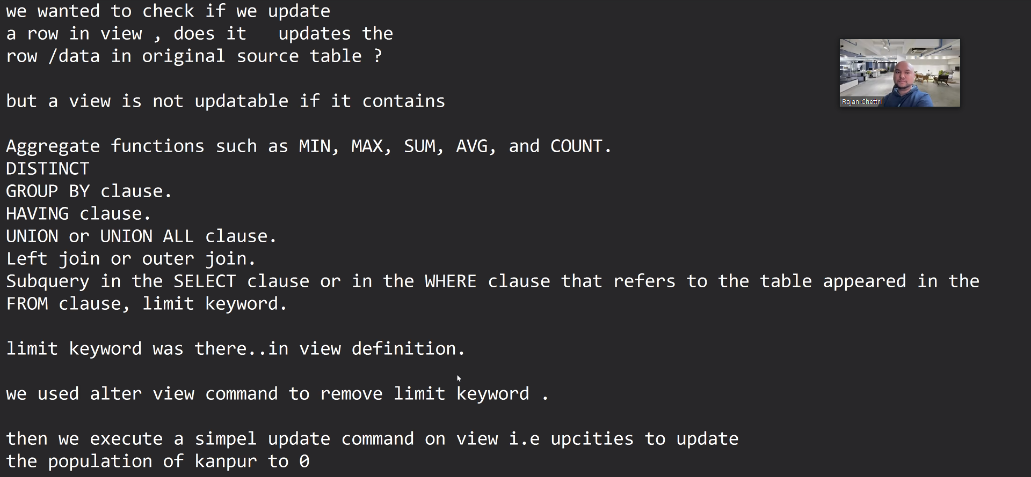

Then we checked if the data of kanpur is also updated in source table

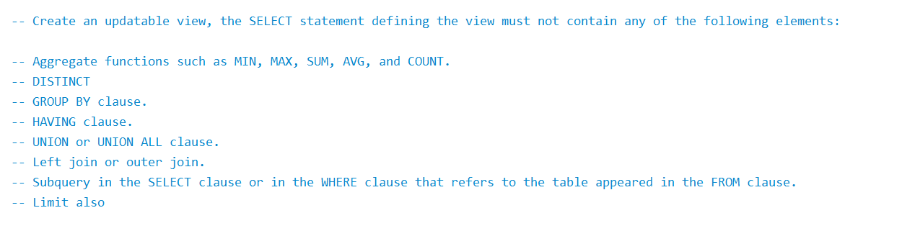

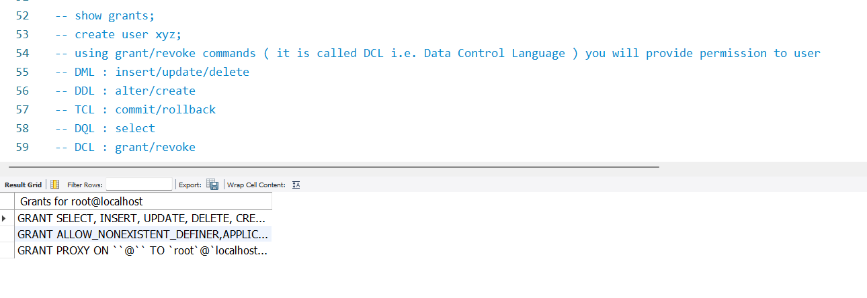

##### Procedures

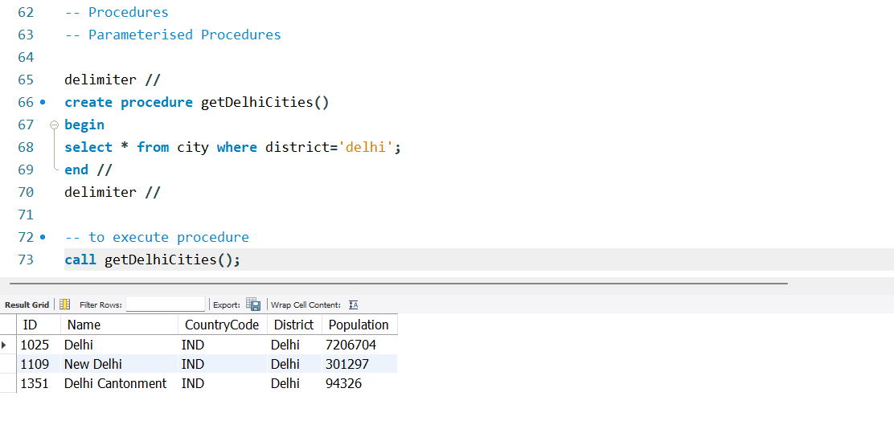

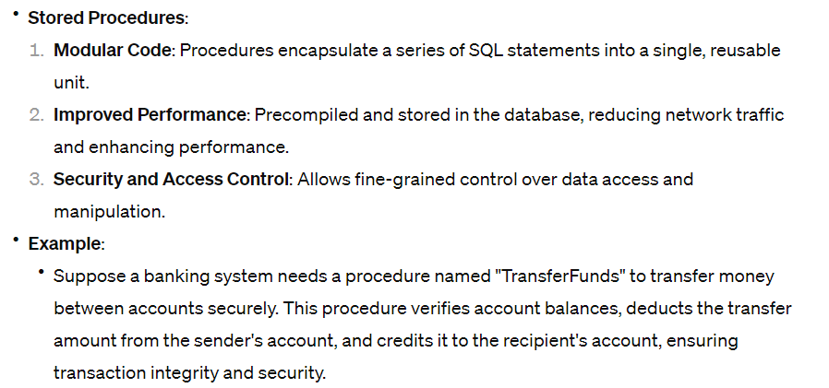

Procedures are precompiled queries

* let us understand what happens when we execute a query

1. Query is checked/parsed for its grammar i.e. syntax
2. Specified columns are check for their existence in specified tables
3. Query is then compiled into machine format/language (binary)

* Procedures are step 3 Ready!
  + Why procedures?
  + Procedures help us reduce network traffic !!
    - We define long queries as procedures in the database and then call the procedure on the client side.
    - Long queries on the client side will increase the payload size of the network request

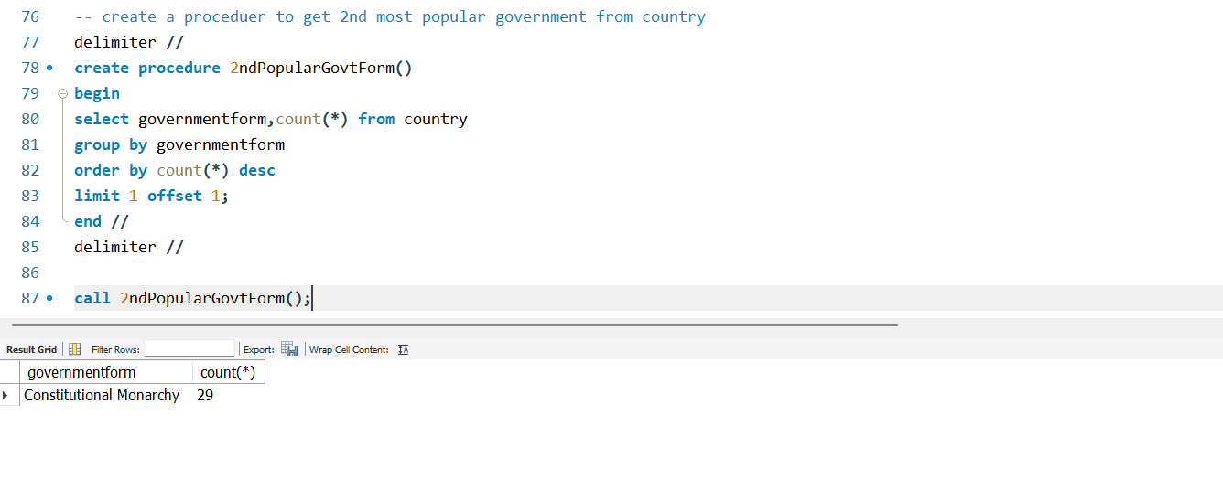

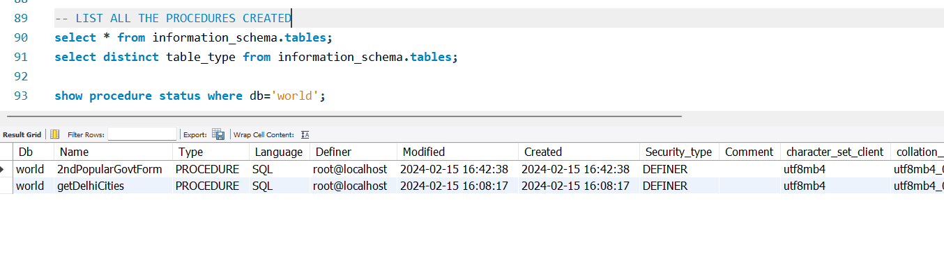

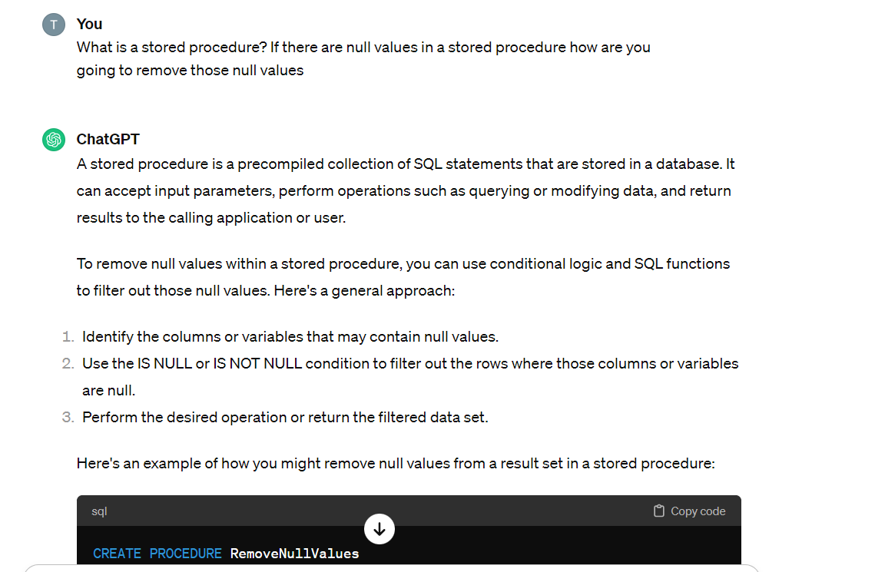

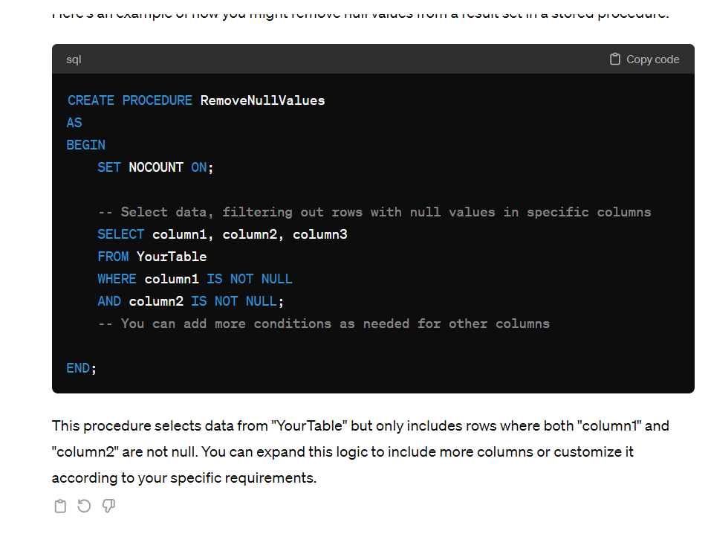

16 Feb

To restart stopped process in window

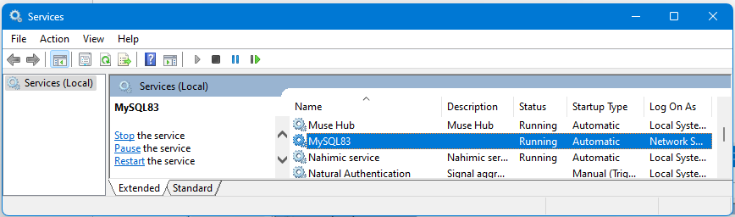

#### Procedures with variables

**IN**

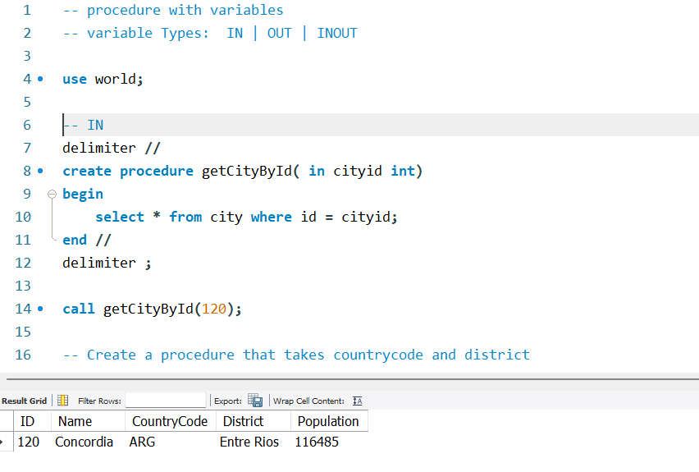

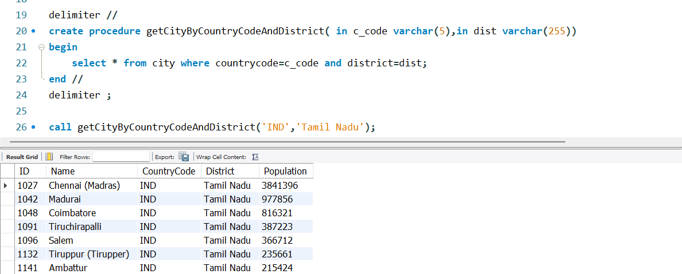

**OUT**

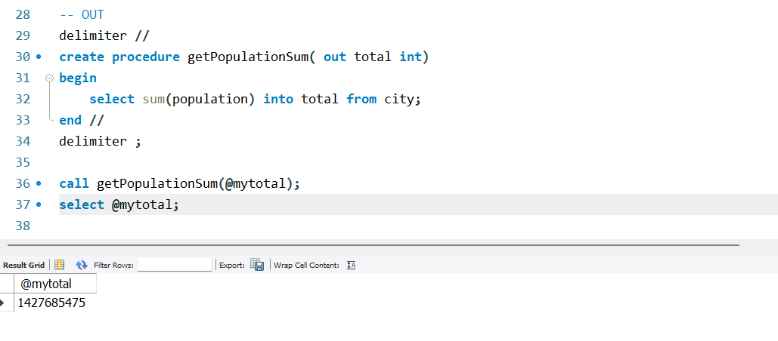

**INOUT**

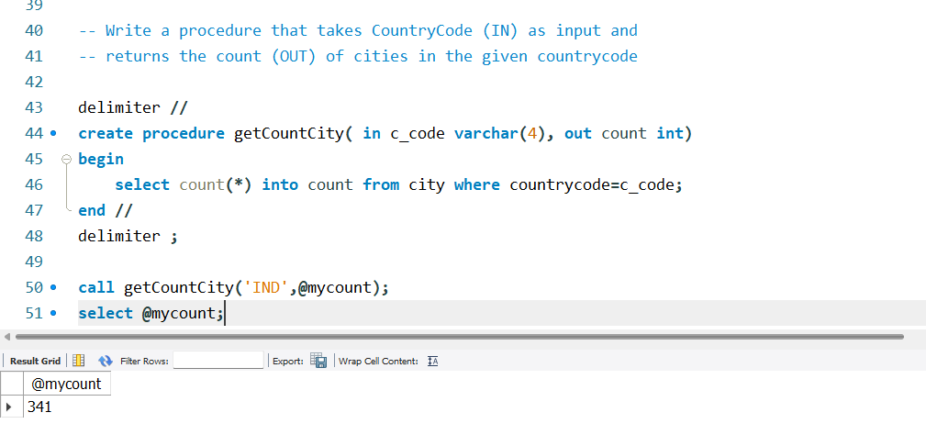

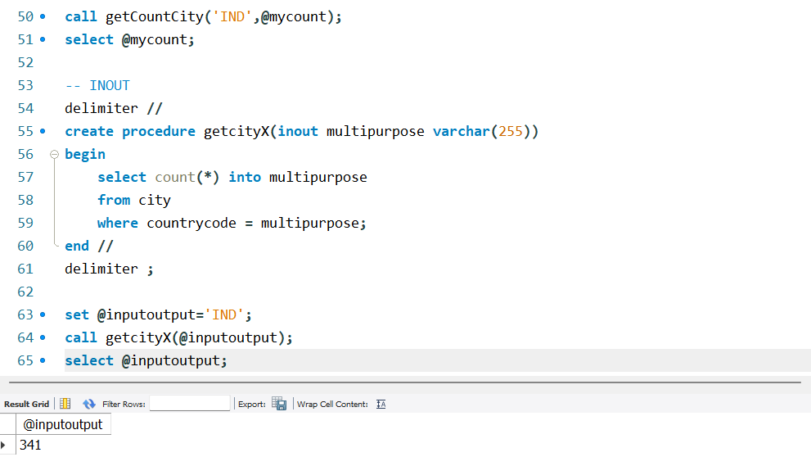

DELIMITER //

CREATE PROCEDURE get_car_stats_by_year(

IN year_filter int,

OUT cars_number int,

OUT min_value decimal(10, 2),

OUT avg_value decimal(10, 2),

OUT max_value decimal(10, 2)

)

BEGIN

SELECT COUNT(*), MIN(value), AVG(value), MAX(value)

INTO cars_number, min_value, avg_value, max_value

FROM cars

WHERE year = year_filter ORDER BY make, value DESC;

END //

DELIMITER ;

CALL get_car_stats_by_year(2017, @number, @min, @avg, @max);

SELECT @number, @min, @avg, @max;

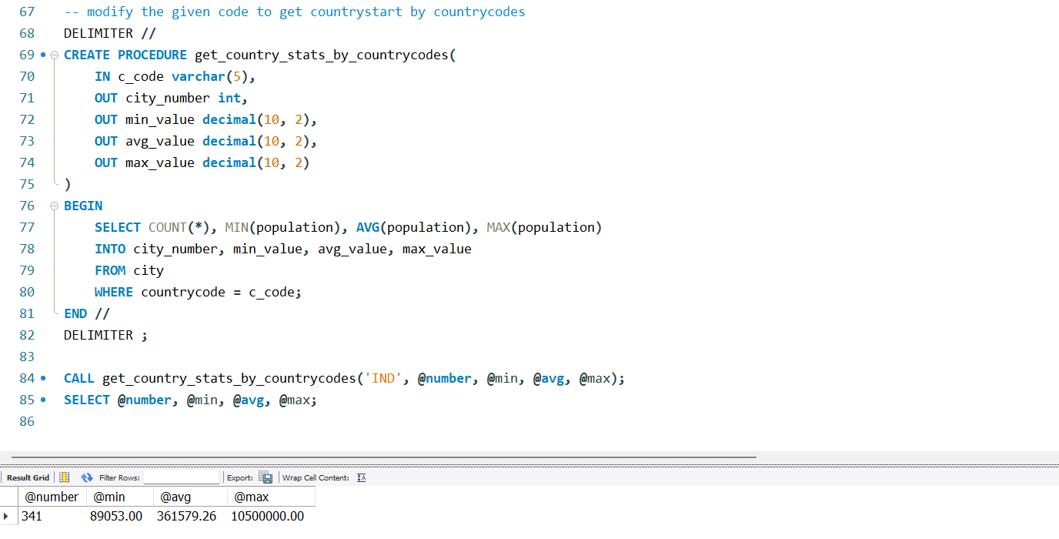

#### Transactions – interview topic

Imagine transaction as a task

It will have a series of subtask or subqueries that is expected to run

In DB terms, a sequence of sql queries executing as a single task/query is called a transaction.

There are only two probabilities. Either the task will

* Complete entirely
* Not execute at all
* There is no inbetween

Need - to make sure that unwanted outputs or half executed are avoided

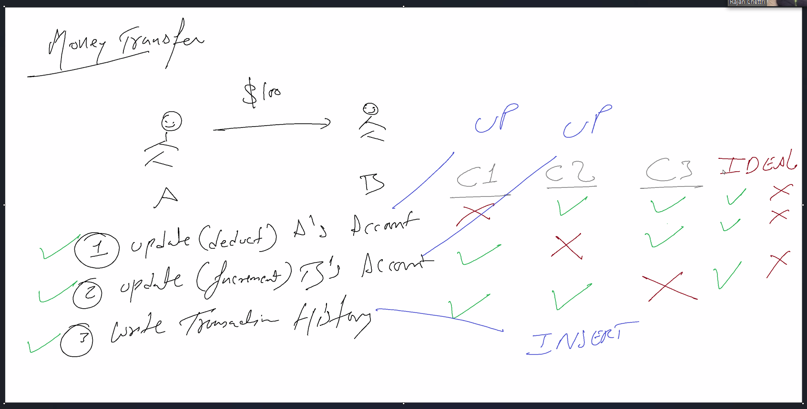

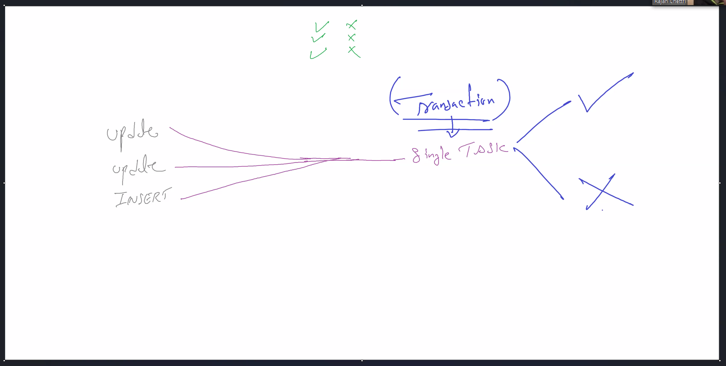

Transactions are ACID in nature

Atomicity

Consistency

Isolation

Durability

#### 

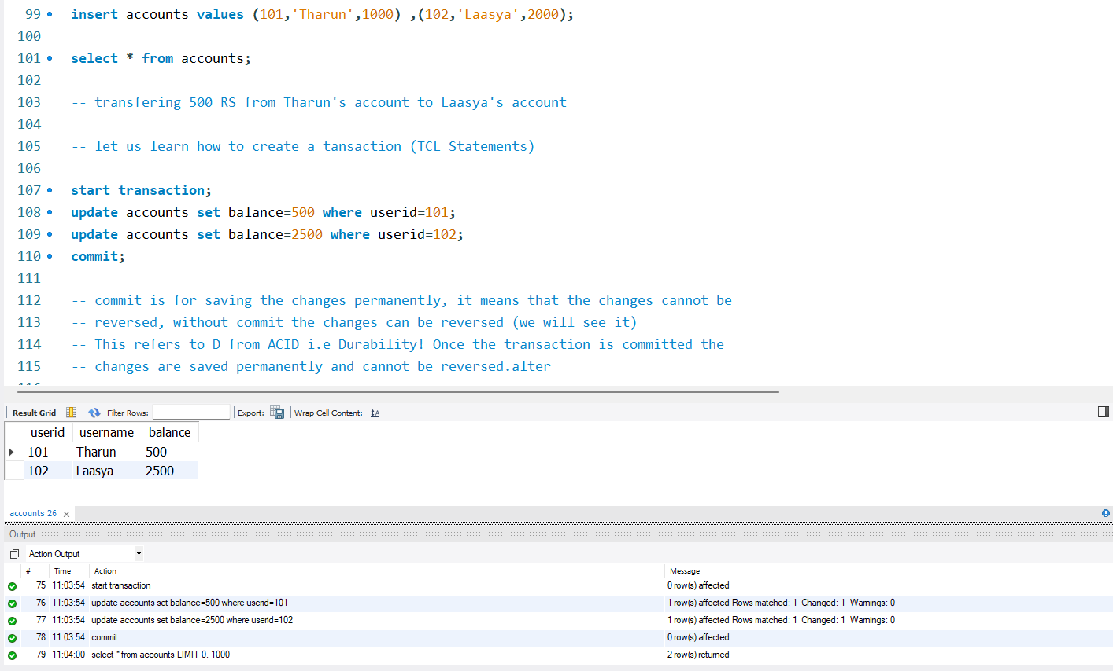

Durability: means once the transaction is committed the changes are saved permanently and cannot be reversed.

Atomicity: guarantees that either all statements(query) in a transaction will succeed or all of them will fail.

Consistency: ensures that once a transaction is committed the data is guaranteed to be in a correct or consistent state. (Data Integrity)

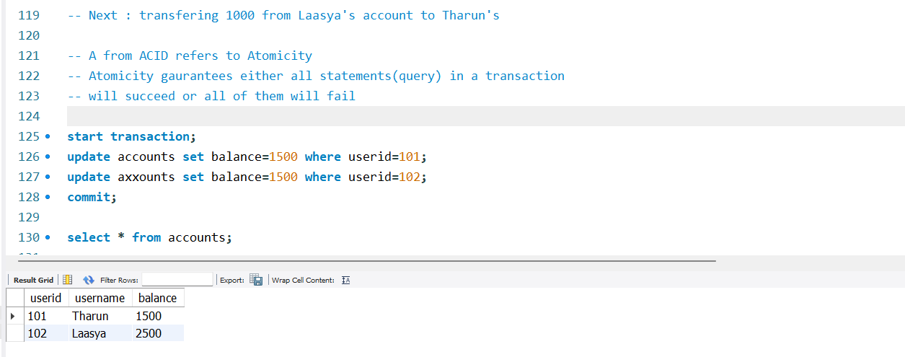

The first query executed even though the second query failed

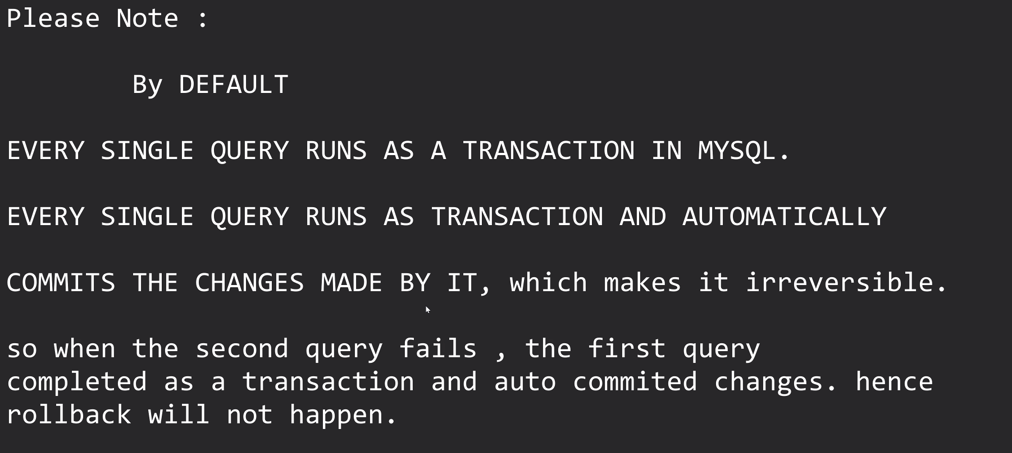

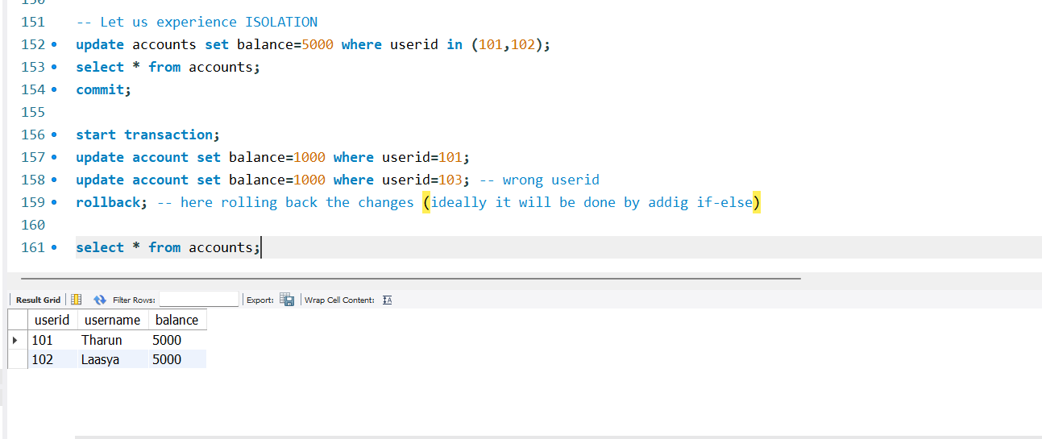

In delete changes can be rollbacked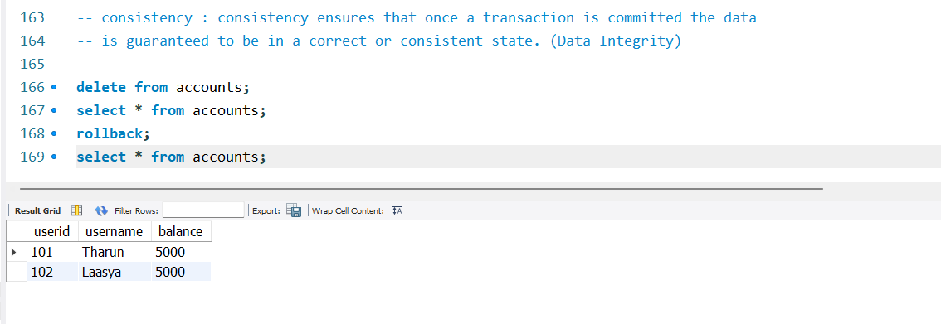

In truncate changes cannot be rollbacked

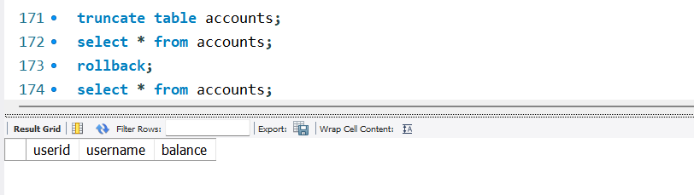

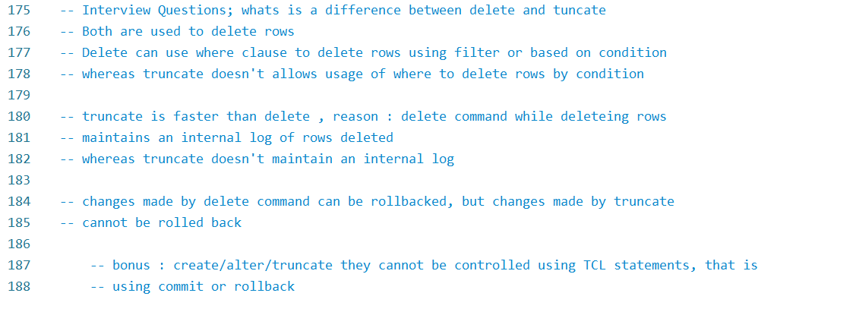

Commit/rollback doesn’t work on DDL statements as well

# Softskill discussion

* Check all external factors - mike, power cut, broadband, lighting
* Be presentable
* Recruiter should feel your commitment and loyalty
* Learn to politely say no i don't know this topic
* The Interviewer's attitude is not your concern. Focusing on delivering properly.
* Technical aspect
* Linux :
* Easy vs Complex
* Easy : get/sed/awk/cut/ (common interview questions)
* complex: write a shell script to find files with.conf extension and move them to /home/abc directory
* Python
* Easy : difference in list and tuple etc.
* complex : write a sorting algorithm
* SQL :
* EASY : joins / agg. functions
* Complex: joins/ cursors / transactions
* Quant Questions : there are 3 goats, 10 mens how many legs. , time and distance etc.
* sql: monitoring tool , didn't taught us
* prometheus
* grafana
* ram 12had a fru23it say app3le and it wa76s very 76delicious98
* # find the sum of all numbers in the given sentence
  + Python
  + str='ram 12had a fru23it say app3le and it wa76s very 76delicious98'
  + print(str)
  + num=0
  + sum=0
  + for i in str:
  + if i.isdigit():
  + num=num*10+int(i)
  + else:
  + sum=sum+num
  + num=0
  + sum+=num
  + print(sum)
  + #288

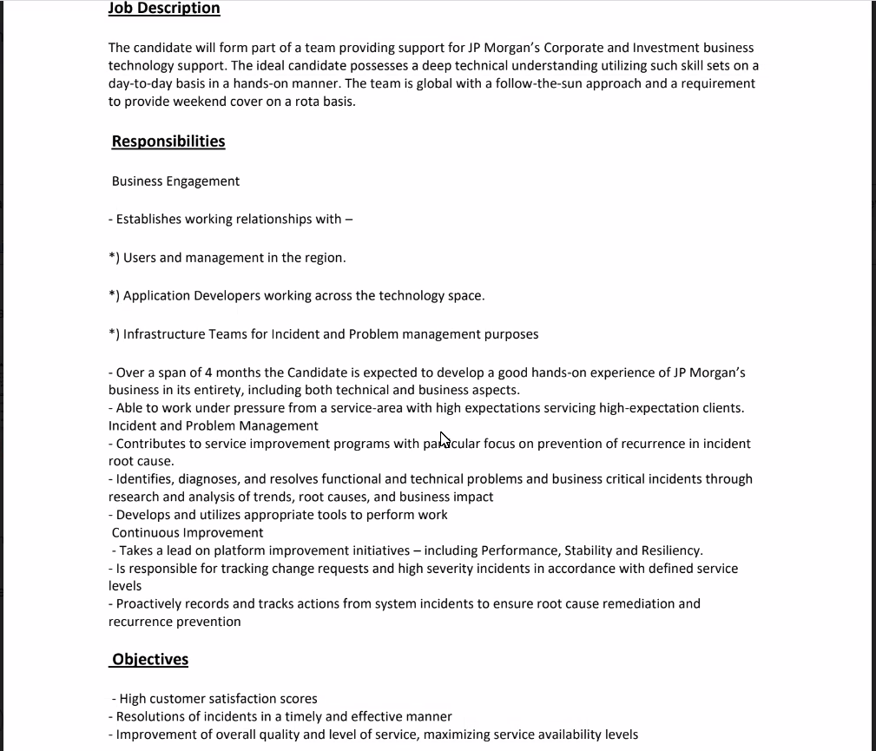

* It will take time for second interview dont fk it up

**Indexing**

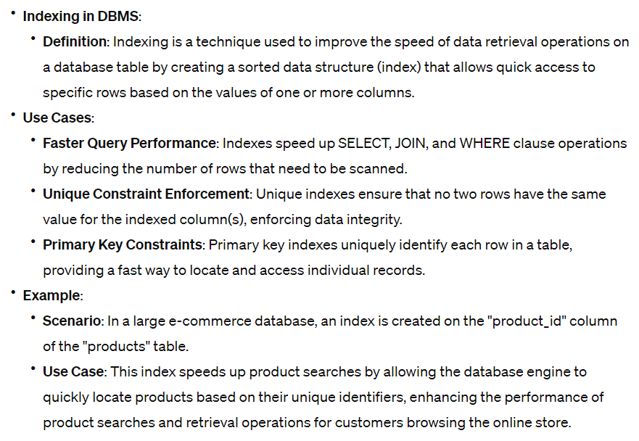

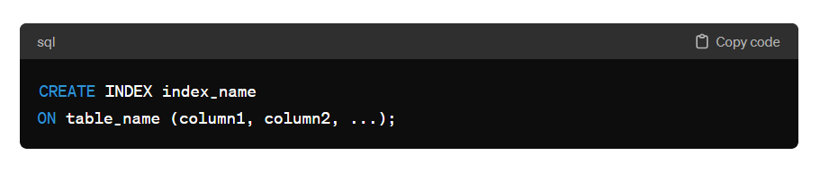

#### Triggers

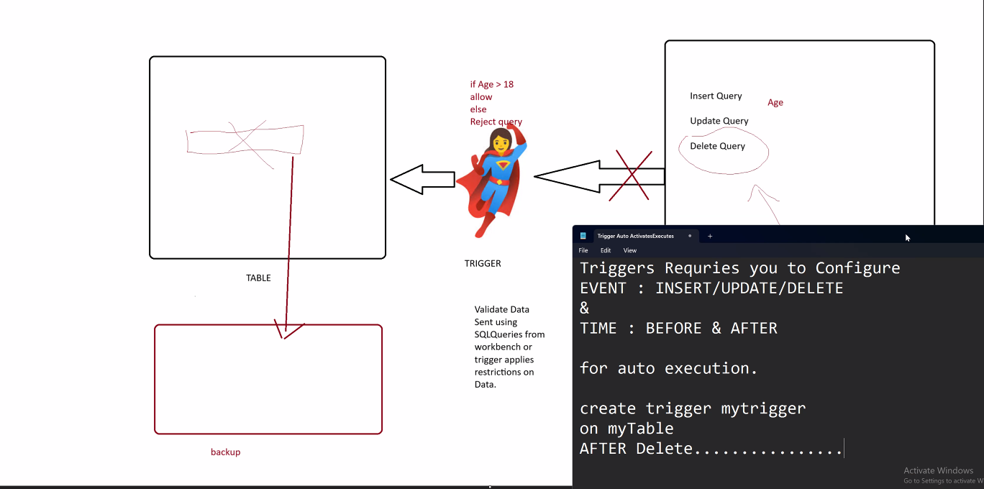

A trigger is a database object that automatically performs predefined actions in response to specified events, like data modifications or certain conditions being met.

-- Triggers are validators that validate the data before execution

-- Triggers Auto activates/executes

-- Triggers require you to configure

-- EVENT : INSERT/UPDATE/DELETE

-- &

-- TIME : BEFORE & AFTER

-- FOR AUTO Execution

-- create trigger mytrigger

-- on myTable

-- before INSERT....

-- create trigger mytrigger

-- on myTable

-- after DELETE....

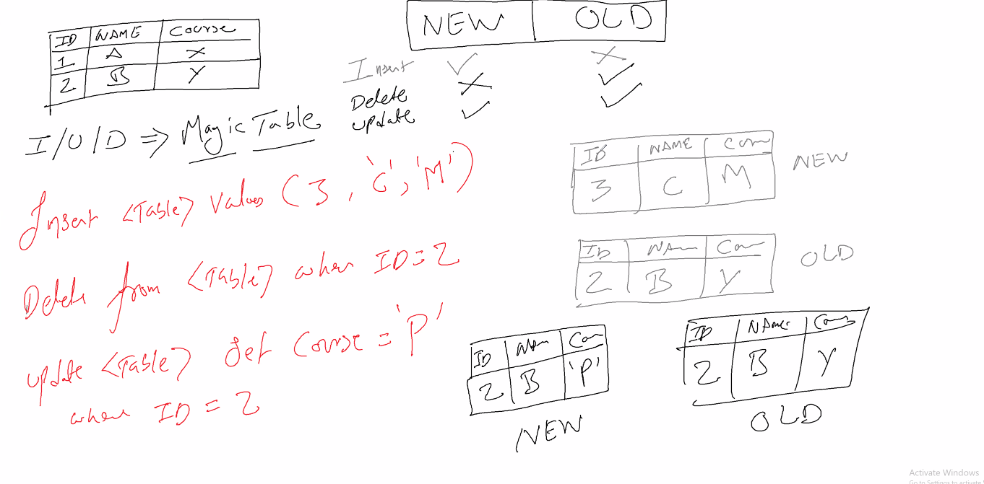

Need for SQL

* Legacy systems are still in use similarly sql
* So there is always a demand for it

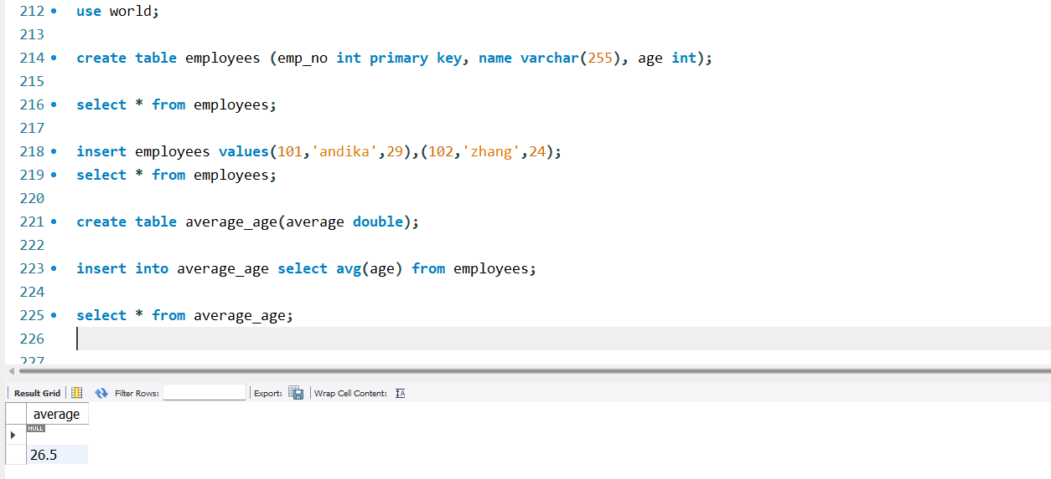

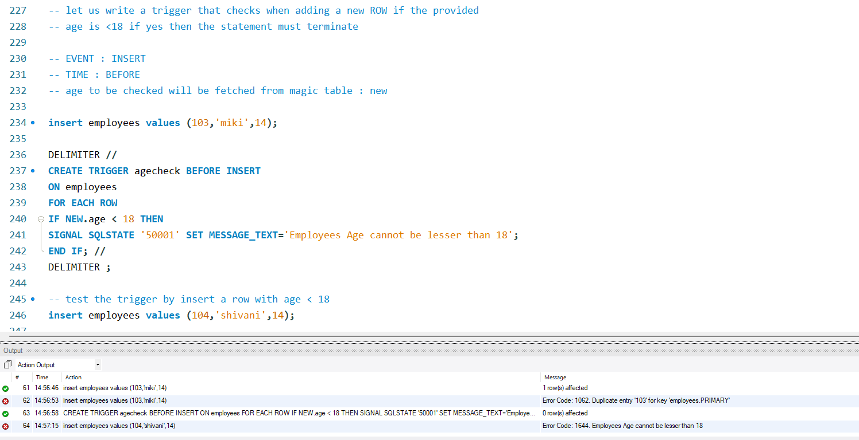

SIGNAL SQLSTATE '50001' this is for raising exception thereby canceling query

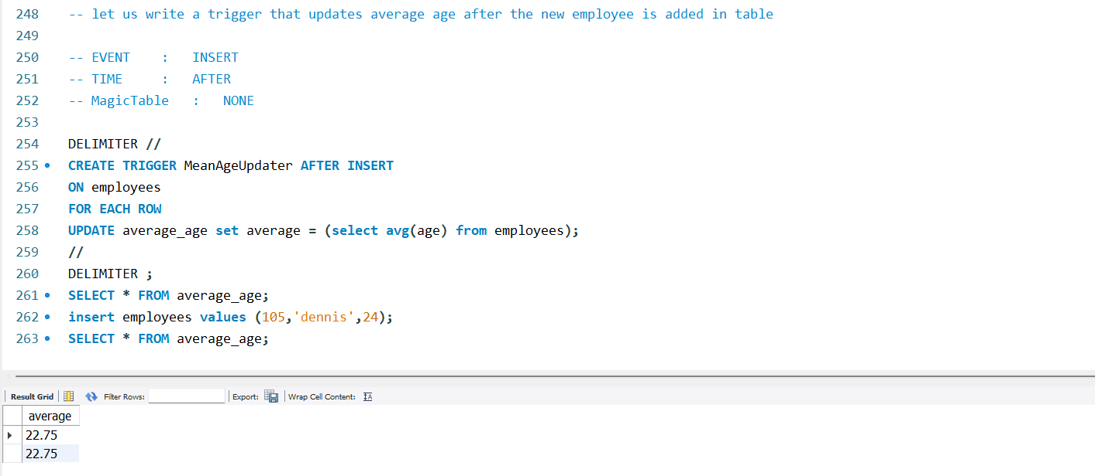

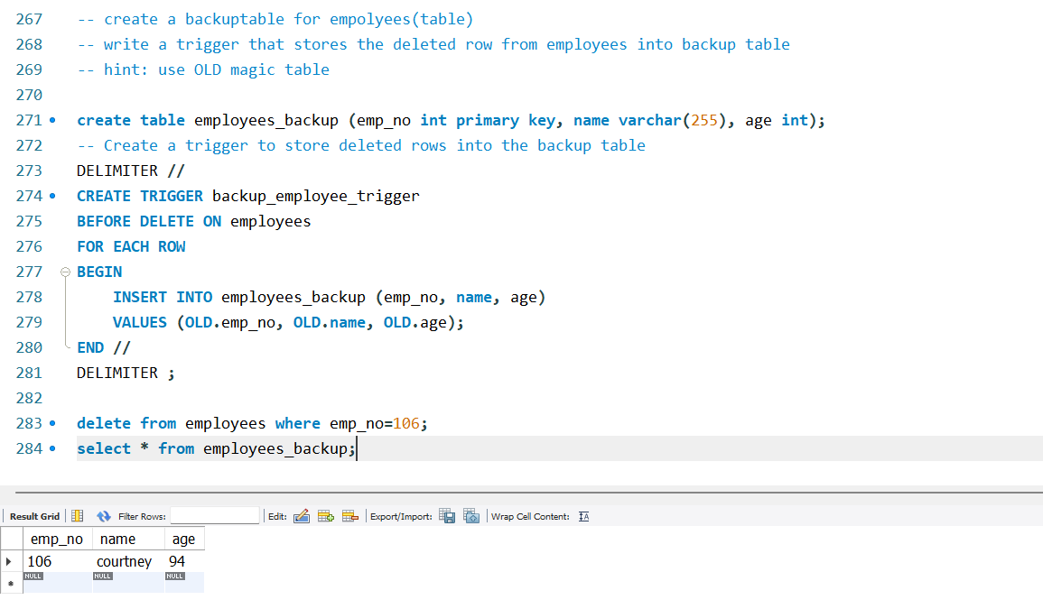

**PL/SQL**

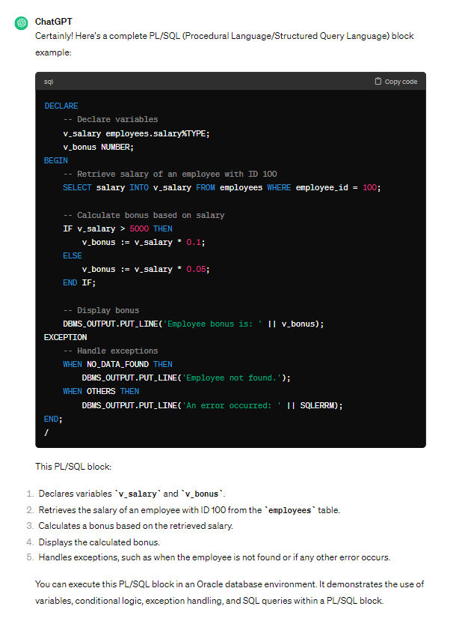

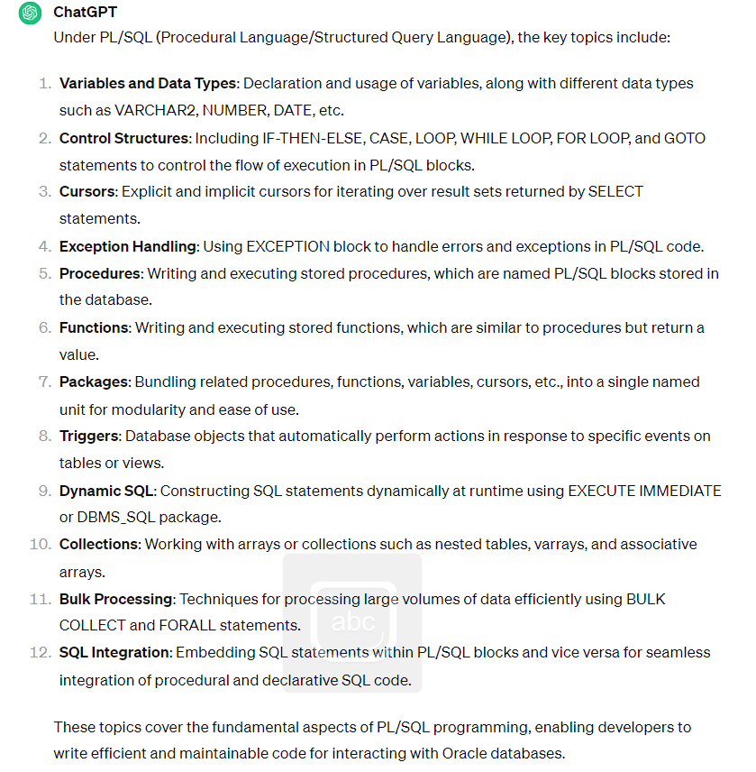

**Cursors** in database management systems are objects used to iterate through query result sets, enabling sequential access to data rows and supporting operations such as fetching, updating, and positioning within the dataset.

**Clusters** in DBMS are database structures that physically group together related rows from different tables based on their shared column values. This arrangement enhances performance by reducing disk I/O and improving data retrieval efficiency for queries involving related data.

**IMPORTANT CODES**

